**GLOBAL ACADEMY**

**WORKSHEET – OCTOBER**

**SESSION 2024 – 25**

**CLASS – VIII (ENGLISH)**

Q1. Answer the following questions -   
a. If someone doesn’t wear a uniform to school, what do you think the teacher will say?

b. When everyone wants a clear sky, what does the rebel want most?

c. Why is it good to have rebels?

Q2. Fill in the blanks with suitable adverbs –

a. ______________ go to bed at 10 o’ clock. (Adverb of frequency)

b. I have ____________ been to the USA. (frequency adverb)

c. I have been to Australia just ____________. (frequency)

d. My grandparents live in Kerala. I Visit them ______________. (frequency)

e. I was ___________ impressed with her performance. (degree of adverb)

Q3. Identify the type of adverb used in each sentence.

a. The boy practiced his speech regularly.

b. The phone kept ringing constantly.

c. The people are out of Ukraine.

d. I have heard this story before.

e. Are you quite sure?

Q4. Use the suitable adverb from the box to fill in each blank –

(below, down, further, under, underneath)

1. The hostages were forced to lie ________________.

2. He bought an old car with some rust ______________.

3. The bridge was too low for the ship to sail _________________.

4. We didn’t go than the first five miles because of the thunderstorm ______________.

Q5. Fill in the blanks with appropriate prepositions –

1. We should not laugh _____________ anyone.

2. The man died ______________ malaria.

3. Sita was married _____________ ram.

4. The chief guest arrived ______________ 10 o’clock.

5. Nisha is confident ______________ her success.

6. The land was distributed ______________ the two sons.

7. I am fond _________________ a light music.

8. My cousin sister lives ____________ us.

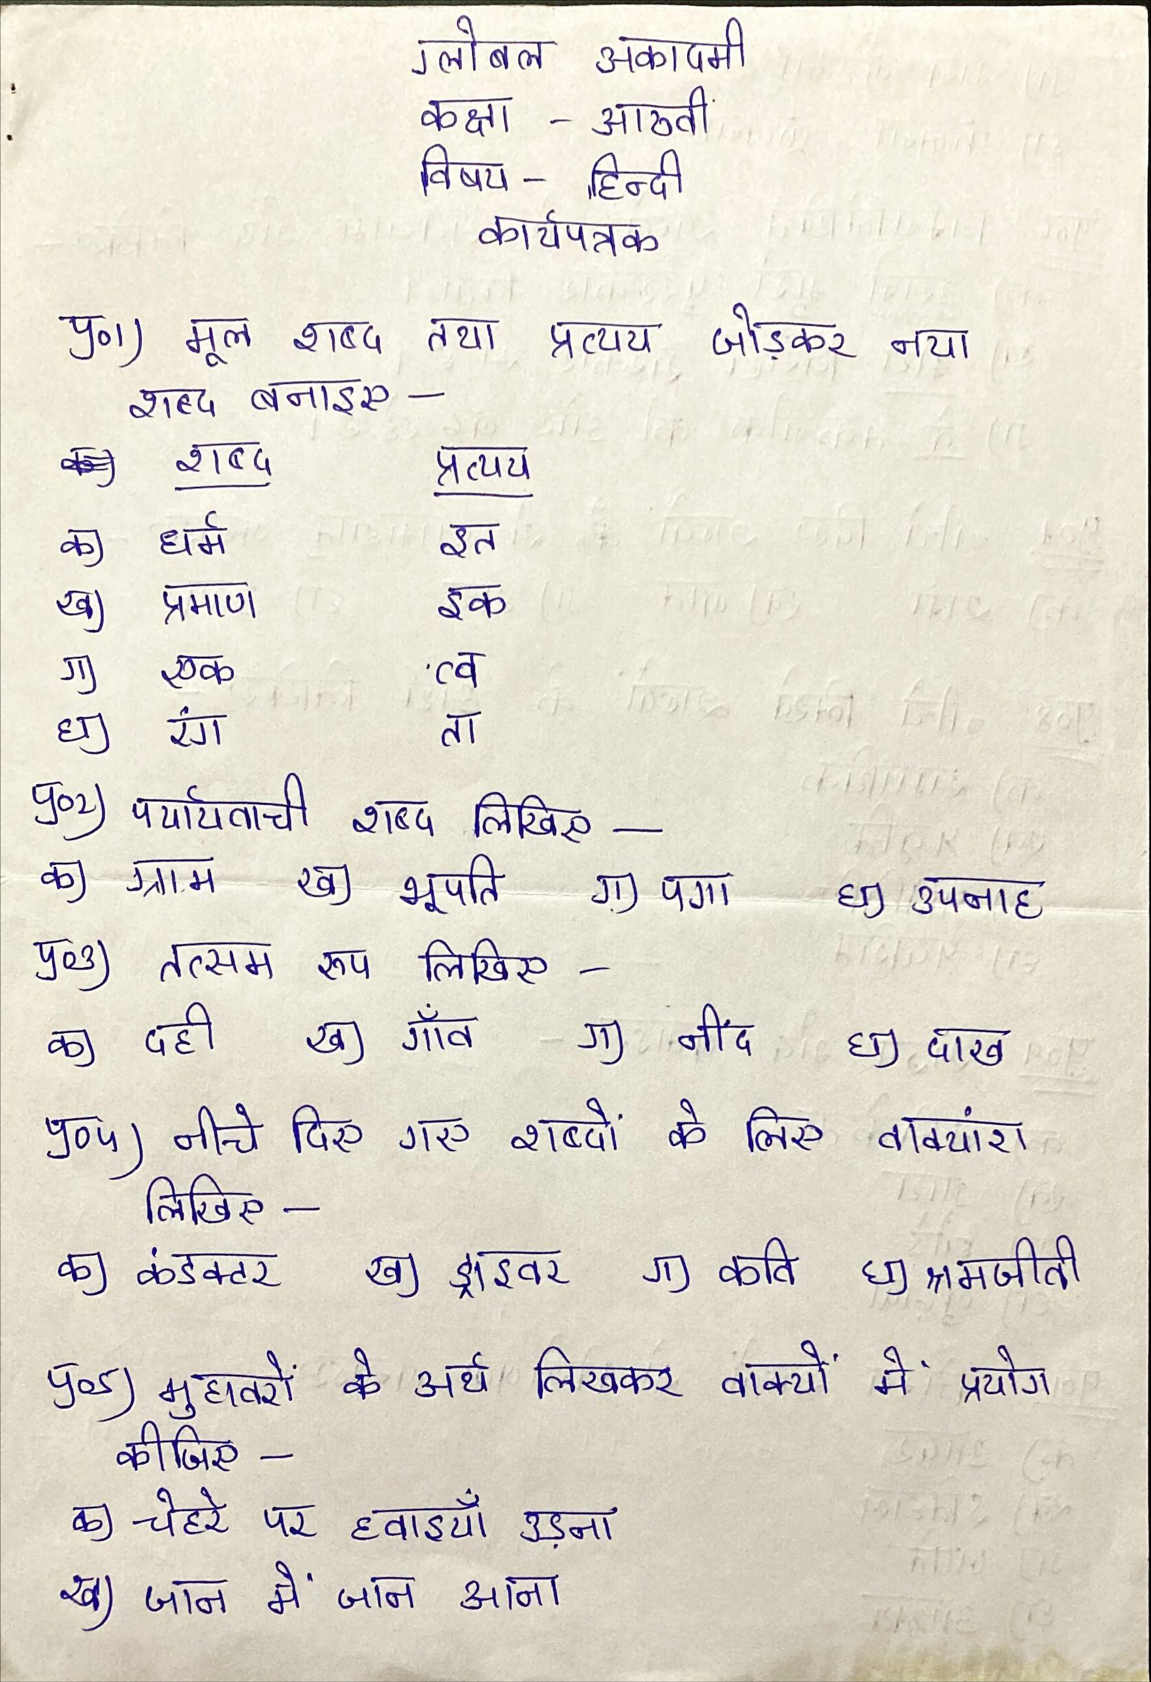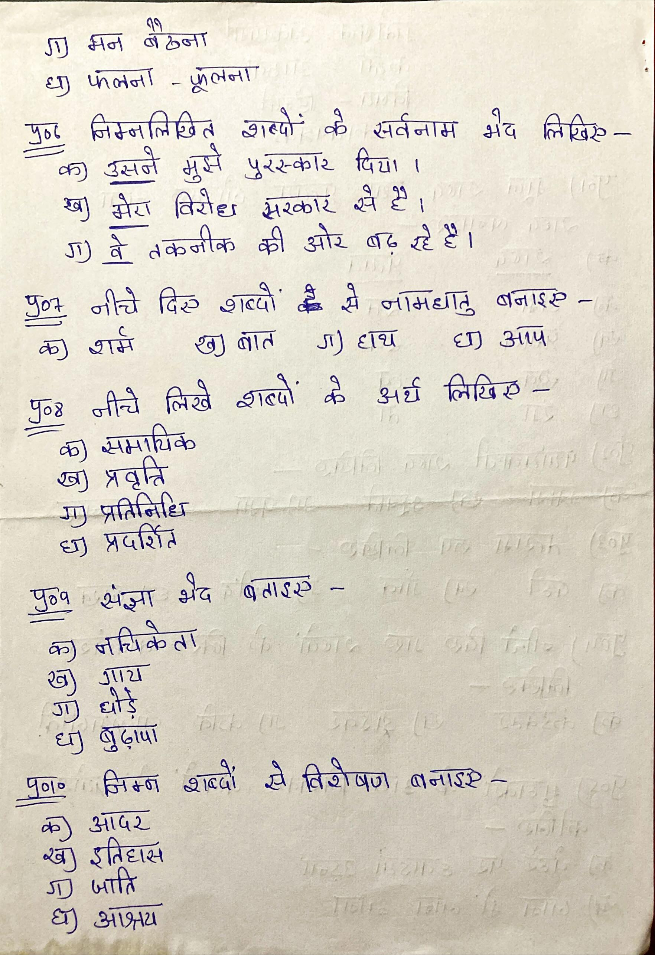

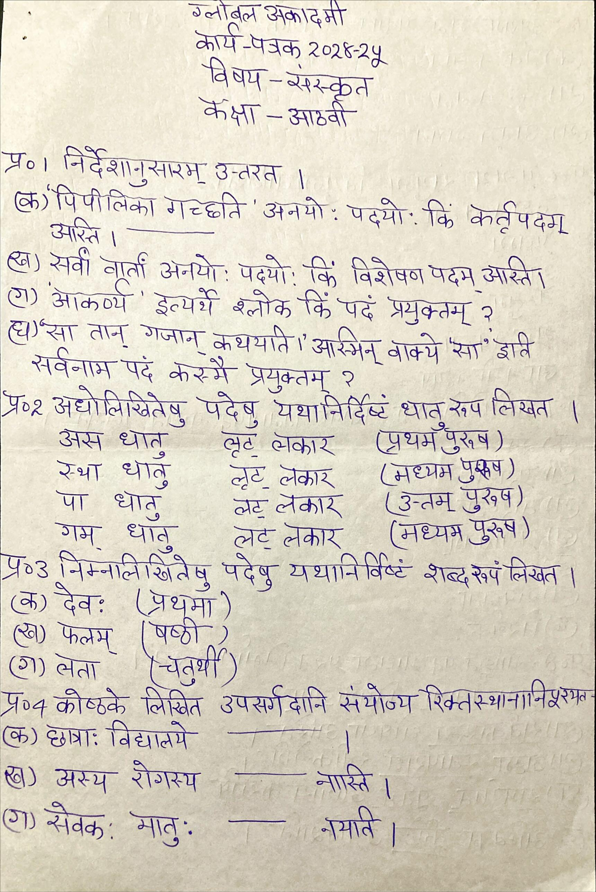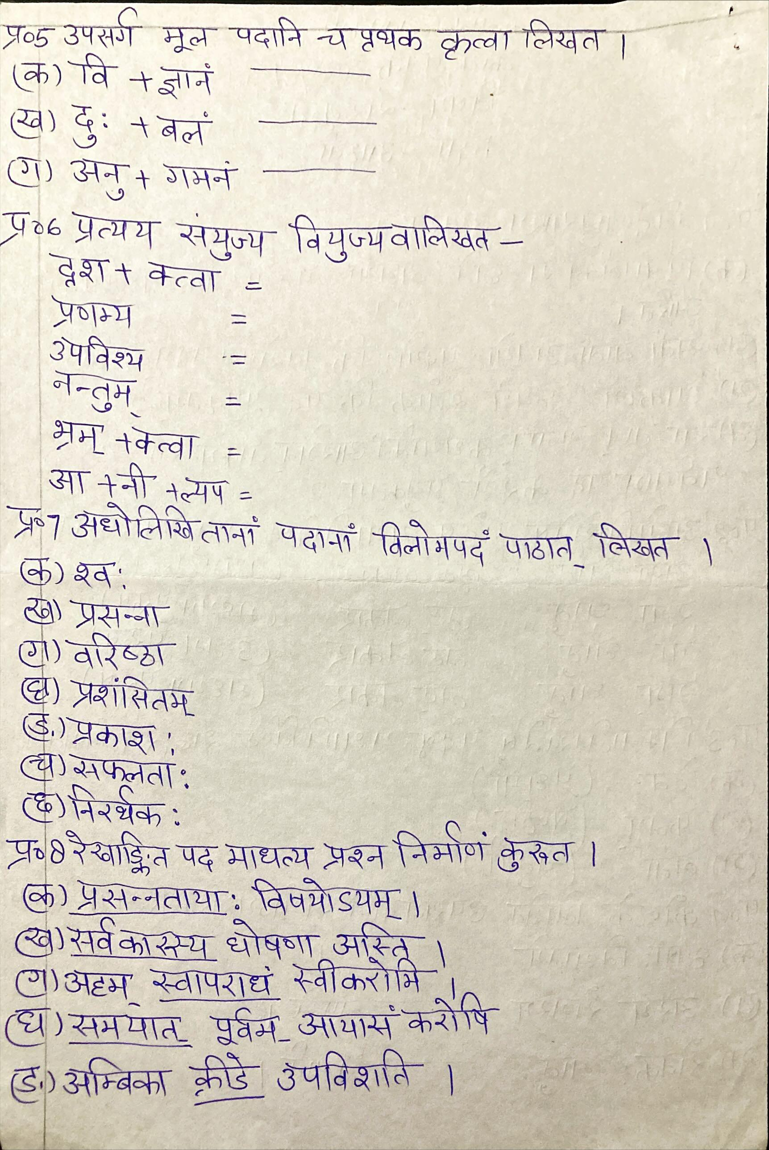

**GLOBAL ACADEMY**

**WORKSHEET – OCTOBER**

**SESSION 2024 – 25**

**CLASS – VIII (MATHS)**

Q1. Multiple choice questions –

a. Saina invested in mutual funds. If that mutual fund offered an interest rate of 5% per annum compounded annually, then find the amount invested by Saina given that she got a total amount of 77175 from the funds after 2 years.

i. 20,000

ii. 7000

iii. 5000

iv. 70,000

b. The value of a property increases every year at the rate of 10%. If its value at the end of 2 years is 5,32,400. What was its original value at the beginning of these years?

i. 5,50,000

ii. 7,90,000

iii. 4,40,000

iv. 6,80,000

Q2. Fill in the blanks –

a. The population of a town was 5600 four years back. It is 7000 right now. Four years down the line, if the rate of growth of the population has been constant over the years and has been compounding annually, the population will be _________________.

b. If an amount of 80,000 is invested for 2 years such that the compound interest received for the first and the second year is 9% and 11% per annum respectively, then the value of interest received is ________________ and the value of final amount is ________________.

c. Population of a town increased by 1 % every year. If current population of the town is 80,000. Find the population of town after 2 years.

d. Find the least number of complete years in which a sum of money put out at 3% compound interest will be more than doubled.

e. Number of workers in a factory increased by 20% every year. If there are 8000 workers in the factory. Find the number of workers in factory after 2 years.

f. Sarika invested 5,12,000Rs. in mutual fund. She is being offered 8 $\frac{3}{4}$ interest per annum compounded annually. If Sarika takes out all her money from the funds at the end of 3 years. Find the amount of interest received by her.

g. The population of a town was 10,000 three years ago. If it increased by 7.5%, 5% and 4% respectively in the last three years then what is the present population of the town?

**GLOBAL ACADEMY**

**WORKSHEET – OCTOBER**

**SESSION 2024 – 25**

**CLASS – VIII (SCIENCE)**

Q1. Differentiate between Asexual reproduction and sexual reproduction.

Q2. Write function of sperm, testis, ovary and uterus.

Q3. How embryo developed in mother womb.

Q4. Have you ever heard the term ‘cloning’ do some research and make a report?

Q5. A frog and a duck lays egg. Is there any difference in their life cycles?

Q6. The features of the offspring produced by sexual reproduction are different from those of their parents. Why?

Q7. Why should a pregnant woman be well nourished and eat a balanced diet.

**GLOBAL ACADEMY**

**WORKSHEET – OCTOBER**

**SESSION 2024 – 25**

**CLASS – VIII (SST)**

Q1. Tick the correct options -   
1. Law is critical for regulating our life as well as to guarantee

a. Personal benefit

b. Liberty for all

c. Entertainment for all

2. What is a bill

a. A proposal for a new law

b. an act

c. the final statement of account

3. It is the final authority on the constitution.

a. Parliament

b. Judiciary

c. Citizen

4. PIL was evolved by the supreme court in the early

a. 1970

b. 1980

c. 1990

5. What are non – cognisable offences?

a. Murder, robbery, theft

b. harm to public property

c. public nuisance, assault, mischief

Q2. Fill in the blanks –

a. ___________ that are responsible for assessing and collecting land revenue.

2. Criminal cases involve gross violation of law that includes theft, murder and ______________.

3. The _______________ is the custodian of our constitution.

4. The ___________ is responsible for preventing and investigating any crime.

5. ________________ play the most crucial role in the whole justice system.

Q3. True or false –

1. The land on which crops are grown is known as arable land.

2. 40% of the population is engaged in agricultural activity.

3. Which is the mostly widely cultivated crop in the world.

4. Jute is not called as Golden fibre throughout the world.

5. In India, Rabi crop are sown in summer.

Q4. Answer in one word –

1. The largest producers of jute in the world.

2. Name one plantation crop.

3. The revolt of 1857 was termed as.

4. Governor General declared ‘sati’ as an illegal practice in 1829.

5. He was against the system of Beth began or forced labour.

Q5. Answer the following questions –

1. When and where did Bahadur Shah Zafar die?

2. Name the Bengali writer who was involved with the tribal communities within India.

3. What is Pisciculture.

4. Name the two varieties of coffee.

5. What is Mineral Based industries?

Q6. Difference between –

1. Agro based industries and mineral based industries.

2. Private sector and public sector industries.

Q7. Give reason for the following –

1. The High courts and the supreme courts in India is called the count of records.

2. Article 21 of the Indian Constitution assures the right to life.

Q8. Mark the following on Map of world. (MAP)

1. Rice 2. Wheat 3. tea 4. Coffee