**GLOBAL ACADEMY**

**WORKSHEET – OCTOBER**

**SESSION 2024 – 25**

**CLASS – VII (ENGLISH)**

Q1. Give brief details about Michael stone?

Q2. How Michael fulfil his dream?

Q3. Identify the principles and verbs, state its types.

a. The baby laughing heartily.

b. Students are reading the books.

c. Smita writes a long letter.

d. The man was jumping on the floor.

Q4. Find the correct verb.

1. The old man liked to watch the children ___________ in the garden.

2. Don’t disturb her. She is ____________ an application to her principal for leave.

3. The king of spain ____________ to celebrate. Christopher Columbus return from his famous royage.

Q5. Write an application to the principal of your school to request him to open a computer club in your school.

Q6. Write an application to principal of your college for a seat accommodation in the hostel.

Q7. You are Priti – your expensive watch is lost in the school play-ground. Write a notice on the school notice board providing all necessary details.

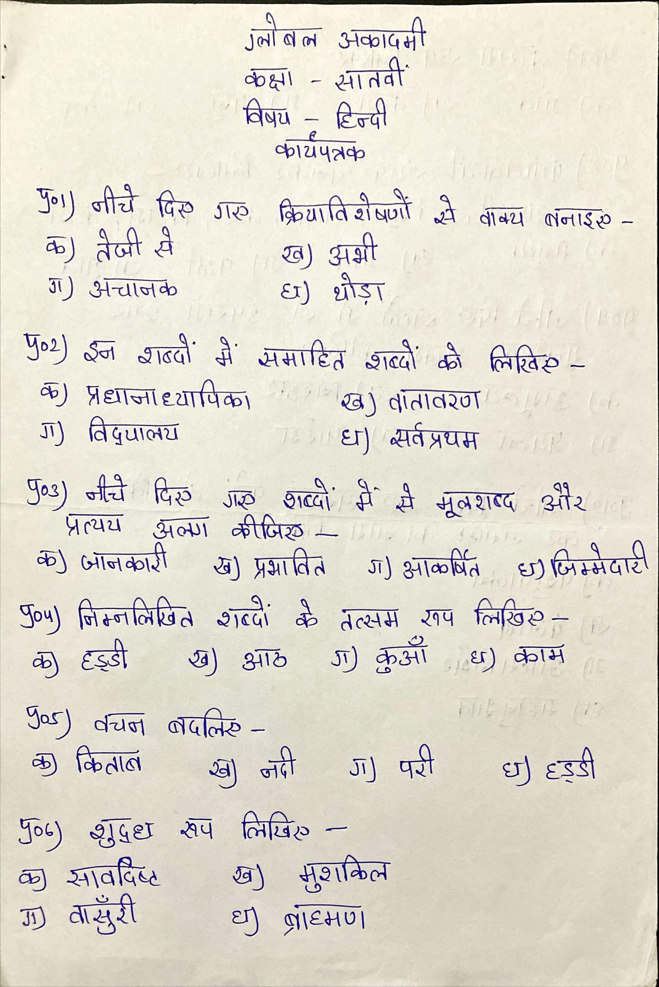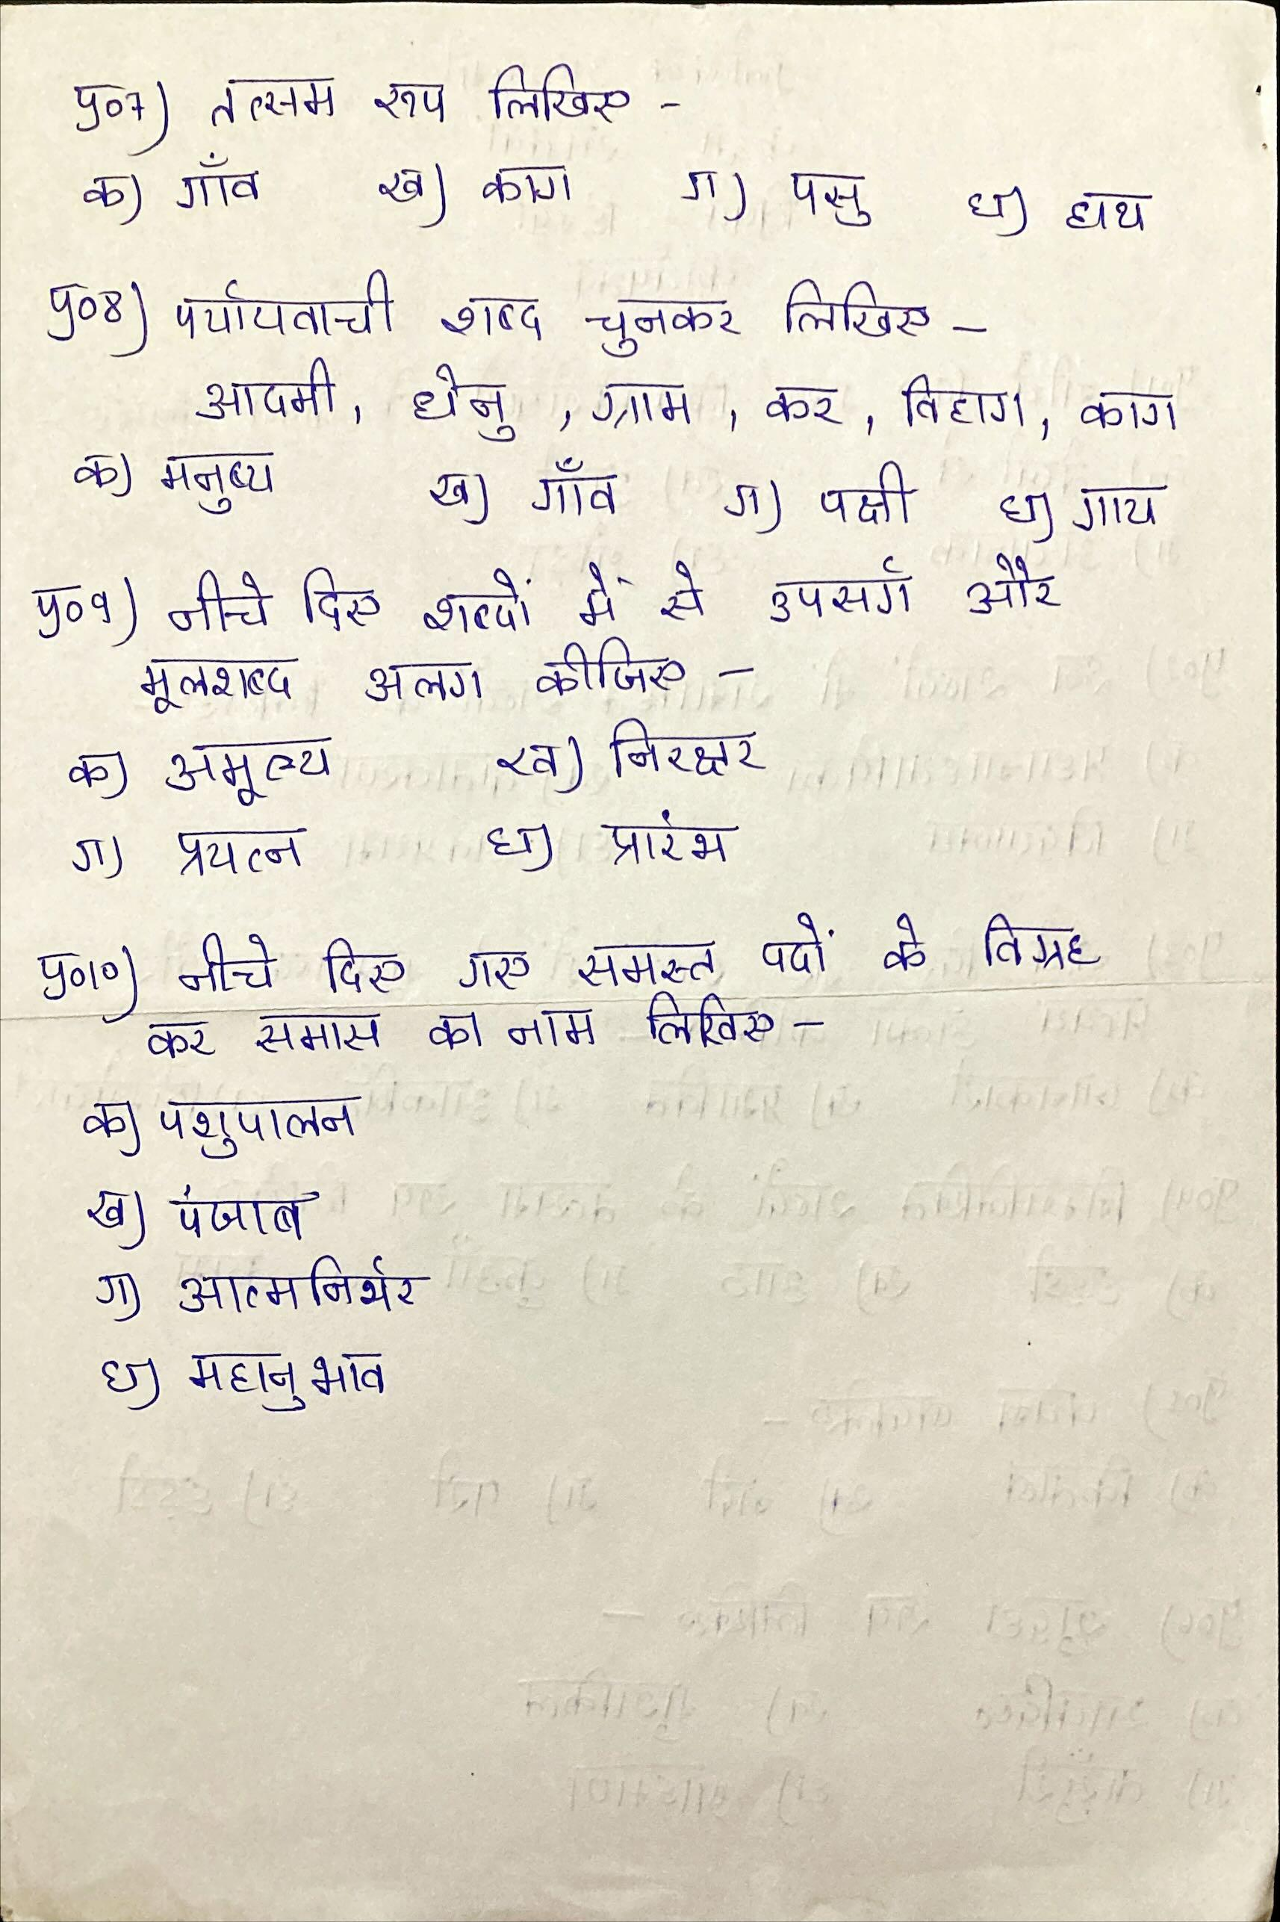

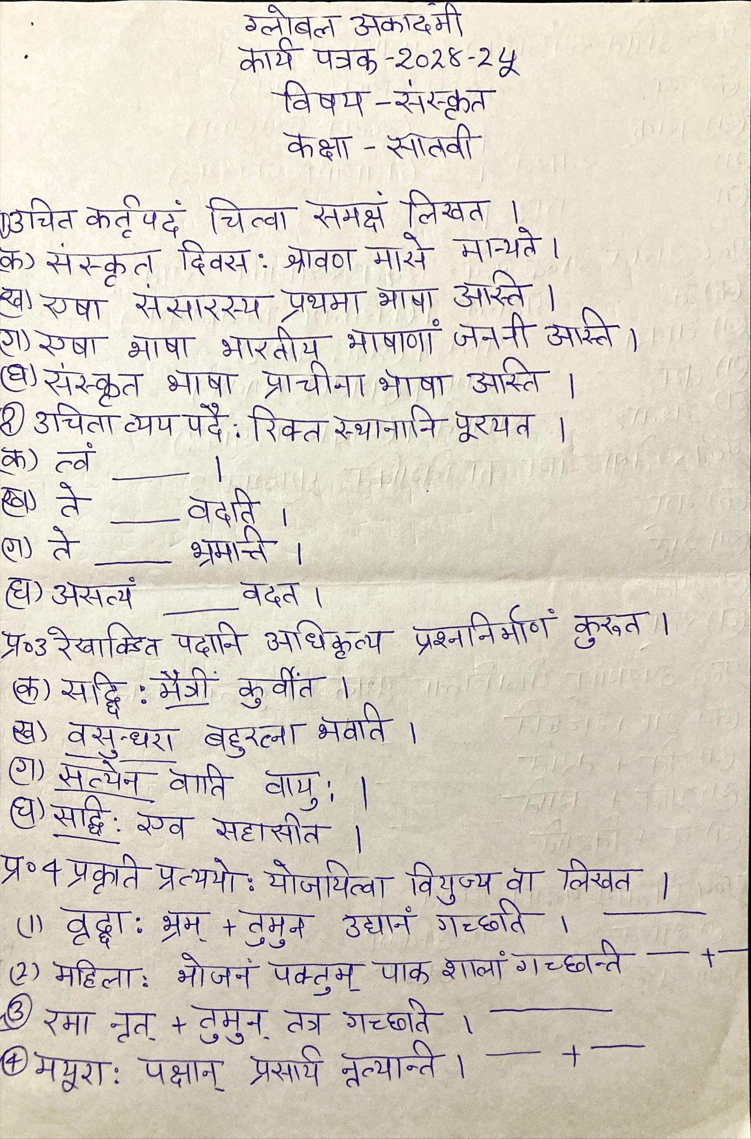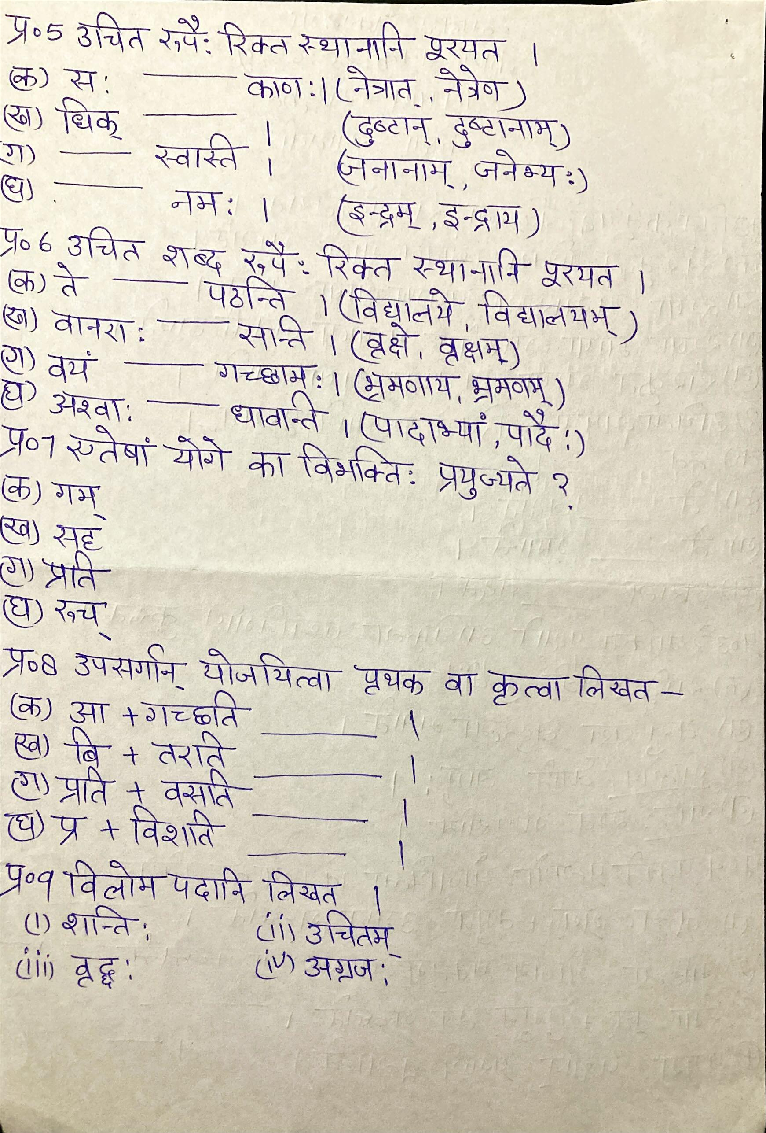

**GLOBAL ACADEMY**

**WORKSHEET – OCTOBER**

**SESSION 2024 – 25**

**CLASS – VII (MATHS)**

Q1. Sum of two complementary angles is 180o. (T/F)

Q2. Two lines in a plane which never meet at any point are called ___________ lines.

Q3. Angles between south and west and south and east are _____________angles.

Q4. If two lines are intersected by a transversal, then the number of pairs of interior angles on the same side of the transversal is _________________.

Q5. A linear pair may have two acute angles. (T/F)

Q6. In the given figure, find the value of ⦟BOC, if points A, O and B are collinear.

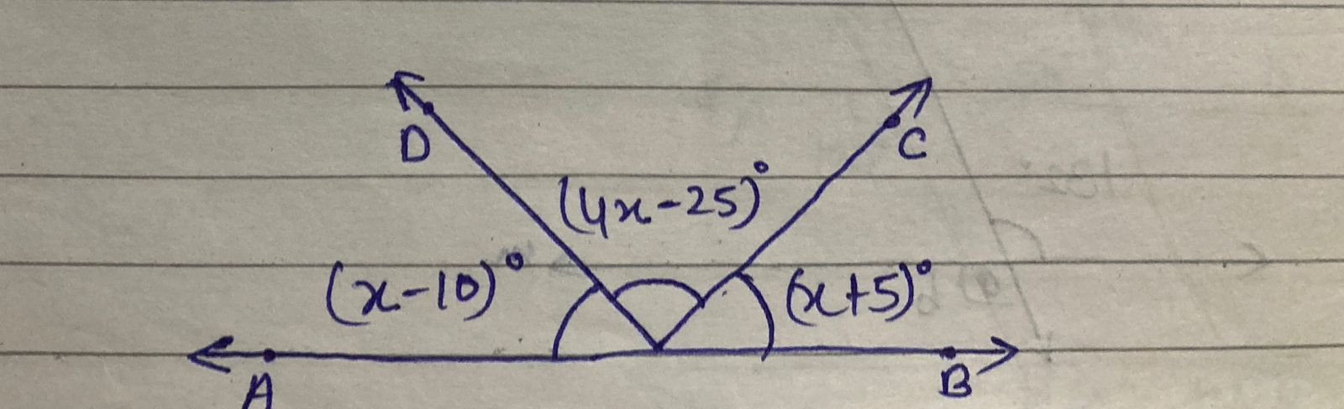

Q7. Out of a pair of complementary angles, one is two third of the other. Find the angles.

Q8. In the given figure, CD intersects the line AB at F, ⦟CFB = 50O and ⦟EFA = ⦟AFD. Find the measure of ⦟EFC.

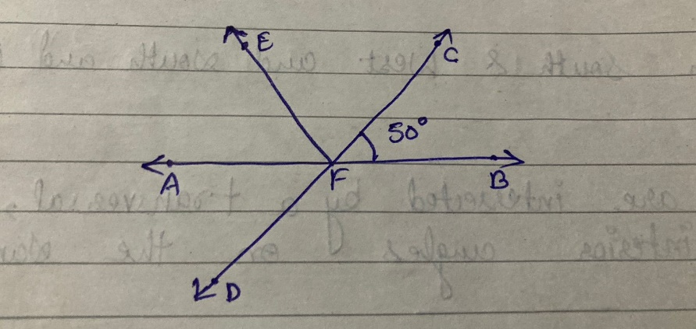

Q9. In the given figure, l ll M and a line intersects these lines at P and Q respectively. Find the sum 2a+b.

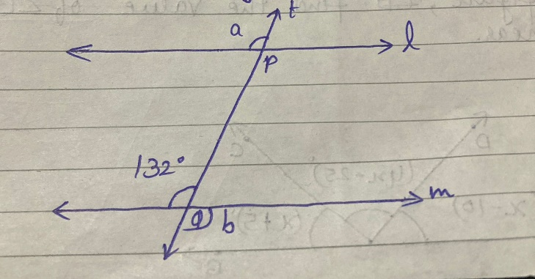

Q10. In the given figure, are the angles 1 and 2 of the letter N forming a pair of adjacent angles? Give reasons.

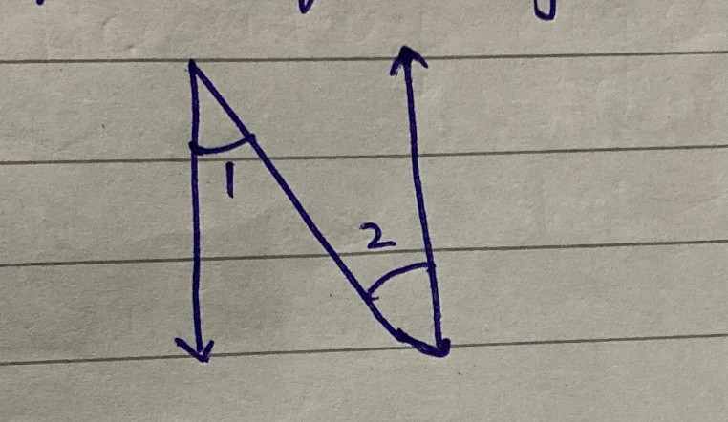

Q11. In the given figure, PQ ll RT. Find the value of a+b.

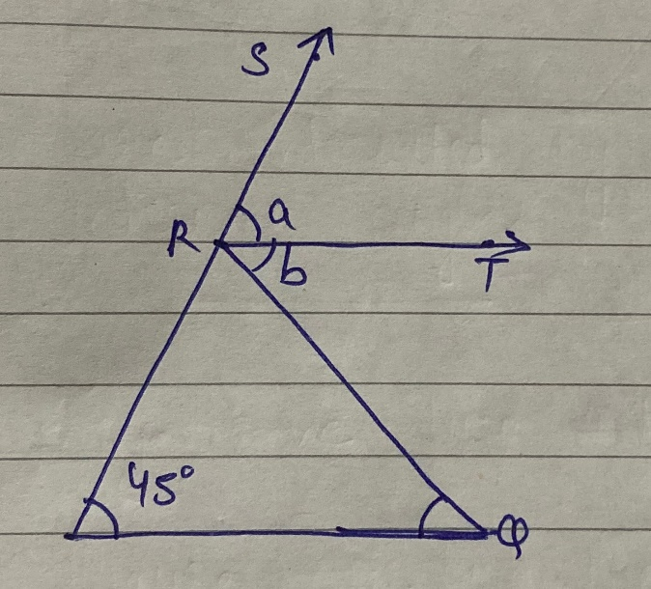

Q12. In the given figure, show that.

a. AB ll CD

b. EF ll GH

**GLOBAL ACADEMY**

**WORKSHEET – OCTOBER**

**SESSION 2024 – 25**

**CLASS – VII (SCIENCE)**

Q1. Differentiate between breathing and respiration.

Q2. Describe the role of diaphragm in breathing during inhalation and exhalation.

Q3. Differentiate between Aerobic respiration and Anaerobic respiration and write the product formed during these two respirations.

Q4. A money plant that was uprooted from its pot was completely submerged

in a glass jar of water. The plant turned yellow. Why?

Q5. Sprinting is a faster form of running and is possible to do only for a short period of time. Can you think of why?

Q6. Make a model of human respiratory system using easily available material.

Q7. Smoking has been prohibited. It can lead to cancer of mouth, larynx, trachea, stomach. Write a repart by which we can cure this type of diseases.

**GLOBAL ACADEMY**

**WORKSHEET – OCTOBER**

**SESSION 2024 – 25**

**CLASS – VII (SST)**

Q1. Fill in the blanks –

1. ________________ is the lowest and densest layer of the atmosphere.

2. The _______________ lies above the mesosphere and extends from 80km to 400km.

3. _______________ is the blanket of air which surrounds the Earth.

4. _______________ is also called Ionosphere because of the presence of electrically charged particles called ions.

5. The atmosphere is a mixture of colorless, odorless and ____________ gases.

Q2. True or false –

1. The main gases which constitute our atmosphere are nitrogen and oxygen.

2. All weather changes occur in troposphere.

3. Ozone gas protects us from sun’s harmful ultraviolet Rays.

4. The term ‘strato’ means ‘straight’.

5. Mesosphere is the hottest layer of the atmosphere.

Q3. Short question Answer –

1. What is Ozone gas?

2. What is Greenhouse effect?

3. Name the layers of the Atmosphere.

4. What are the advantages of the atmosphere.

5. What is weather?

Q4. Difference between –

1. Torrid Zone and Temperate Zone.

2. Relief Rainfall and cyclonic Rain.

Q5. Answer in one word –

1. Forms of condensation.

2. A tropical cyclone formed in the Bay of Bengal.

3. Instrument is used to measure temperature.

4. Heat we receive on the earth’s surface.

5. Two types of Barometer.

Q6. Tick the correct option –

1. Celsius scale is used to measure

a. Temperature

b. wind

c. pressure

2. Polar region lies in the

a. Torrid Zones

b. Temperate zones

c. Frigid zones

3. These winds blow in both the hemispheres

a. Monsoon winds

b. Westerly winds

c. Local winds

4. The most important form of precipitation is

a. rainfall

b. hail

c. sleet

5. Tornado, hurricanes and typhons are examples of

a. Local winds

b. Local storms

c. Condensation

Q7. Draw a diagram of heat zones.