**GLOBAL ACADEMY**

**WORKSHEET – OCTOBER**

**SESSION 2024 – 25**

**CLASS – VI (ENGLISH)**

Q1. How all the birds understand each other?

Q2. Who was the leader of the gang?

Q3. Fill in the blanks –

a. Rita ____________ a mile every day. (run/runs)

b. The dogs ____________ all night. (barks/bark)

c. Mita ______________ school yesterday. (went/go)

d. My brother and I _____________ every day. (talk/talks)

Q4. Identify the transitive and intransitive verb –

a. I like all of katy perry’s songs.

b. New Delhi is the capital of India.

c. Billie Eilish is a singer.

d. I ate a sandwich for breakfast.

Q5. You are the head girl/boy of your school. Write a notice on the annual day celebration which will held on 15th march 2025, at Raina Auditorium.

Q6. Write an application to the principal ma’am asking for arranging a tip.

Q7. Holy faith society, Udaipur is organizing a camp for blood donation. Draft a poster to invite donors for this cause.

Q8. Suppose you are Rakesh. Your uncle has sent you an alarm clock on your birthday. Write a postcard thanking him.

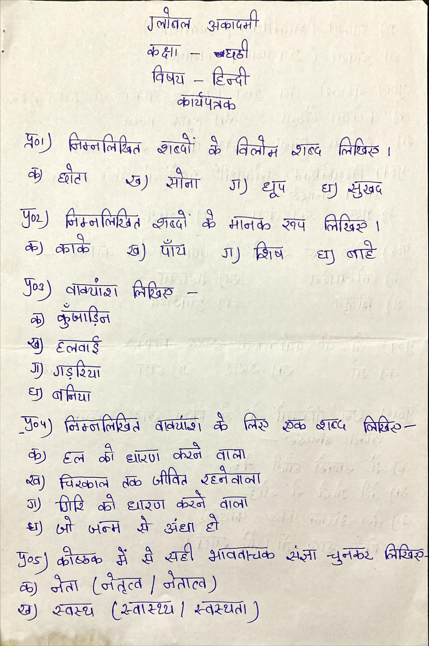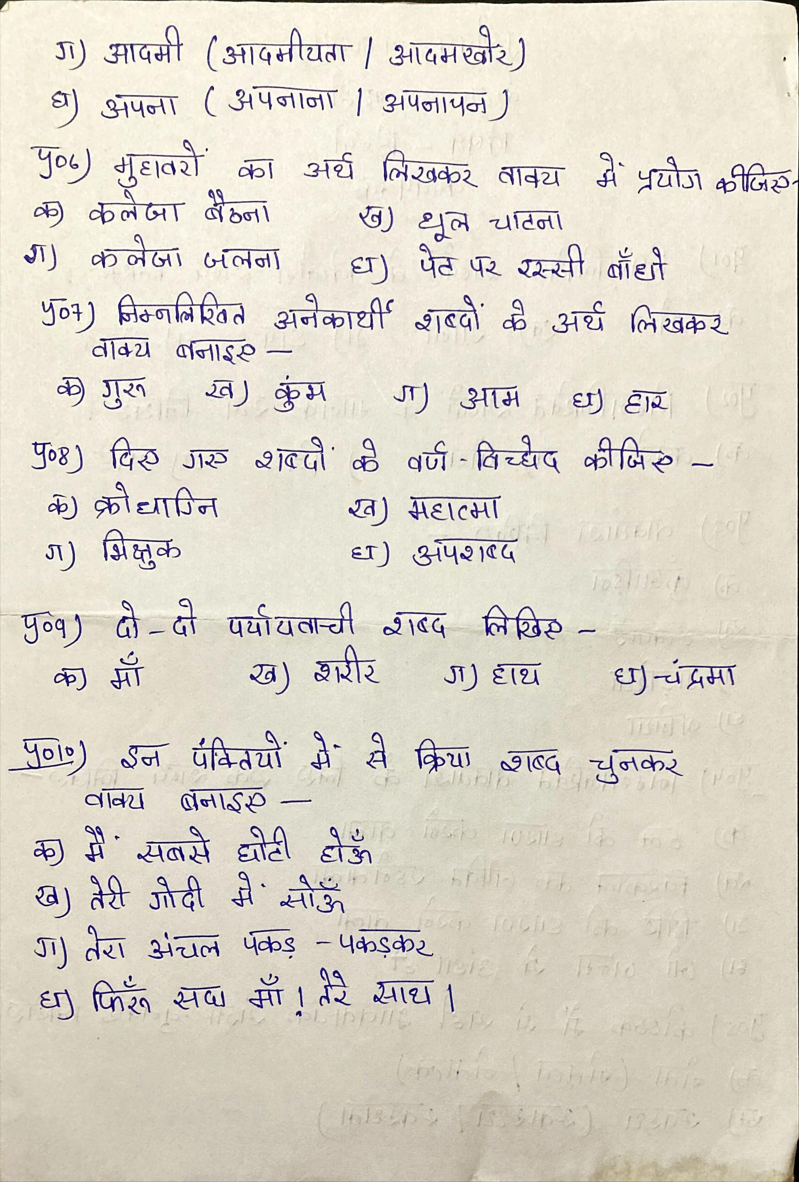

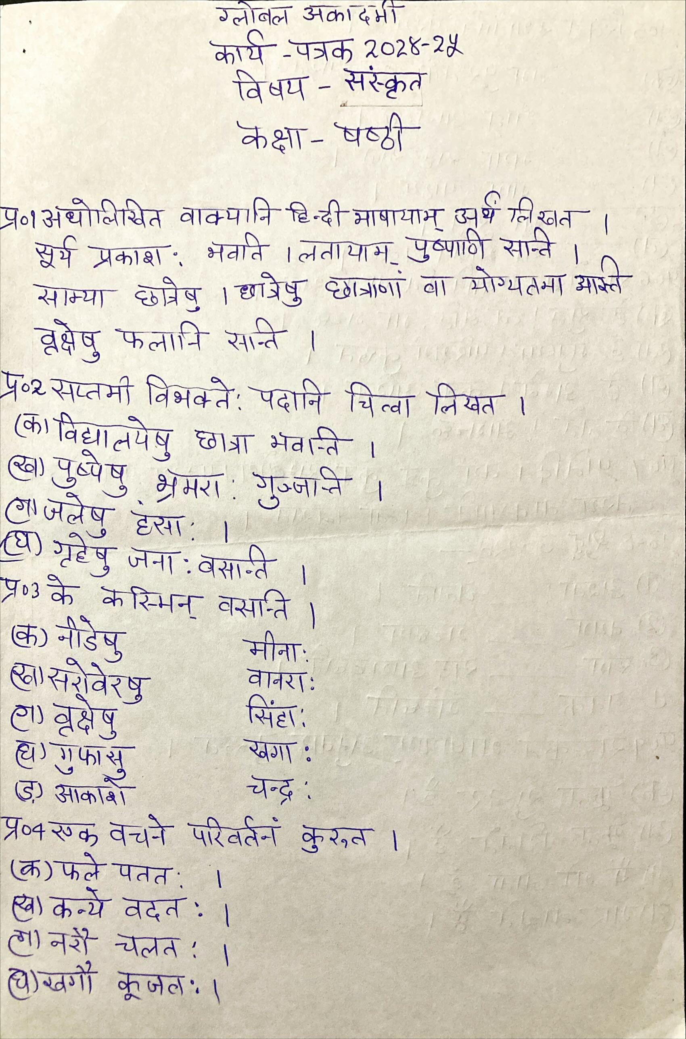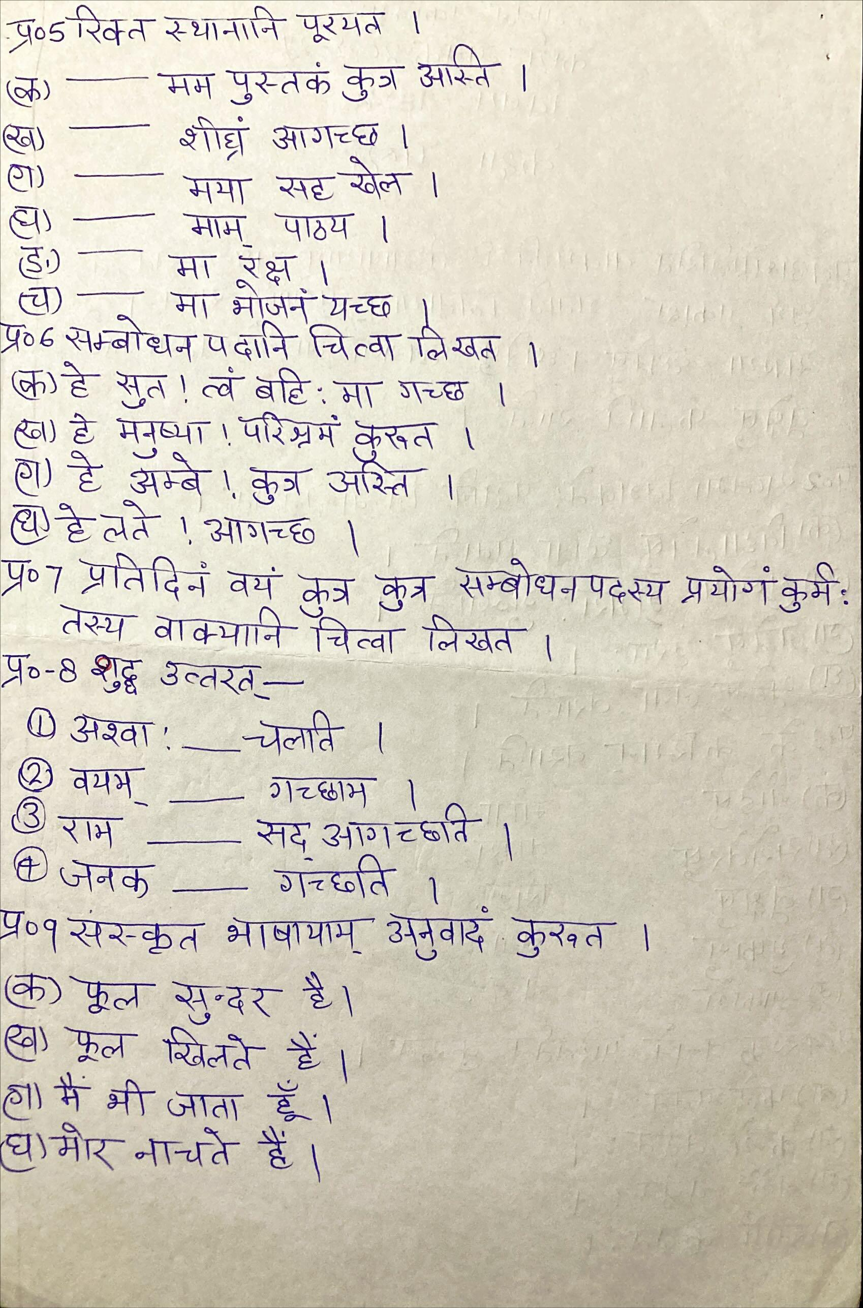**GLOBAL ACADEMY**

**WORKSHEET – OCTOBER**

**SESSION 2024 – 25**

**CLASS – VI (SCIENCE)**

Q1. Differentiate between locomotion and movement with example.

Q2. Is skeleton for our body and what is the function of skeleton.

Q3. Describe all the parts of skeleton.

Q4. You might have seen people with bone and joint problems. Find out the various reason with cause such problems.

Q5. Is it possible to trace a cartilage in an X-ray image? Explain.

Q6. John’s mother told him to wear his helmet before riding his bike why?

Q7. Justify the statement –

‘Sit straight while reading a book do not lie down.’

**GLOBAL ACADEMY**

**WORKSHEET – OCTOBER**

**SESSION 2024 – 25**

**CLASS – VI (MATHS)**

A. Choose the correct option –

1. If a = 2, b = -2, the value of a – ab is _________________

a. O

b. 6

c. -2

d. None

2. If b – 2/5 = 2, b = _____________

a. 1.4

b. 1.6

c. 2.4

d. -1.6

3. The product of two numbers is 390. One number is 13. Find the other one.

a. 20

b. 3

c. 30

d. 377

4. Which of the following is not a polynomial?

a. a + bc

b. a – b2 x c

c. a3 – bc – 4

d. none

5. Pick the odd one out.

a. -15abc

b. 12bac

c. 3a x 6bc

d. 11cb

6. 3p2 equals

a. P2 + P2 + P2

b. 3 + P2

c. p2 x p2 x p2

d. 3 x p2 x p2

B. Fill in the blanks –

1. The cost of a pen is Rs. 2. The cost of 109 pens is ________________.

2. The number of months in y years is ___________________.

3. The solution of p – 6 = -3 is _________________.

4. The equation -3t = -21 is satisfied by the value t = _______________

5. There are ________________ minutes in h hours.

6. The present age of a child is g years. After 10 years, his age will be ________________.

C. Solve the following questions.

1. 7 added to a number gives 100. Find the number.

2. 15 times a number gives 105. Find the number.

3. Sheena is twice as old as her daughter. If Sheena’s age is 46, Find her daughter’s age.

4. The perimeter of a square is 4times its side. If the side is 18m, find the perimeter of the square.

5. 2x + 3 – x = 6.

6. d + ½ = ¾

7. 5x – 4 = 6x + 6

8. 2.5/2 = 3/x

9. 6 = x – 3.5

10. Amir is 7 years older than his brother Farhan. If Amir’s age is 40 years. Find Farhan’s age.

**GLOBAL ACADEMY**

**WORKSHEET – OCTOBER**

**SESSION 2024 – 25**

**CLASS – VI (SST)**

Q1. Fill in the blanks –

1. The standard Meridian of India is ________________.

2. The Arctic Circle is located in the _________________ Hemisphere.

3. A book of maps is called an _______________.

4. If north is at the top in map, west is to the _______________.

5. The science of map making is called ______________.

Q2. True or false –

1. A map is a storehouse of information.

2. There are seven oceans and continents on the earth.

3. We can make a globe for a small part of the earth.

4. A map is more convenient to use than a globe.

5. Forests and Industries cannot be shown on a map.

Q3. Tick the correct option –

1. Which of these is shown in a thematic map?

a. Mountain

b. rivers

c. climate

2. A _________________ is a three-dimensional model.

a. Plane

b. globe

c. map

d. political

3. Which map shows a lot of details?

a. Political map

b. Large scale map

c. globe

4. _____________ map shows countries and states.

a. Arial photography

b. Plan

c. Political

5. What are the pictures taken from space called.

a. Map

b. Aerial Photographs

c. Graphs

d. Plans

Q4. Answer the following questions –

1. What is the most widespread color on globe/picture of the earth represent, what does it represent?

2. What is the large body of land called?

3. Why is ocean water unfit for consumption by humans?

4. What are the main limits of Indian ocean?

5. Give names of two parts of the Indian ocean which are on the either side of India?

Q5. Answer in one word –

1. Name a domain of the earth.

2. Name the largest continent.

3. Mountain Range separates Europe from Asia.

4. Name the first person to sail across the Pacific Ocean.

5. Name the continent also called ‘Oceania’

Q6. Name the following –

1. Domain of the earth __________________

2. Any three deserts in Africa __________________

3. Major oceans ________________

4. Gases found in the atmosphere ______________

5. Continents lying down in the Northern Hemisphere ________________

Q7. Give reasons –

1. Australia is also called ‘Island Continent’.

2. Africa is also called ‘Dark Continent’.

3. Antarctica is also called ‘White Continent’.

Q8. Mark the following on world map –

1. Asia

2. North America

3. Australia

4. South America

5. Antarctica

6. Europe