**GLOBAL ACADEMY**

**WORKSHEET – OCTOBER**

**SESSION 2024 – 25**

**CLASS – V (ENGLISH)**

Q1. What is moral value of the play in “An Earth Day Carol”?

Q2. Name the characters of the play in “An Earth Day Carol”?

Q3. Choose the correct auxiliary verbs: is, am, are, was, were, has, have, had.

1. What ____________ you doing at 10am tomorrow?

2. Anne ____________ not going to school today.

3. She _____________ in her school now.

4. They _____________ playing the whole of yesterday.

Q4. Circle the action verb in each sentence.

1. Sal listens to his favourite song.

2. Craig hits the baseball over the fence.

3. The roof of the house leaks.

4. The hunter searches for a deer.

Q5. Write a letter to your principal ma’am requesting him to grant you leave on account for your sister’s marriage.

Q6. Write an application to the principal of your school asking for leave of absence for two days as you were not well.

Q7. Write a paragraph on the topic of “Save Earth” in about 100 words.

Q8. Write a story on the topic of “The selfish Giant” in about 50 words.

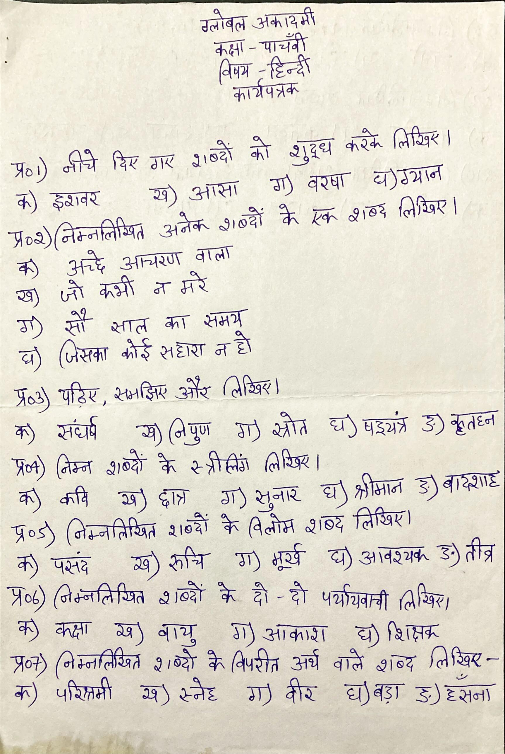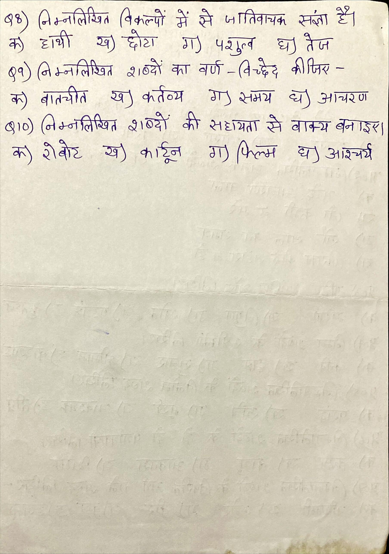

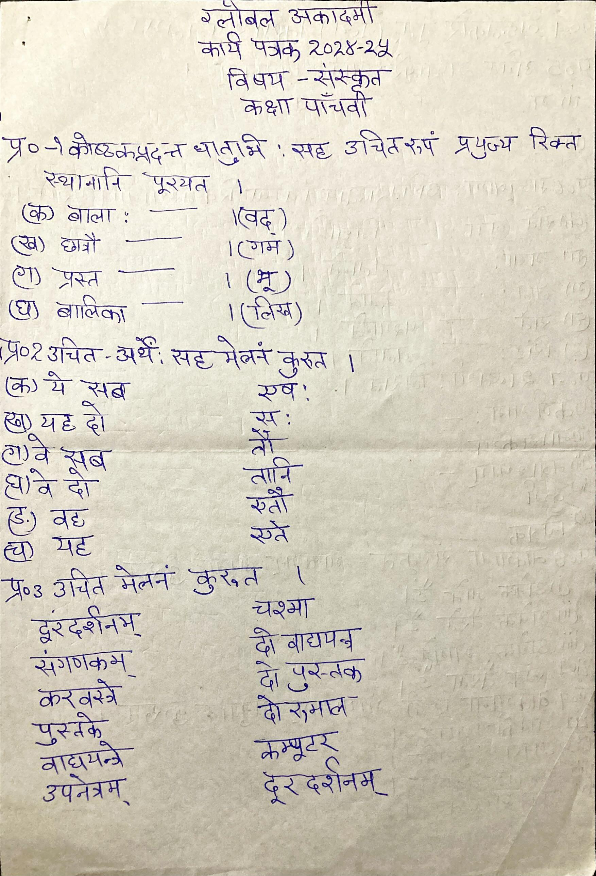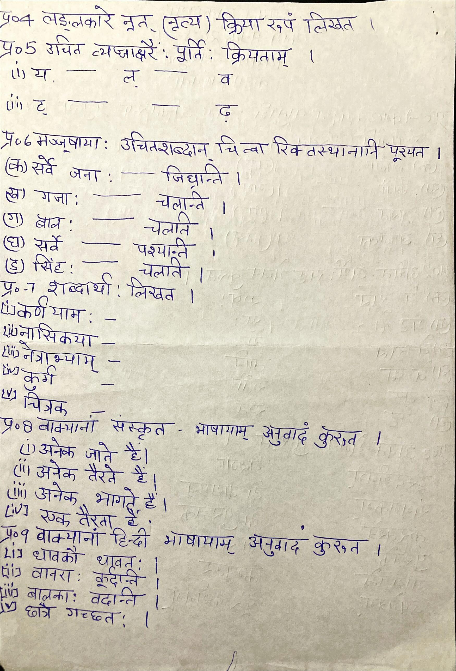

**GLOBAL ACADEMY**

**WORKSHEET – OCTOBER**

**SESSION 2024 – 25**

**CLASS – V (MATHS)**

Q1. Compare the given measurement:

1. 0.047 dg ________ 470mg

2. 80l _______ 800hl

3. 5.7kg _________ 5936g

4. 17.2m ______ 172cm

Q2. Simplify the following –

a. 44l 325ml + 65l 811ml

b. 85 hl – 28hl 34l

c. 6km 23m + 12km 16m + 9km32m

d. 47 km 296m x 8

Q3. Divide the following:

a. 6g 9dg 7cg 5mg by 3

b. 4kl 2hl 5dal 4l by 2

Q4. Express in term of meters –

a. 814.38 dm

b. 594.67 cm

Q5. Fill in the blanks –

a. 8cm = ________mm

b. ______km = 4000m

c. 120mm = ________cm

Q6. How many packets of 400mg snacks can be made from 49.2 kg of snacks?

Q7. Jan has 63m of ribbon. If cuts 56m 21cm ribbon from it. What length of ribbon will be left?

Q8. Maya used 1m 50cm of red ribbon and 4m28cm of blue ribbon to make a flower. How much ribbon did she use in all?

**GLOBAL ACADEMY**

**WORKSHEET – OCTOBER**

**SESSION 2024 – 25**

**CLASS – V (SCIENCE)**

Q1. Differentiate between the solid, liquid and gases.

Q2. When we dissolve sugar in water, a stage reaches when no more sugar can be dissolved in water. Name the stage.

Q3. When we burn a candle is this a chemical change or physical change.

Q4. Write all the methods by which we can interchange the states of matter.

Q5. When we keep an iron nail in open atmosphere it gets rusted. Is it a physical change? Justify.

Q6. How does aroma of food being cooked in the kitchen spread in the whole house.

Q7. Take three plastic bottles. fill 1. By ice 2. By tap water 3. Empty and closed all bottle with rubber cork and put in warm water. Which bottle would pop the cork first.

**GLOBAL ACADEMY**

**WORKSHEET – OCTOBER**

**SESSION 2024 – 25**

**CLASS – V (SST)**

Q1. Fill in the blanks –

1. _________________ disasters show the destructive force of nature.

2. Low rainfall causes _____________.

3. The scientific study of earthquake is called _______________.

4. The place of origin of an earthquake is called ______________.

5. ______________ are the worst affected in a drought.

Q2. True or False –

1. Tsunami is not a natural calamity.

2. There are three types of volcanoes and active volcano is one of them.

3. Tsunami can severely affect plain areas.

Q3. Tick the correct options –

1. People studying earthquakes are called –

a. Seismologists

b. Doctors

c. Astrologers

d. All of these

2. The upper layer of the earth is made up of –

a. Core

b. Tectonic plates

c. Magma

d. Fire

e. None of these

3. Earthquakes are measured on

a. Ruler

b. Barometer

c. Richter scale

4. Which one of the following are causes of drought?

a. Less rainfall

b. High temperature

c. Dry winds

d. All of these

5. The shaking of the earth is called

a. Wave

b. Cyclone

c. Earthquake

d. Storm

Q4. Answer the following questions –

1. What is a natural disaster?

2. What are some examples of natural disasters?

3. What causes earthquakes?

4. What causes droughts?

5. What is tsunami.

Q5. Give reasons –

1. To save the environment, we need to encourage carpooling.

2. In India floods are very common during monsoon.

3. Drought affects plants, animals and the lives of people.

Q6. Answer in one word –

1. The study of earthquakes.

2. Instrument used to record the intensity and duration of an earthquake.

3. Collecting and storing rain water for later use.

4. Causes of floods.

5. Magma Erupts and flows out on the surface.