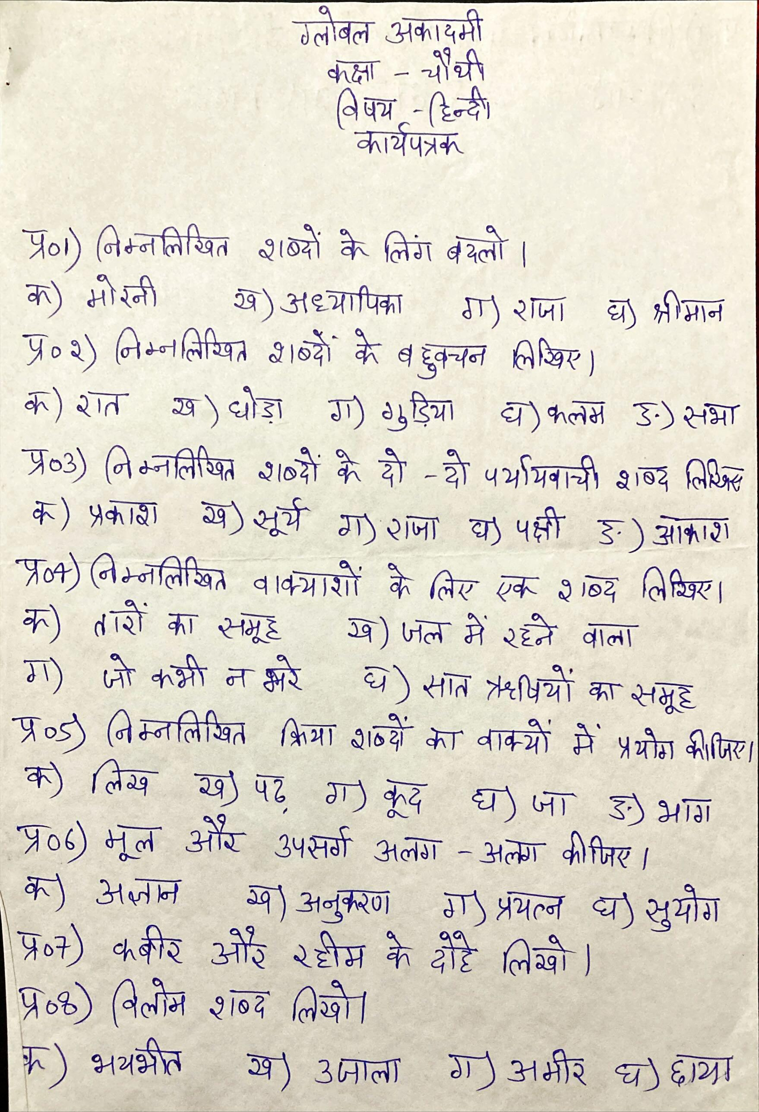

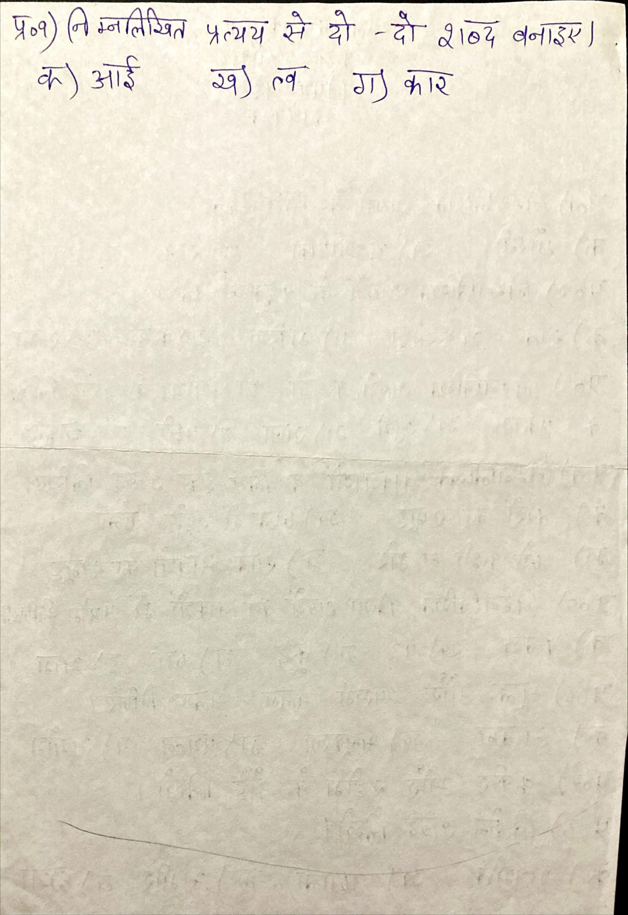

**GLOBAL ACADEMY**

**WORKSHEET – OCTOBER**

**SESSION 2024 – 25**

**CLASS – IV (ENGLISH)**

Q1. Why father dove made distressing sounds?

Q2. Why Peggy opened her window a little late?

Q3. Fill in the blanks with simple past tense.

1. I _________ (meet) an old friend today.

2. I _________ (visit) him in London several times.

3. I __________ (see) her in the school but we didn’t speak.

4. He ____________ (throw) the ball to me.

Q4. Fill in the blanks with the past continuous form of the verbs given in brackets.

1. It _____________ when I got up this morning. (rain)

2. We ____________ the last exercise when the bell rang. (do)

3. The children ________________ when I last saw them. (play)

4. You ___________when I peeped into your room. (sleep)

Q5. Write a letter to your principal ma’am inviting to attend a family function.

Q6. Write a paragraph on the topic of “clothes I like to wear” in about 80 words.

Q7. Write a story on the topic of “The cows and the tiger” in about 50 words.

Q8. Write a letter to your friend wishing him/her a happy birthday.

**GLOBAL ACADEMY**

**WORKSHEET – OCTOBER**

**SESSION 2024 – 25**

**CLASS – IV (MATHS)**

Q1. Fill in the blanks –

a. A square has ______________vertices.

b. A rectangle has ____________ sides.

c. A triangle has ______________ sides.

d. A circle has ________________ vertex.

e. A cone has ________________ edge.

Q2. Write true(T) or false (F) for the following statements.

a. A polygon with 4 sides is called a pentagon.

b. Every square is a rectangle.

c. The adjacent sides of a quadrilateral have a common vertex.

d. A triangle is a polygon.

e. All quadrilaterals are rectangle.

f. a hexagon has 6 sides.

Q3. Observe the given circle and name the following –

a. center of the circle.

b. Radii of the circle.

c. Diameter of the circle.

d. Chord of the circle.

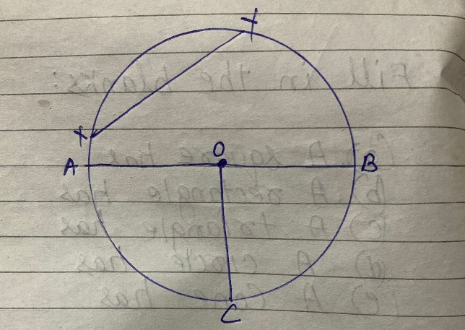

Q4. Draw a net of cube, cuboid and cone.

Q5. Draw a circle of radius 3cm using a compass.

Q6. The diameter of a circle is 28cm. Find its radius.

Q7. How many triangles are there in the given figure.

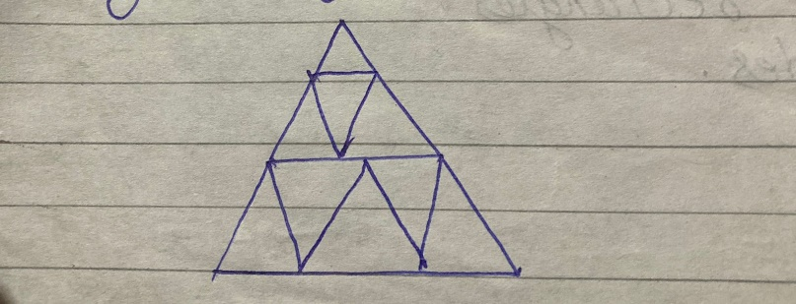

Q8. Identify the words by looking at their halves.

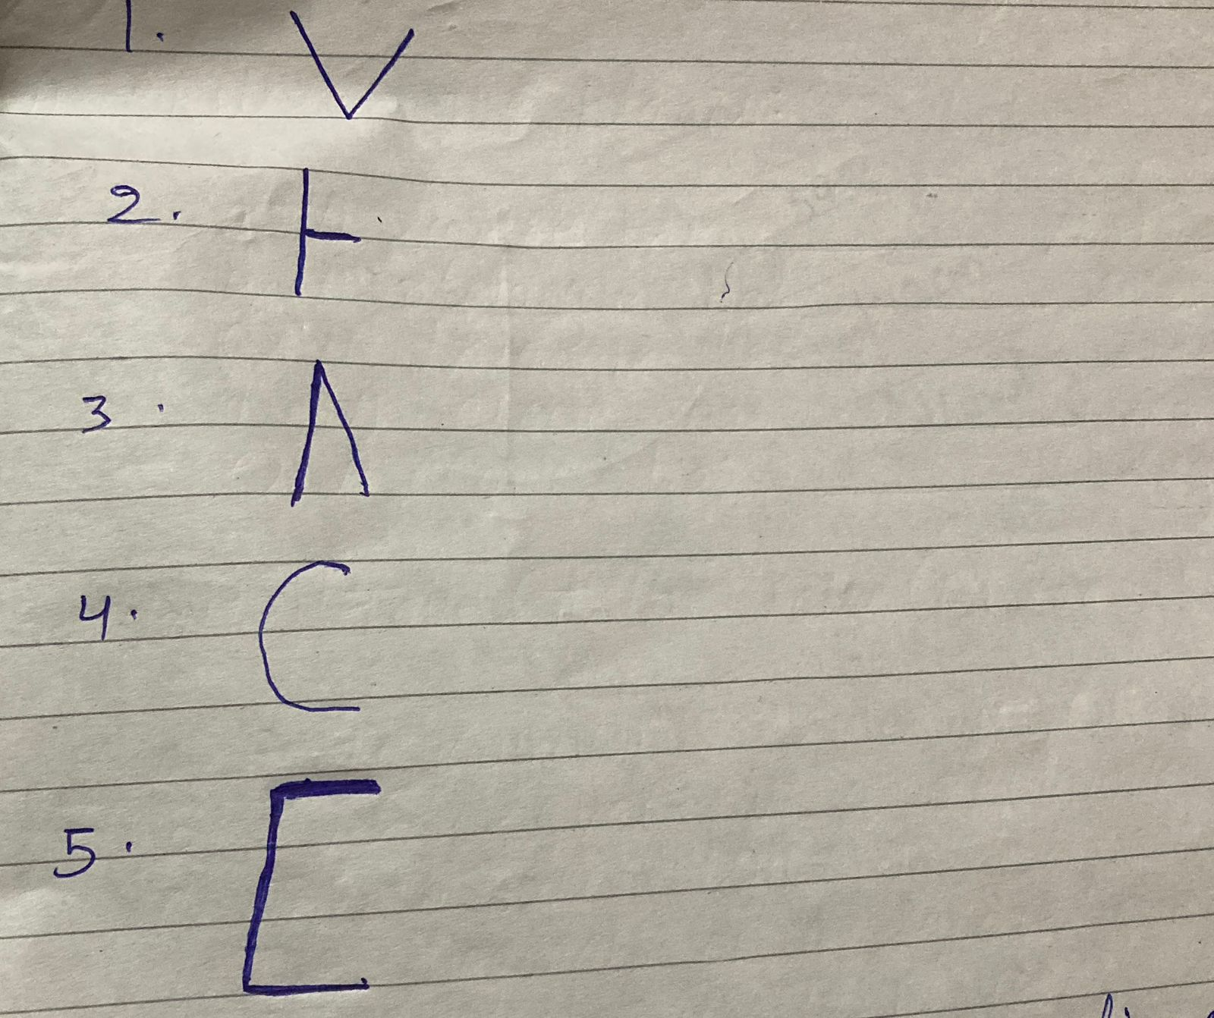

Q9. Draw and name the ray, line segment and line.

Q10. Draw the line segments of the given lengths.

a. 7cm

b. 5 cm 5 mm

c. 2.5 cm

d. 6 cm

**GLOBAL ACADEMY**

**WORKSHEET – OCTOBER**

**SESSION 2024 – 25**

**CLASS – IV (SCIENCE)**

Q1. What do you understand from circulatory and excretory systems. Is they different or same?

Q2. Differentiate between heartbeat and pulses.

Q3. Draw a neat and clean excretory system and label it properly.

Q4. Lekha goes out for jogging every morning. She feels her heart beats faster while jogging. Can you explain. Why?

Q5. What steps we should take while get healthier life style.

Q6. Name any three waste products formed in the body.

Q7. Using flow chart with picture. Explain the motion of the blood in our body.

**GLOBAL ACADEMY**

**WORKSHEET – OCTOBER**

**SESSION 2024 – 25**

**CLASS – IV (SST)**

Q1. Fill in the blanks –

1. ___________ and ______________ are the famous coal mines.

2. _______________ energy can be a good substitute for petroleum.

3. ______________ are impure metallic substances as they come out of the mines.

4. Petroleum is being dumped out from beneath the sea bed at____________.

5. ______________ are deep holes dug to bring out minerals.

Q2. True or false –

1. There is a big coal mine at Rourkela.

2. Petroleum will last forever.

3. There are a number of oil refineries in Assam.

4. Manganese is used in making steel.

5. Bihar has many coal mines.

Q3. Tick the correct word –

a. Mineral oil refined to get _____________

i. Kerosene

ii. Iron

iii. Water

iv. None of these

b. Iron ore is found in _____________

i. Himachal Pradesh

ii. Odisha

iii. Uttar Pradesh

iv. None of these

c. One of the causes of pollution is the use of ______________.

i. Coal

ii. Water

iii. Sun light

iv. None of these

d. Mines are made to takeout _______________.

i. Metals

ii. Ores

iii. Minerals

iv. none of these

e. One of the refineries is in ________________.

a. Delhi

b. Mathura

c. Goa

d. None of these

Q4. Answer the following questions –

1. What is a mineral?

2. What is a conventional source of energy?

3. Name the mineral used for manufacturing –

a. Aluminum

b. Cement

c. Synthetics

4. Write three uses of each of the following –

a. Copper

b. Iron

c. Aluminum

Q5. Write one-word answers –

1. Holes dug to take out ore.

2. Minerals such as iron and gold.

3. Light metal

4. Richest plateau in minerals.

5. conventional source of energy.

Q6. Match the columns –

1. Iron used for making jewellery

2. Copper black diamond

3. Gold used in making electric wires, machinery, pipes, utensils

4. Coal used to make machines, bridges, dams and utensil

Q7. Think and answer –

1. Petroleum is so expensive

2. ‘Conservation of minerals in the need of the hour’ Do you agree.