**GLOBAL ACADEMY**

**WORKSHEET – OCTOBER**

**SESSION 2024 – 25**

**CLASS – III (ENGLISH)**

Q1. Write 10 lines of the poem ‘The Button Box’.

2. The poem is about a box. What does the box have?

3. Where is the box kept?

4. Who was Androcles? Where did he live?

5. Why was the lion limping?

6. How did Androcles help the lion?

7. What was the punishment for slaves who ran away?

8. Why did the hungry lion not attack Androcles in the arena?

Q2. Write the rhyming words from the poem.

1. old –

2. box –

3. rips –

4. white –

5. red –

6. shirt –

Q3. Fill in the blanks with a, an or the.

1. There is __________ bird in the nest.

2. Mom will be home in _____________ hour.

3. Bring me _____________ bottle of water.

4. Our city is on the banks of _____________Ganga.

5. He is ________________ honest man.

6. A tiger is _____________ strong animal.

7. Giraffes are ____________ tallest animals in the word.

Q4. Tick the correct option –

1. Androcles used to live in Paris/Rome.

2. Androcles was a soldier/slave.

3. Masters were kind/cruel to their slaves.

4. Androcles ran away and reached a hut/cave in a forest.

5. Androcles hugged/threw a spear at the lion in the arena.

Q5. Circle the prepositions.

a. Father is in his office.

b. Hemant is sleeping on the bed.

c. Gauri is working on her computer.

d. There is a fridge in the room.

e. Birds are flying above the building.

f. This door opens into a garden.

Q6. Make adverbs from the following words by adding ‘-ly’ or ‘-lly’

a. Soft _____________

b. Near _____________

c. Quiet _____________

d. Busy _____________

e. Neat _____________

f. Easy ______________

g. Dear _____________

h. Careful _____________

i. Happy ______________

j. Smart ______________

Q7. Underline the adverbs.

1. He speaks loudly.

2. Barking dogs seldom bite.

3. A horse runs fast.

4. God is everywhere.

5. He is quite strong.

6. Father will come tomorrow.

7. He is quite strong.

8. How is she now?

9. He is standing there.

10. He gets up early.

Q8. Complete the table.

Positive Comparative Superlative

1. ______________ Sooner ___________

2. ______________ more softly ___________

3. Brightly _____________ ___________

4. Slowly _______________ ____________

5. ______________ earlier ____________

6. Fast ________________ ____________

7. Wisely ________________ ____________

8. Easily ________________ ____________

9. Beautifully ________________ _____________

10. Badly _________________ _____________

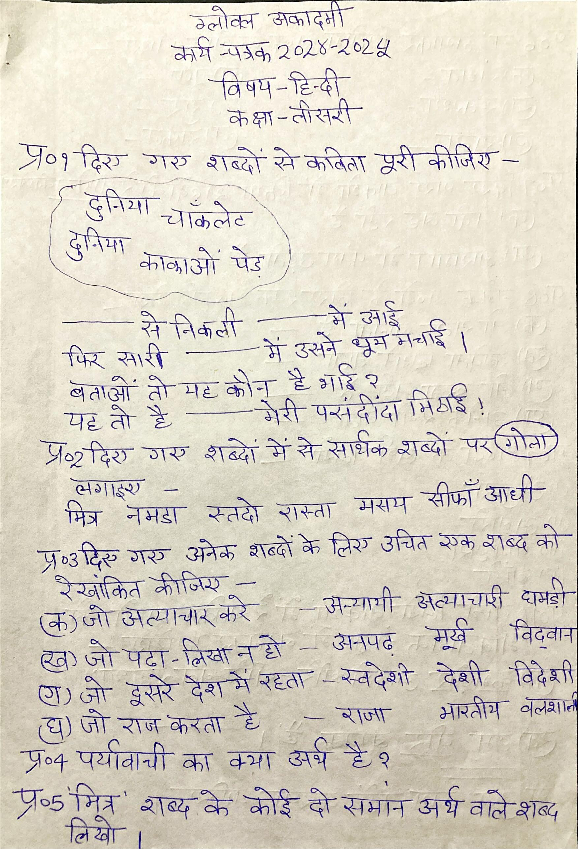

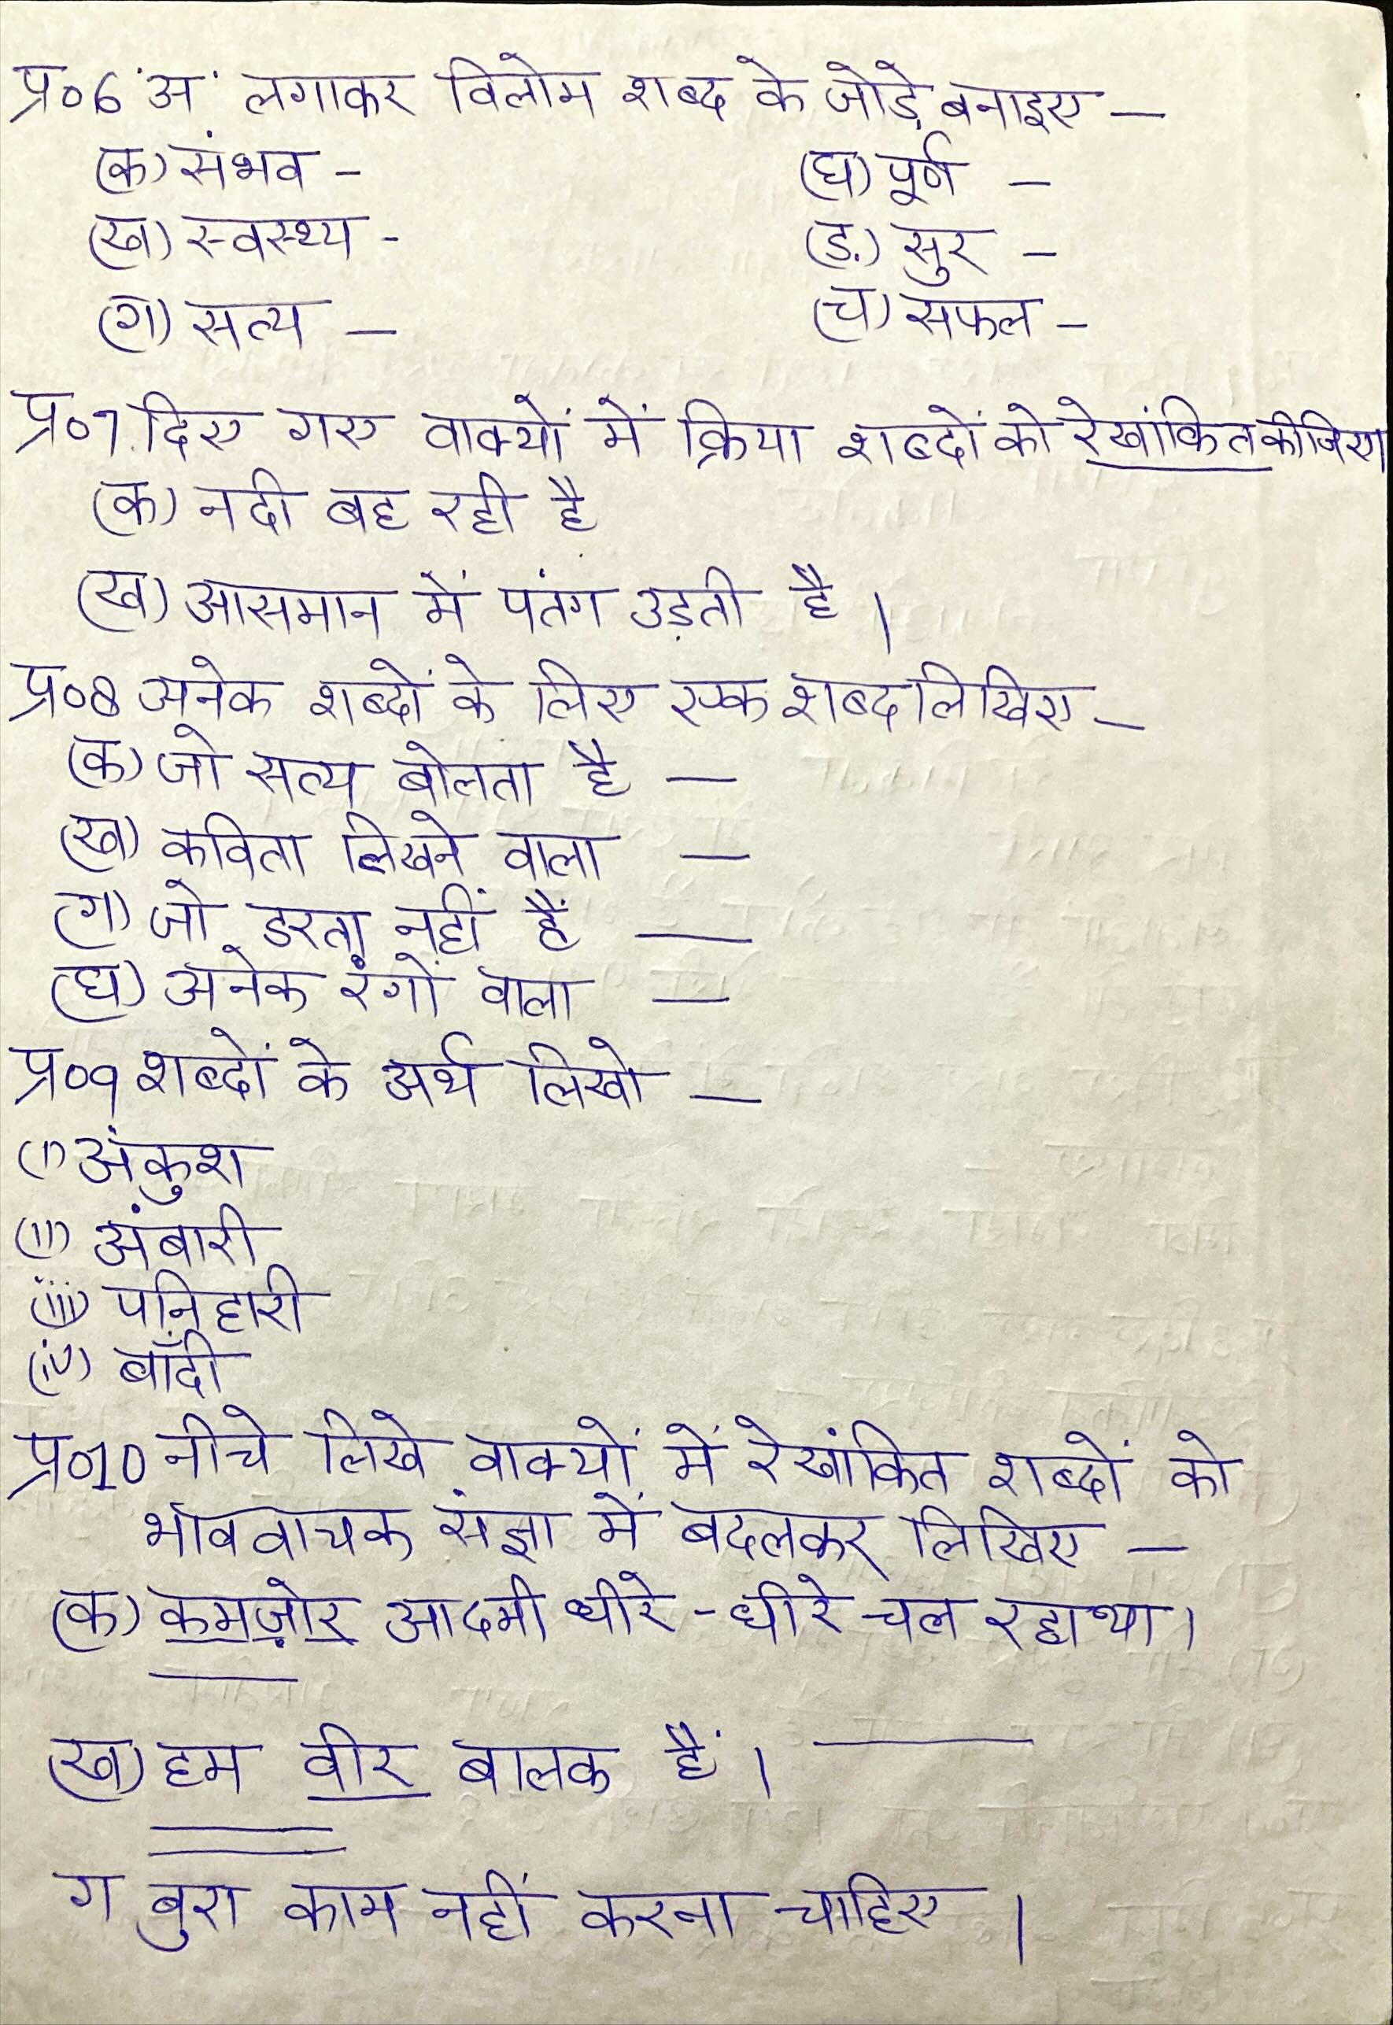

**GLOBAL ACADEMY**

**WORKSHEET – OCTOBER**

**SESSION 2024 – 25**

**CLASS – III (MATHS)**

Q1. Fill in the blanks –

a. 1 meter =

b. 1 kilometer =

c. 1000 meters =

d. 1 gram =

e. 1 kilogram =

f. 100 grams =

g. 1 liter =

h. 1000 ml =

i. 1 hour =

j. 1 day =

k. 1 minute =

l. 1 year =

Q2. Write the given units of measuring length in increasing order.

Centimeter =

Kilometer =

Meter =

Q3. Write the correct unit of measurement (cm, m or km) for each of the following

a. Length of a pen =

b. length of a swimming pool =

c. Distance from one town to another =

d. Height of a bookshelf =

Q4. Convert the following to cm.

a. 3m = ________________ cm

b. 9m = ________________ cm

c. 3m 42cm = ____________ cm

d. 4m 59cm = ____________ cm

Q5. Convert the following –

a. 300 cm = _______________ m

b. 4km 320 m = ________________ m

c. 469cm = ____________ m

d. 1596 m = _____________ km ______________ cm

e. 3 kg 245g = ______________ g

f. 3249 g = _____________ kg

g. 5kg = ________________ g

h. 1 kg 375 = _____________ g

i. 7kg 130g = _____________ g

j. 2467 g = _________ kg ______ g

k. 3581 g = ___________ kg _________ g

l. 50000 g = __________ kg _________ g

Q6. Convert 5l 306 ml to ml.

Q7. Convert 6792 ml to l and ml.

Q8. The capacity of a juice container is 2 liters 370 milliliters. Calculate the capacity in milliliters.

Q9. Nidhi gave 2 meters of cloth to the tailor to stitch a shirt. How many centimeters is that?

Q10. Sudha bought 5kg of apples. How many grams is that?

Q11. Match the following –

Column A Column B

1. 5m 12m

2. 1200 cm 2035 g

3. 2 kg 35g 500 cm

4. 7 l 298 ml 7298 ml

Q12. Write the number of days in the following months.

a. January = __________________

b. July = ________________

c. March = ___________________

d. August = ___________________

e. June = ___________________

f. November = _________________

Q13. How many minutes does the minute hand take to move from 12 to 8?

Q14. Samaira takes music classes which get over at 5:45. If the class lasts for 2 hours, when does the class begin?

Q15. Sakshi reached a park at 4’o clock and left from there after one hour. At what time did Sakshi leave the park?

Q16. The movie began at 3:30 and was 3 hours long. At what time did the movie get over?

**GLOBAL ACADEMY**

**WORKSHEET – OCTOBER**

**SESSION 2024 – 25**

**CLASS – III (EVS)**

Q1. Tick the things that you like doing after finishing your homework.

1. Going out to play

2. Watching television

3. Playing with pets

4. reading a book

5. drawing

6. swimming

Q2. Write T for true and F for false.

1. Many animals and birds are found in the zoo.

2. Recreation makes us happy.

3. Reading is a great source of entertainment.

4. A postman brings books and parcel for us.

5. A carpenter uses wood to make furniture.

Q3. Fill in the blanks –

1. Police takes care of our ________________.

2. Masons build ___________ and _______________ weave clothes.

3. A policeman enquires about any theft or ______________.

4. Recreation keeps our mind fresh and _________________.

5. We can have fun when we go far a ___________________.

6. Indoor games make us feel relaxed and _______________.

Q4. List any two services provided by the post office and police station.

Post office police station

1. _______________ 1. ________________

2. _______________ 2. _________________

Q5. Rearrange the following words.

1. E I L C P O

2. M M L K I A N

3. R E B B A R

4. Y I L F A M

5. G E U H

Q6. Write the missing word.

1. O ____ ____ D O O ____

2. G ____ M ____ S

3. S ____ E ____ ____ E R

4. ____ A S ____ ____ S

5. B ____ ____ E R

6. P ____ L ____ C ____

Q7. Answer the following.

1. What is recreation? Explain it?

2. What is occupation?

3. What is child labour?

4. Who deliver letters from door to door?

5. Write the most popular recreational activities?

Q8. In the given word search, find the names of any four people related to school.

