**GLOBAL ACADEMY**

**WORKSHEET – OCTOBER**

**SESSION 2024 – 25**

**CLASS – II (ENGLISH)**

Q1. Answer these questions.

a. What fell on Bhola’s head?

b. What were the deer eating?

c. Where was Bhola sitting when something fell on his head?

d. Where are the bridges?

Q2. Write T for true and F for false.

a. Bhola was a happy boy.

b. Bhola did not like going to school.

c. Bhola was always complaining.

d. Bhola loved to play in the rain.

e. Bhola thought his village was beautiful.

Q3. Fill in the blanks to complete the story.

One day I ____________ under a tree.

The tree was _________ Chikoos.

Not far away, I saw some

Deer ___________ melons growing

On a creeper _____________ the ground. I wished

These melons grew on tall trees, not on the

Ground. Suddenly, something hit my _______________

I looked up at the tree. I was glad

That a ______________ chikoo had fallen on

My head, not a ___________ melon.

|  |  |  |  |  |
| --- | --- | --- | --- | --- |
| Head | Eating | On | Was sitting | Small |
| big | Full of |  |  |  |

Q4. Unscramble the names of the colours in a rainbow. Colour the rainbow.

Iovlet –

Goindi –

Lueb –

Egren –

Ollwye –

Onager –

Der –

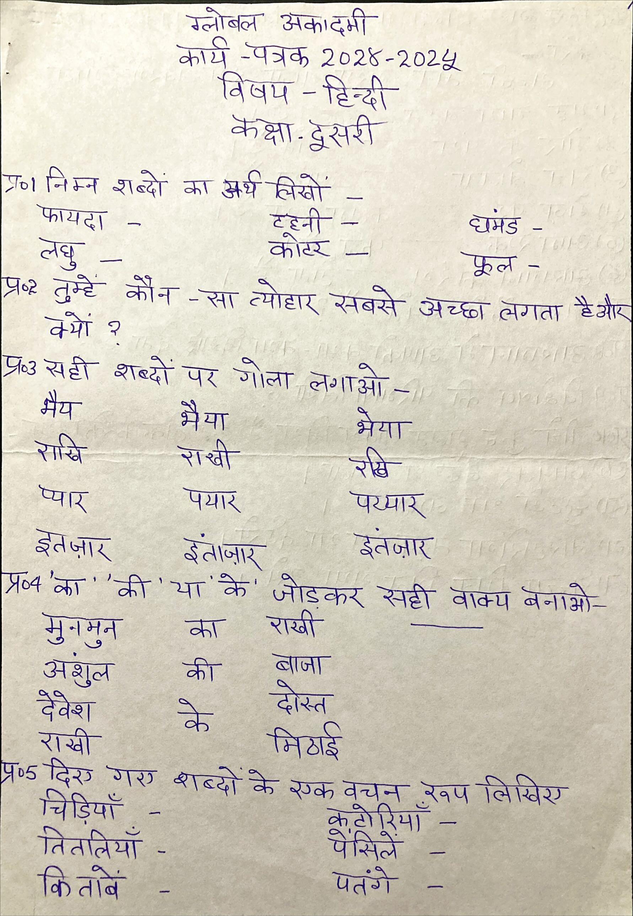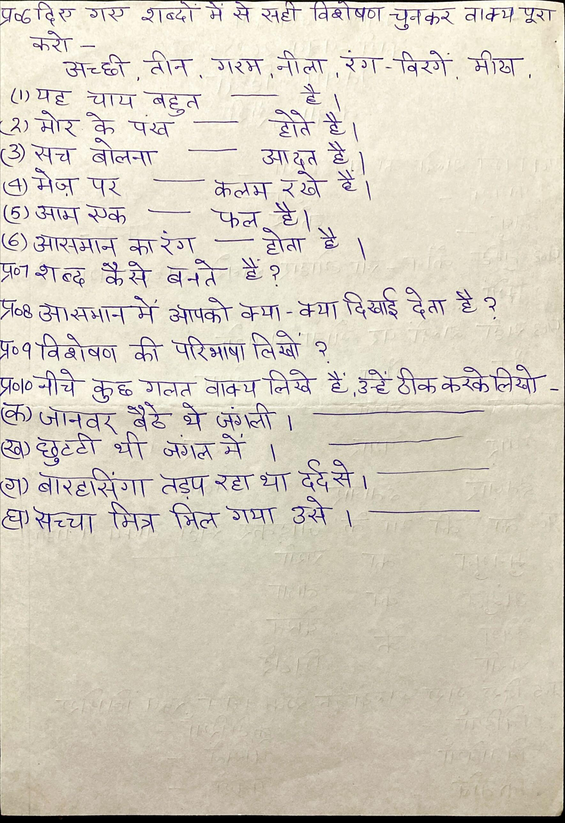

**GLOBAL ACADEMY**

**WORKSHEET – OCTOBER**

**SESSION 2024 – 25**

**CLASS – II (MATHS)**

Q1. 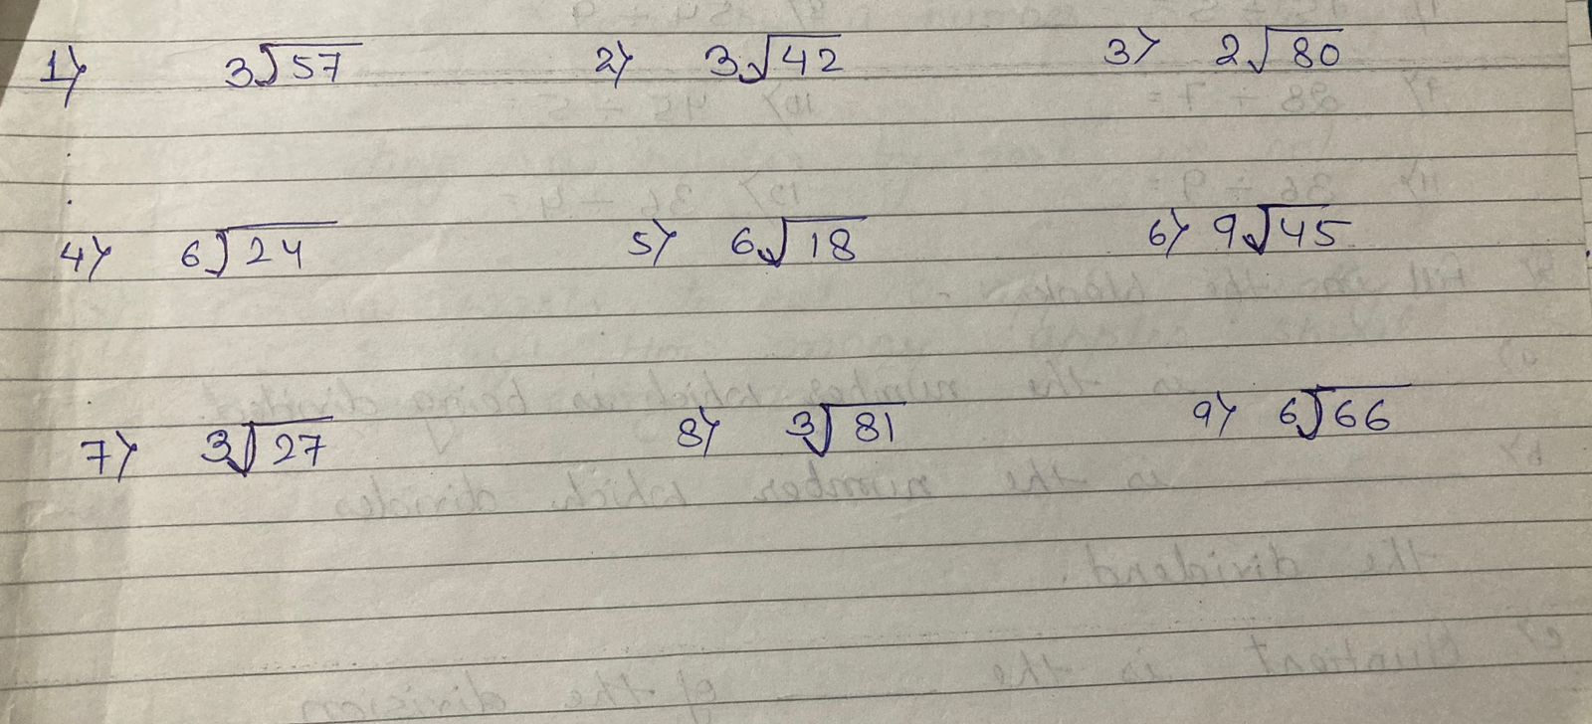

Q2. Fill in the blanks –

1. 6 ÷ 2 =

2. 10 ÷ 2 =

3. 16 ÷ 4 =

4. 15 ÷ 5 =

5. 28 ÷ 7 =

6. 36 ÷ 9 =

7. 8 ÷ 4 =

8. 12 ÷ 3 =

9. 30 ÷ 6 =

10. 54 ÷ 9 =

11. 45 ÷ 5 =

12. 36 ÷ 4 =

Q3. Fill in the blanks –

a. _______________ is the number which is being divided.

b. _______________ is the number which divides the dividend.

c. Quotient is the __________________ of division statement.

d. Dividing a number by 1 is always _________________ to the number itself.

e. Dividing a number by itself is always equal to _________________.

f. Dividing zero by a number is always equal to __________________.

g. Dividing a number by zero is not _________________.

Q4. Taraba wants to eat 10 apples equally in 5 days. How many apples should se eat every day?

Q5. If a teacher has 40 students and wants to divide them into groups of 8, how many groups will there be?

Q6. A bag of candy contains 48 pieces and you want to divide it into 8 equal portions. How many pieces will be in each portion?

Q7. Fill in the blanks –

1. The fixed units to measure length are _________________ and _____________. (l, ml/ m, cm)

2. The length of a notebook will be measured in _______________. (m/cm)

3. Mass is measured in ______________ and _____________(m, cm/g, kg)

4. Three onions will weight in ________________. (g, kg)

5. The capacity of a container is measured in ________________. (l/m)

Q8. Share 12 pieces of cheese equally among 3 mice.

Each mouse will get _______________ pieces of cheese.

12 ÷ 3 = _____________

Q9. Put 14 balls in equal groups of 7 each. How many groups are there that carry 7 balls each?

14 ÷ 7 = _____________

Q10. Put 15 butterflies in equal groups of 5 each. How many groups are there that carry 5 butterflies each?

15 ÷ 5 = ______________

Q11. Share 6 bones equally between 2 dogs. Each dog will get ____________ bones.

6 ÷ 2 = _______________

**GLOBAL ACADEMY**

**WORKSHEET – OCTOBER**

**SESSION 2024 – 25**

**CLASS – II (EVS)**

Q1. Look at the picture and label the parts of the plant.

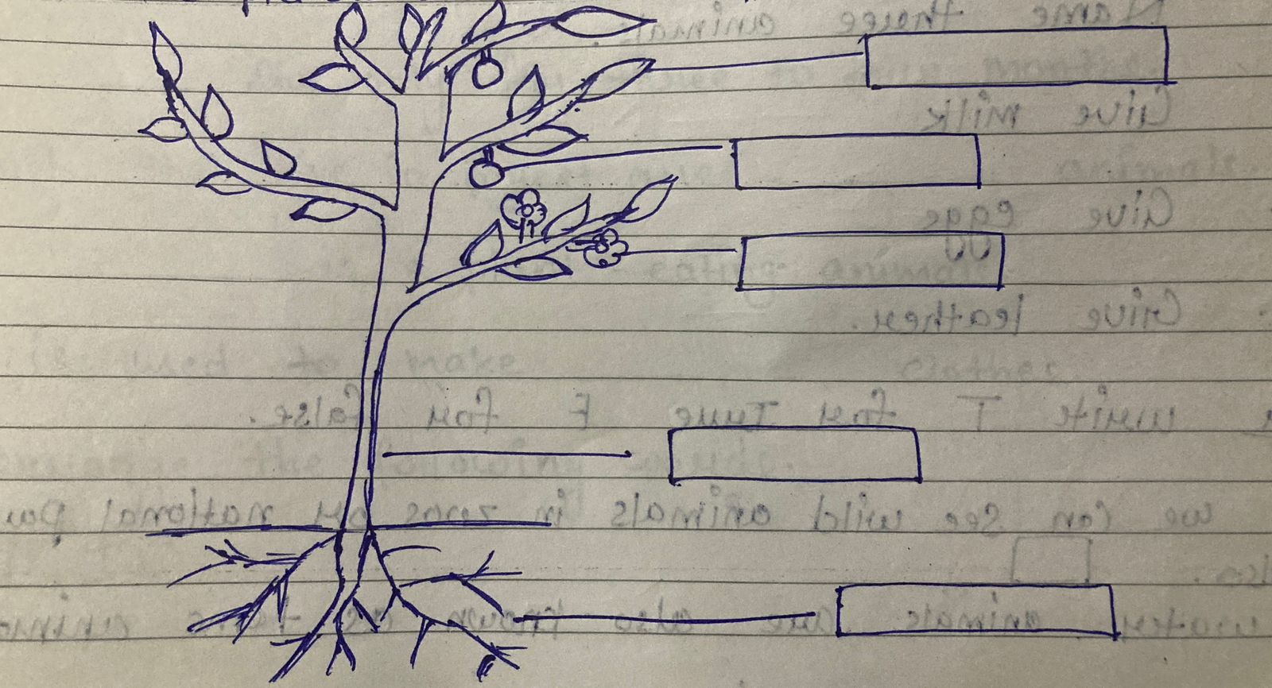

Q2. Write the names of the following –

1. King of the jungle.

2. Cleverest animal

3. Tallest animal

4. Foolish animal

Q3. Name three animals.

1. Give milk

2. Give eggs

3. Give leather

Q4. Write T for true and F for false.

1. We can see wild animals in zoos or national parks.

2. Water animals are also known as tame animals.

3. Lion and horse are known as milch animals.

4. Climber are the plants with very weak stems.

5. Roots are not lowest part of the plants.

Q5. Fill in the blanks using the correct options.

1. The _______________ is the part from which a new plant grows.

2. Humans and animals cannot ______________ without plants.

3. _______________ live only for three to four months.

4. Animals that live in forest are ________________ animals.

5. A ______________ is a plant – eating animals.

6. Wool is used to make ______________ clothes.

Q6. Rearrange the following words.

1. LHMIC -

2. MLINAA -

3. RAMF -

4. REET -

5. RHBES -

6. UTIFR -

Q7. Write the missing words.

1. C ___ I M ___ ___ R

2. S ___ ___ D

3. F ___ O ___ E ___

4. ____ N I ____ ____ L

5. F ____ R ____ ____ T

6. T R ____ N ____ ____ O R ____

Q8. Draw the picture of the following –

1. Potato

2. Apple

3. Papaya

4. Sunflower

5. Rose

Q9. Answer the following –

1. Write the useful things given by plants.

Ans. ________________________________________________________________________________________________________________________________

2. How do creepers differ from climbers?

Ans. ________________________________________________________________________________________________________________________________

3. Write the main parts of the plant.

Ans. ________________________________________________________________________________________________________________________________

4. What are domestic animals?

Ans. ________________________________________________________________________________________________________________________________

5. What are milch animals?

Ans. ________________________________________________________________________________________________________________________________