**GLOBAL ACADEMY**

**WORKSHEET – OCTOBER**

**SESSION 2024 – 25**

**CLASS – I (ENGLISH)**

Q1. Fill in the names of the baby animals.

a. duck –

b. cat –

c. dog –

d. goat –

e. hen –

f. cow –

g. bear –

h. sheep –

Q2. Complete the sentences using ‘is’, ‘am’ or ‘are’

a. I ____________ Lucy.

b. The bird ______________ on the branch.

c. My friends ____________ coming to play with me.

d. I _____________ sorry I _____________ late today.

e. You _______________ doing your homework now.

f. The cake _______________ on the table.

Q3. Complete the names of these fruits.

a. m ___ ____ g o

b. g ___ a ___ ___ s

c. p ___ p ___ ____ a

d. g ___ a ____ a

e. P ___ n e ___ p ___ l ___

Q4. Match the animals with sound.

a. cow mew

b. Donkey neigh

c. dove bray

d. Lion moo

e. cat coo

f. horse roar

Q5. Match and write the sentences –

1. Raj was tried. a. It sets in the evening.

2. Simi has a test b. They are shining

3. My shoes are new c. She is studying

4.The sun rises in the morning d. He sat under a tree.

a. __________________________________________________________

b. __________________________________________________________

c. ___________________________________________________________

d. ___________________________________________________________

Q6. Circle the doing words –

a. shake rain desk plate

b. broad grape sing see

c. Play pen flock bread

d. Flowers girl jump bread

Q7. Circle the adjectives and write it.

1. The sky is blue. _______________

2. The apple is red. ______________

3. The grass is green. _______________

4. The ice cream is cold. _______________

5. The sun is bright. _______________

6. The flower is pretty. _______________

Q8. Answer the questions.

a. What came out of the first egg?

________________________________________________________________

b. What did the ugly duckling grow into?

________________________________________________________________

c. Who stopped Juhi from eating the apple?

________________________________________________________________

d. Who ate the apple?

________________________________________________________________

Q9. Complete the lines from poet ‘What Do I Do’?

What do I do

If _____________________

If _____________________

Or ____________________

What do I do

If ______________________

If ______________________

Or _____________________

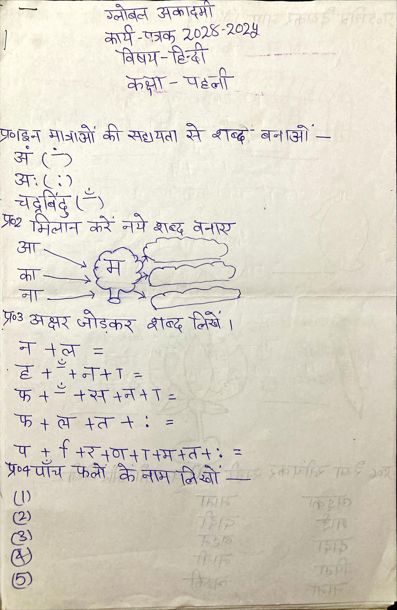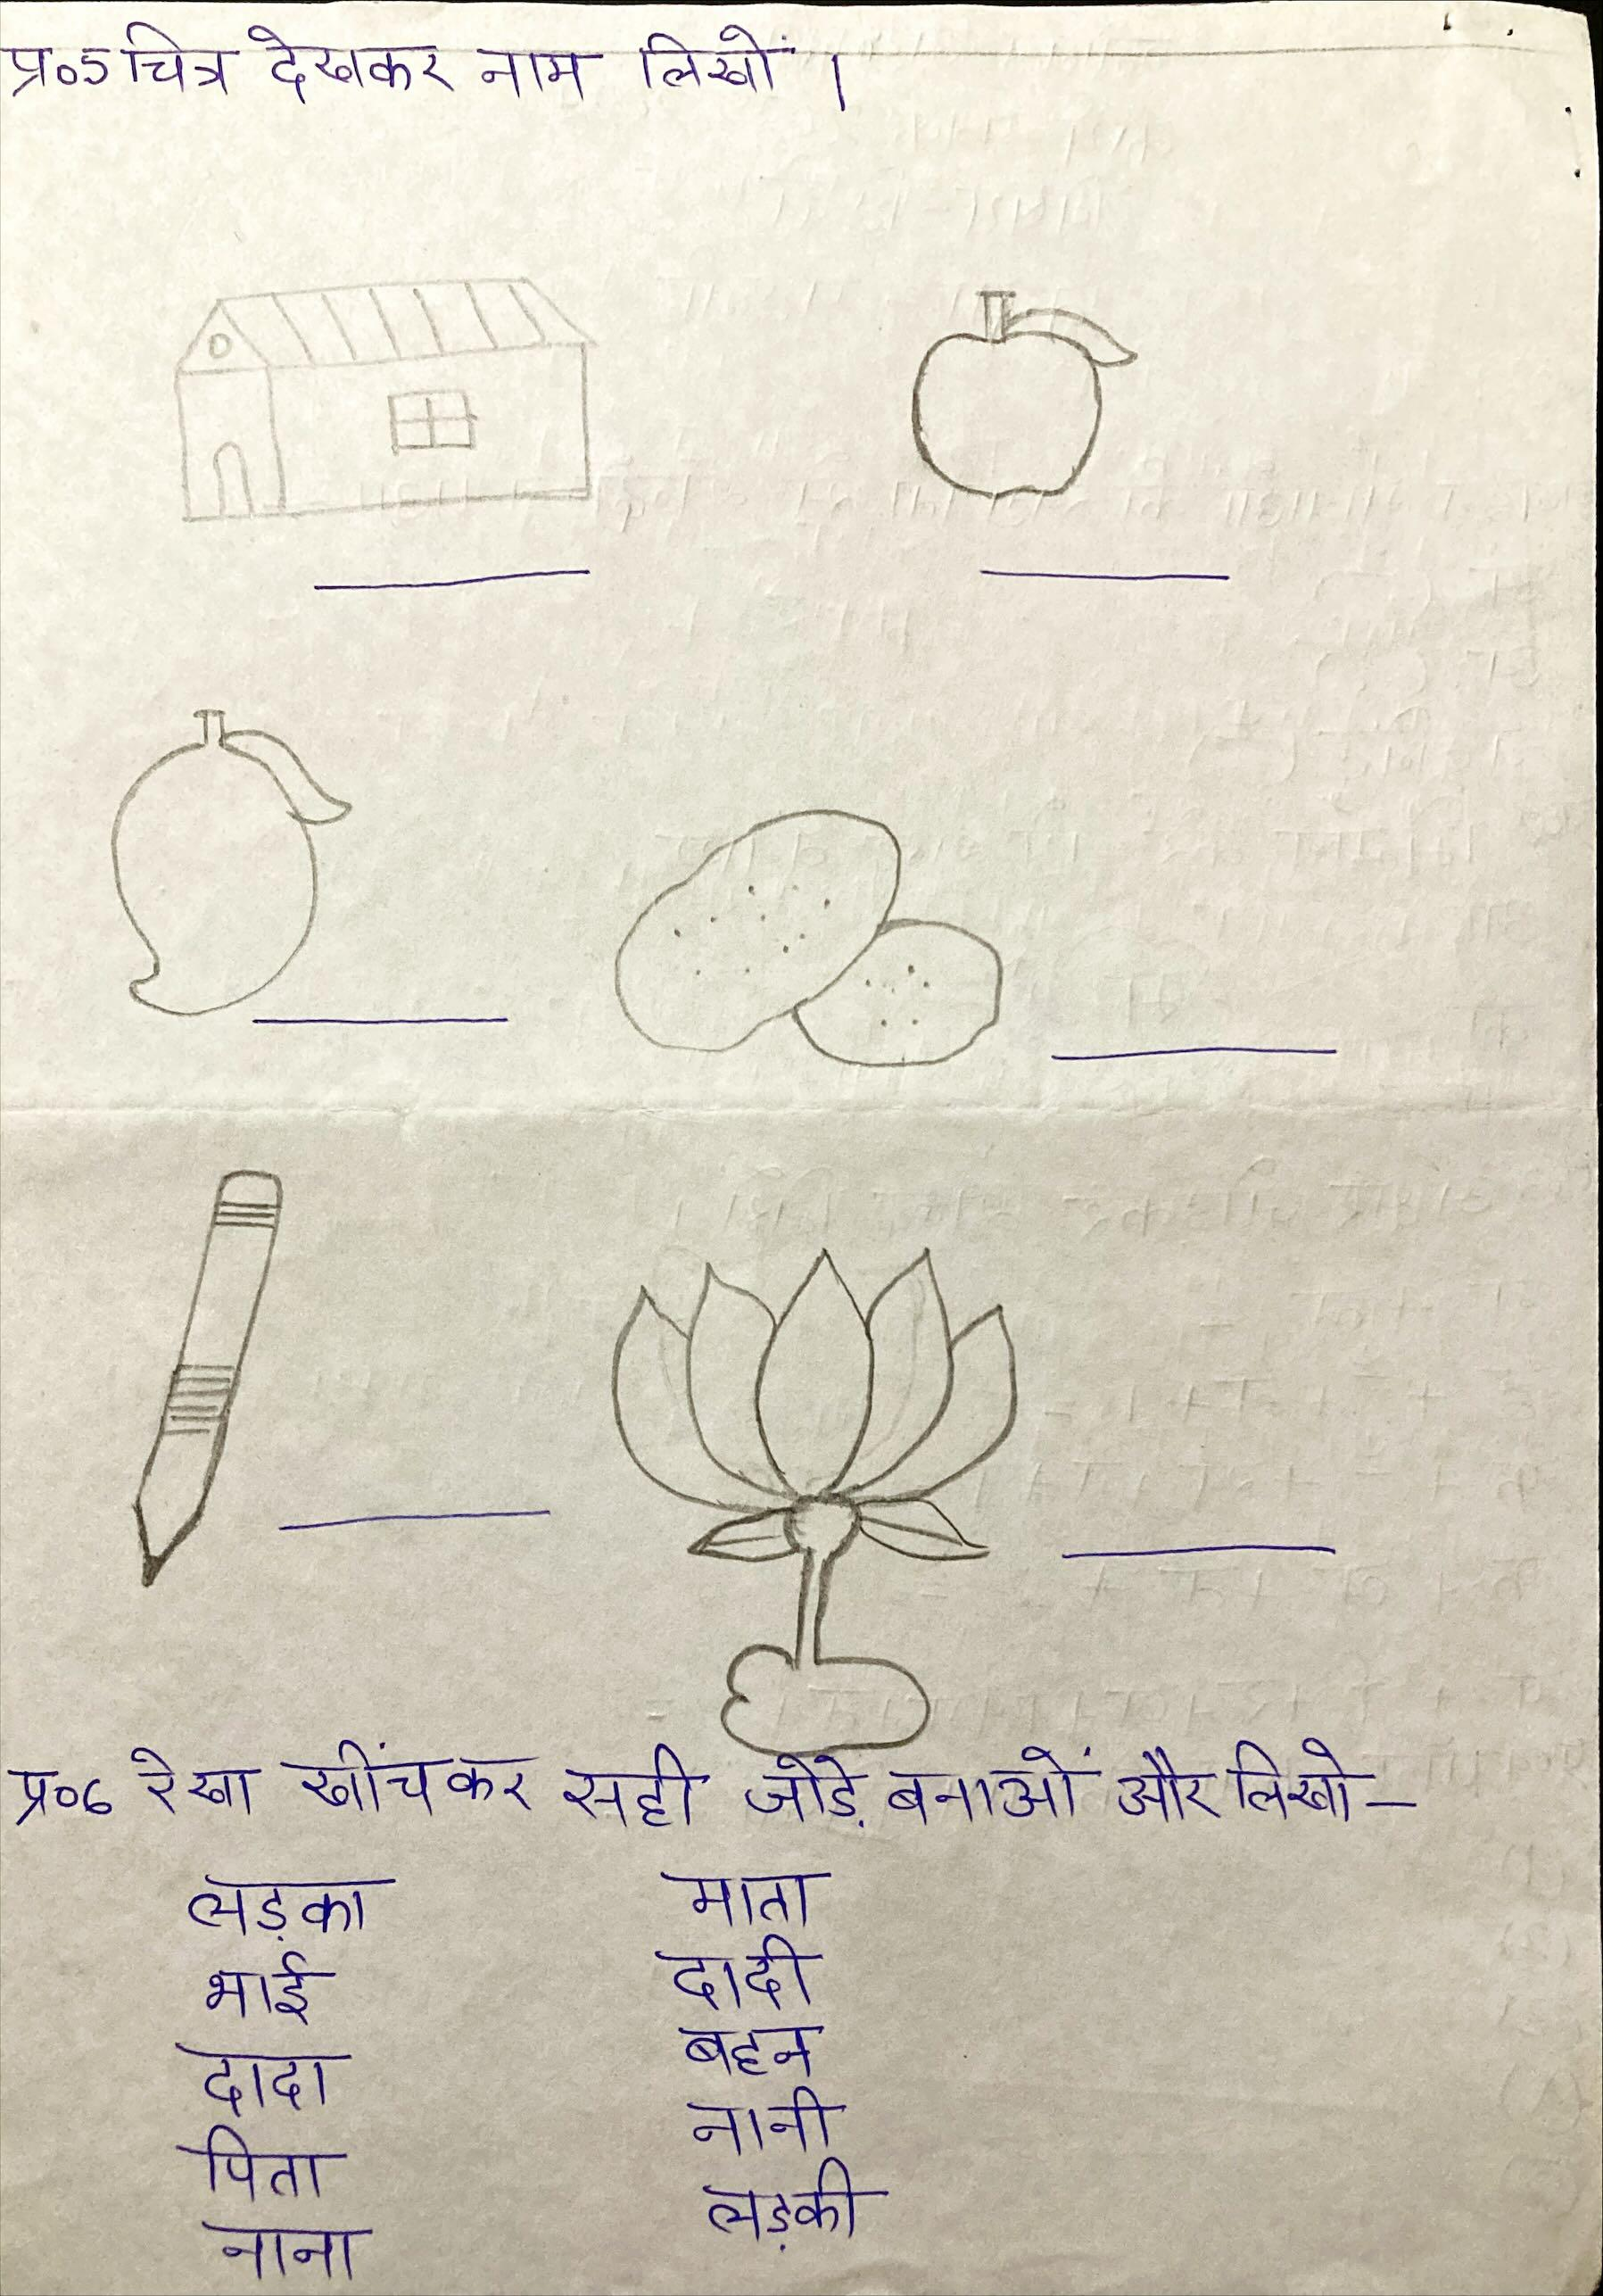

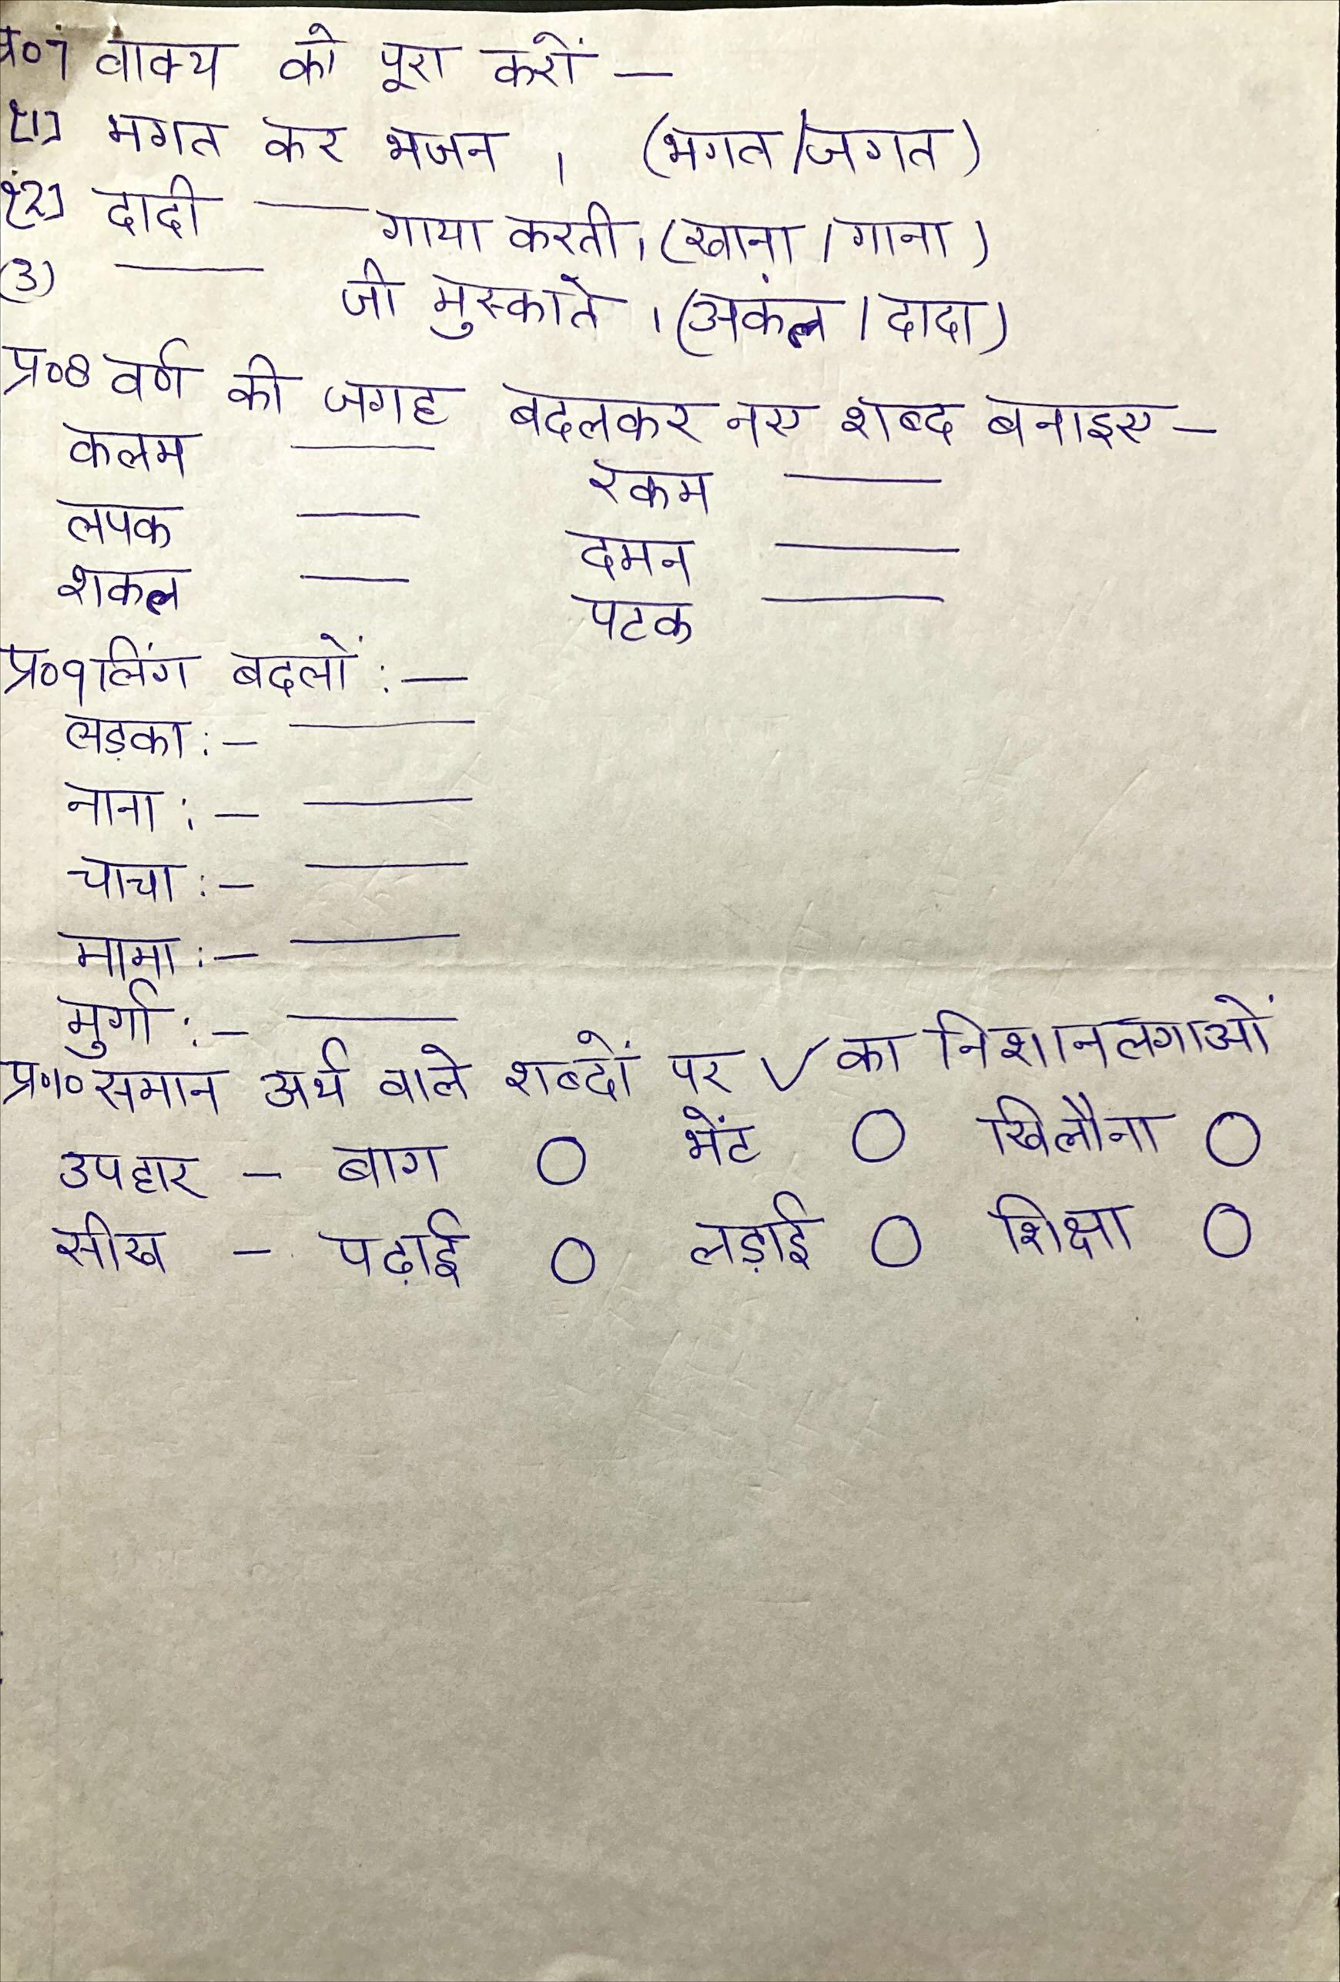

**GLOBAL ACADEMY**

**WORKSHEET – OCTOBER**

**SESSION 2024 – 25**

**CLASS – I (MATHS)**

Q1. Write number names

1. 68

2. 24

3. 35

4. 66

5. 70

6. 54

7. 72

8. 49

Q2. Subtraction borrow sums –

T O T O T O T O T O

6 5 7 2 9 2 6 2 7 5

* 2 3 - 1 8 -2 5 - 1 8 - 4 6

__________ ________ _________ ________ __________

__________ ________ _________ ________ __________

Q3. Riya made 52 paper flowers and Naveen made 35 paper flowers. How many more paper flowers did Riya made?

Q4. In a class, there are 42 students. If 25 are boys, how many are girls.

Q5. There are 52 balloons. 13 balloons burst. Hoe many balloons are left?

Q6. Tick for correct option.

a. 23 – 11 stands for

10

12

11

21

b. 45 – 22 stands for

33

24

32

23

c. 50 – 25 stands for

25

28

15

35

Q7. Multiply and write the answer

1. 2 x 5 =

2. 4 x 4 =

3. 3 x 7 =

Q8. In a class, there are 14 boys and 15 girls. How many students are there in the class?

Q9. Shyam scored 58 points and Ram scored 35 points. How many points did they scored altogether?

Q10. Fill the missing number.

1. 5 - = 3

2. 2 – 1 =

3. – 4 = 6

4. 5 + 8 =

5. 6 + = 11

6. + 3 = 12

Q11. Carry sum addition –

T O T O T O T O T O

5 6 3 6 2 8 2 9 3 6

+1 4 +2 8 +3 4 +4 4 + 1 5

__________ ________ _________ ________ __________

__________ ________ _________ ________ __________

T O T O

4 8 8 5

+ 1 4 + 1 5

__________ ________

__________ ________

**GLOBAL ACADEMY**

**WORKSHEET – OCTOBER**

**SESSION 2024 – 25**

**CLASS – I (EVS)**

Q1. Fill in the blanks –

1. We use ______________ to go to very far __________ off places.

2. Auto rikshaw is a means of _______________ transport.

3. We ________________ in the bathroom.

4. __________________ houses are very big and strong.

5. Some people live in ________________ houses.

6.We feel ________________ in our house.

Q2. Write true or false –

1. We study in the study room.

2. We meet our guest in the kitchen.

3. We also travel by a means of water transport.

4. A bicycle is not a means of land transport.

5. We travel by means of transport in the air also.

6. Train and buses are means of land transport.

Q3. Fill in the missing letter.

1. B __ THR __ __ M

2. K __ __ C __ E N

3. R __ __ A X

4. B __ __ R __ __ M

5. S __ __ L __ __ R

6. S __ __ D __ R __ __ M

7. W __ __ T __ __ R

Q4. Rearrange the letter.

1. T __ A __ __ P O __ T

2. W __ T __ R

3. S __ I __ S

4. W __ __ T H __ R

5. S __ U __ Y

6. __ I T __ H __ N

Q5. Fill the missing letters to complete name of the rooms.

1. We see cups in the

2. We see a towel in the

3. We see a bed in the

4. We see a sofa in the

5. We see books in the

Q6. Write L for land, W for watch and A for air transport.

1. Train ______

2. Bus ______

3. Autorickshaw ______

4. Bicycle ______

5. Scooter ______

6. Aeroplane ______

7. Helicopter ______

8. bout ______

Q7. Circle the name of vehicle in the given word search.

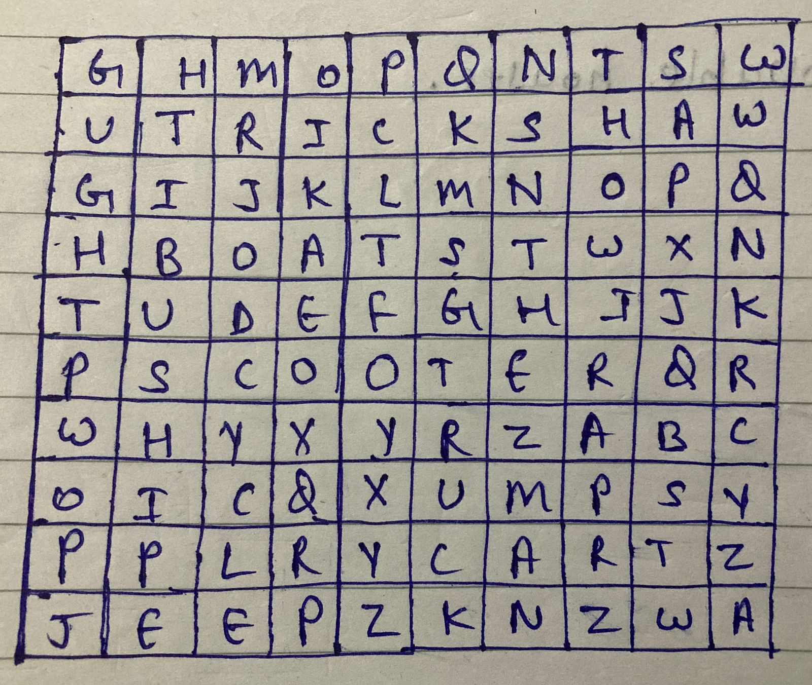

Q8. Write answer of the following questions –

1. Why do we need transport?

Ans. ________________________________________________________________________________________________________________________________

2. Name two means of water transport.

Ans. ________________________________________________________________________________________________________________________________

3. Give two examples of pucca house.

Ans. ________________________________________________________________________________________________________________________________

4. What are different types of houses?

Ans. ________________________________________________________________________________________________________________________________

5. Name three means of air transport.

Ans. ________________________________________________________________________________________________________________________________

6. Give two examples of movable houses.

Ans. ________________________________________________________________________________________________________________________________