GLOBAL ACADEMY

U.T. 2

SYLLABUS

CLASS 5

Maths :- Chapter – 5. Measurement

Chapter – 9. Time and measurement

Science :- Chapter – 7. Solids , Liquids and gases

Chapter – 8. Air and water

S.S.T :- Chapter – 10. Environmental pollution

Chapter – 11. E for Environment

Chapter – 12. Natural disasters

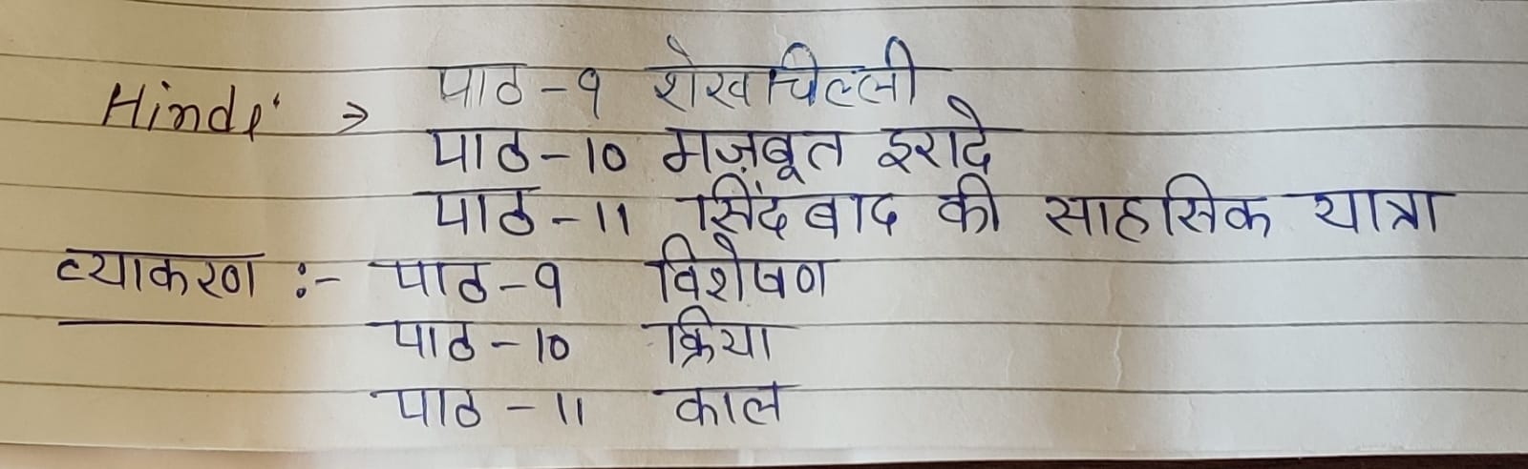

G.K. :- Unit – 5. India – My country

Unit – 6. The world around us

Eng. (R) :- Ch – 6. Black beauty

Ch – 7. Dean Mr. Franks

Ch – 8. A day’s wait

Ch – 9. Donothy meets the Good witch

Story :- Ch – 6. The house trader

Ch – 7. The musicians of Breman

Ch – 8. Pandora’s box

Grammar :- Ch – 8. The pronoun – kinds of pronouns

Ch – 9. The preposition

Ch – 10. The conjunction

Ch – 11. Letter writing

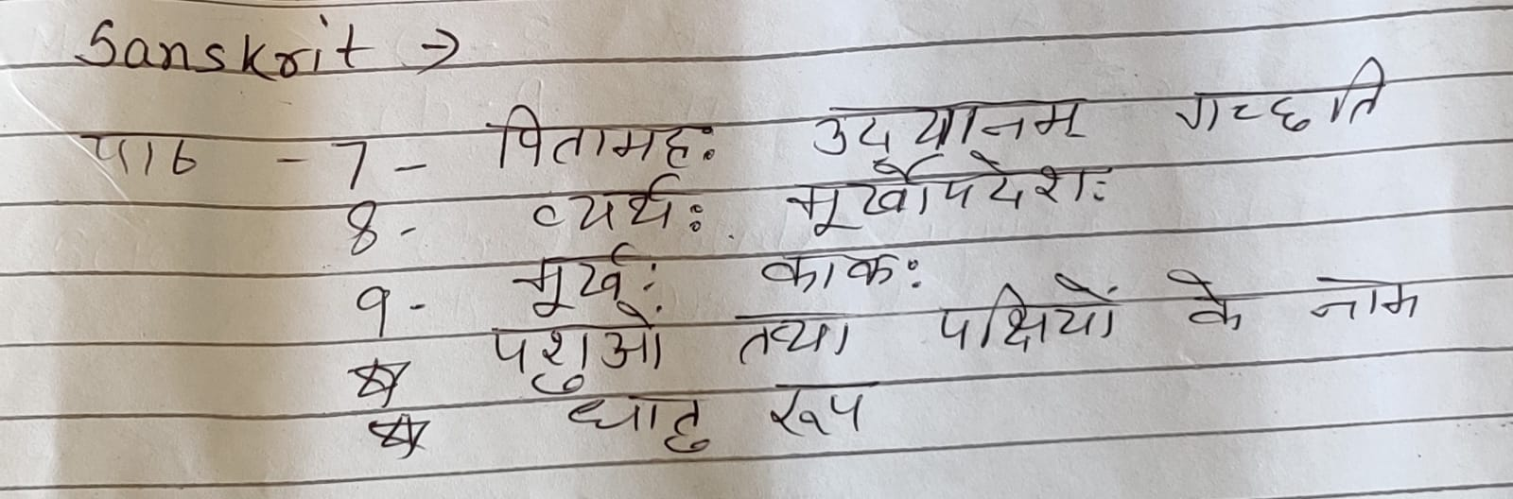

Computer :- Ch – 7. MS PowerPoint 2010 : Animation and Transitions

Ch – 8. Movies and Sounds in MS PowerPoint 2010