GLOBAL ACADEMY

SESSION 2022 – 2023

SYLLABUS: UNIT TEST 2

CLASS 4

English Reader :- Lesson – 7. Sindbad’s voyage

Lesson – 8. Tom paints the fence

The first tooth (Poem)

Lesson – 9. The pied piper of Hamelin

Baby Land (Poem)

Eng. Grammar :- Lesson – 6. Articles

Lesson – 7. Prepositions

Lesson – 8. Conjunctions

Story :- Lesson – 6. The Unwelcome guests

Lesson – 7. A birthday gift

Lesson – 8. Brave captain Vikram Batra

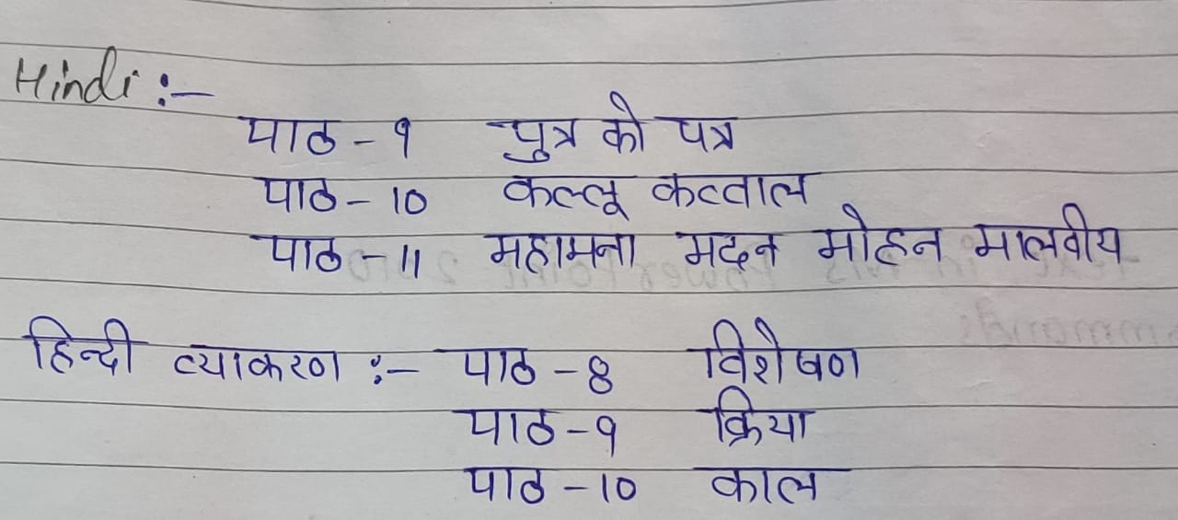

Science :- Chapter – 7. Digestive system

Chapter – 8. Circulatory and Excretory system

G.K :- Unit – 7. L – 37 , 38 , 39 , 40 , 41 , 42

Unit – 8. L – 43 , 44 , 45 , 46 , 47

Computer :- Ch – 6. Working with text in Ms PowerPoint 2010

Ch – 7. More LOGO commands

S.S.T :- Lesson – 10. Transport and communication

Lesson – 11. Our natural resources

Lesson – 12. Our forests

Maths :- Lesson – 8. Measurement

Lesson – 9. Time