GLOBAL ACADEMY

SESSION 2022 – 2023

SYLLABUS: UNIT TEST 2

CLASS 3

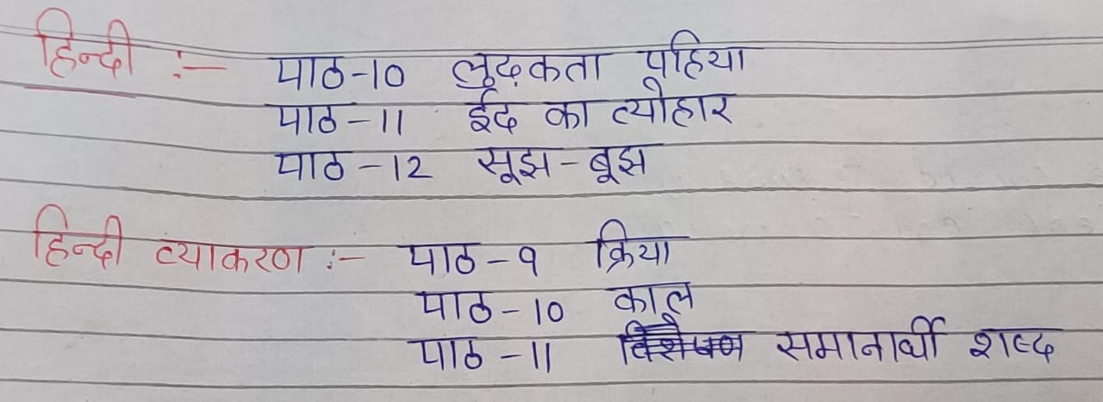

English R :- Lesson – 8. The weaver’s wish

Lesson – 9. The other side of the wall

English Grammar :- Chapter – 6. Pronouns

Chapter – 8. Pegrees of comparison

Math :- Lesson – 7. Measurement

Lesson – 8. Time

E.V.S :- Lesson – 8. People at work

Lesson – 9. Houses we live

Lesson – 10. Means of transport

G.K :- Unit – 6. The world around us

Unit – 7. Science and technology

Computer :- Chapter – 5. Introduction to MSW LOGO

Chapter – 6. More about MSW LOGO

Formative – 3

Formative – 4

Story :- Chapter – 5. The crooked Hyena

Chapter – 6. Fight for equality

Chapter – 7. Yes we can