GLOBAL ACADEMY

SESSION 2022 – 2023

SYLLABUS: UNIT TEST 2

CLASS 2

English :- Lesson – 7. The Frogs & the boys

Lesson – 8. Little pink Lily

English Grammar :- Chapter – 8. Adverbs

Chapter – 9. Prepositions

Chapter – 10. Conjunctions

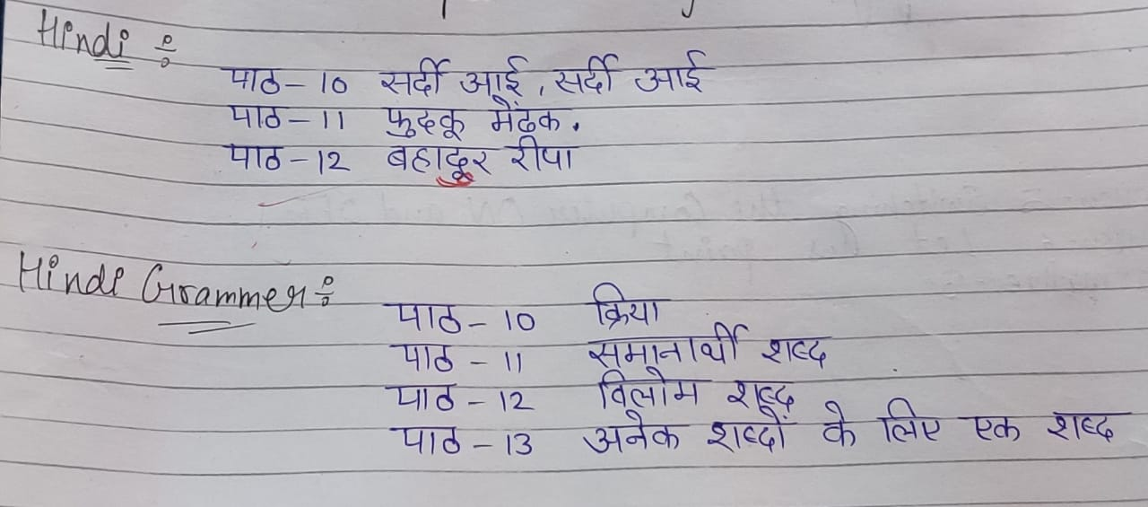

Maths :- Lesson – 7. Division

Lesson – 8. Measurement

Lesson – 9. Time

E.V.S :- Lesson – 9. Places of worship

Lesson – 10. Our Festivals

Lesson – 11. Safety habbits

Computer :- Lesson – 5. Switching the computer ON and OFF

Lesson – 6. Let us paint

Formative – 3

G.K :- Unit – 5. India – My country

Unit – 6. The world around us