**Global Academy**

**Academic Session – 2024-25**

**Holiday Homework**

**Class – VIII**

**Subject – English**

* **Revise the entire syllabus taken up before the summer break of all subject. Make a separate holiday homework copy for each subject .**

1. Make a collage of Nature’s poets. Write a poem from their works with critical appreciation and poetic devices used.

2. Prepared a cover page of magazine entitled on Mother’s Day, dedicating your mother.

3. Make a poster to advertise local and organic food mentioning where they come from and why they are good for you. Draw related pictures.

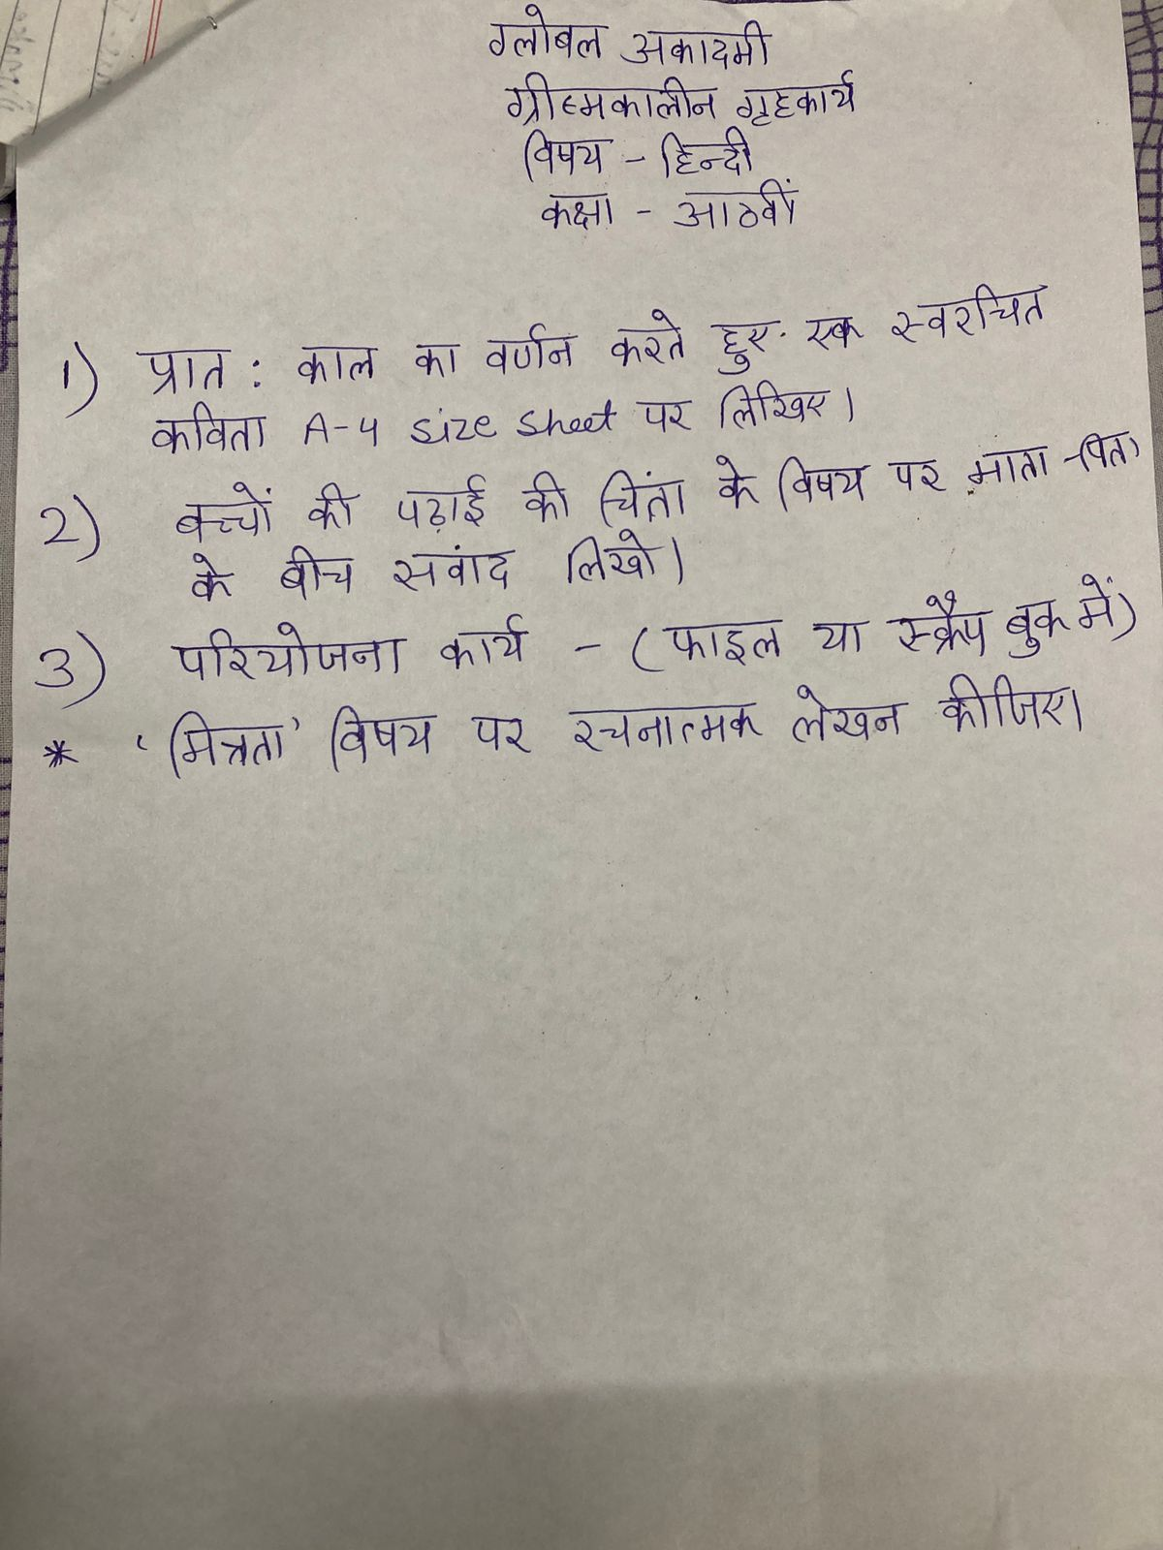

**Global Academy**

**Academic Session – 2024-25**

**Holiday Homework**

**Class – VIII**

**Subject – Maths**

* **Revise the entire syllabus taken up before the summer break of all subject. Make a separate holiday homework copy for each subject .**

A. 1. Make a working model of property of circle. (Roll no. 1 to 3)

2. Make a model of Rational number. (Roll no. 4 to 6)

3. Make 3D shapes by thread/net. (Roll no. 7 to 9)

4. Make a model of trigonometric park. (Roll no. 10 to 12)

B. Make a poster on Indian mathematicians Brahmagupta.

C. Make a chart on different types of quadrilateral using set squares and to learn about their properties.

**Global Academy**

**Academic Session – 2024-25**

**Holiday Homework**

**Class – VIII**

**Subject – SST**

* **Revise the entire syllabus taken up before the summer break of all subject. Make a separate holiday homework copy for each subject .**

Q1. Make a chart on (any one) -

a. Stop child Labour

b. Save Water

Q2. Make a scrap book and paste pictures on these topics –

a. Social Reformers

b. Drought

Q3. Make a 3D model on –

(a)Parliament of India (Roll no. 1 to 5)

(b) Jallianwala Bagh (Roll no. 6 to 10)

(e )Types of soil (Roll no. 11 to 15)

Q4. Imagine yourself as historian who wants to find out the changes in agriculture in remote areas after independence. What sources of history would you use to find information?

**Global Academy**

**Academic Session – 2024-25**

**Holiday Homework**

**Class – VIII**

**Subject – Science**

* **Revise the entire syllabus taken up before the summer break of all subject. Make a separate holiday homework copy for each subject .**

1. Prepare a chart for the phases of moon.

2. Collect information and pictures of the five different kinds of microbes. Write about their structures. Explain how they useful or harmful to us.

3(i) Working model of solar system ( Roll no- 3 and 9 )

ii) Drone ( Roll no – 6 and 9 )

iii) chandrayan ( Roll no- 11 and 1 )

iv ) Periscope ( Roll no – 4 )

v) Alternating source of energy ( Roll no – 10 and 2 )

vi) Electric bell ( Roll no- 12 and 5 )

vii) Light ( reflection / refraction ) ( Roll no – 7 )

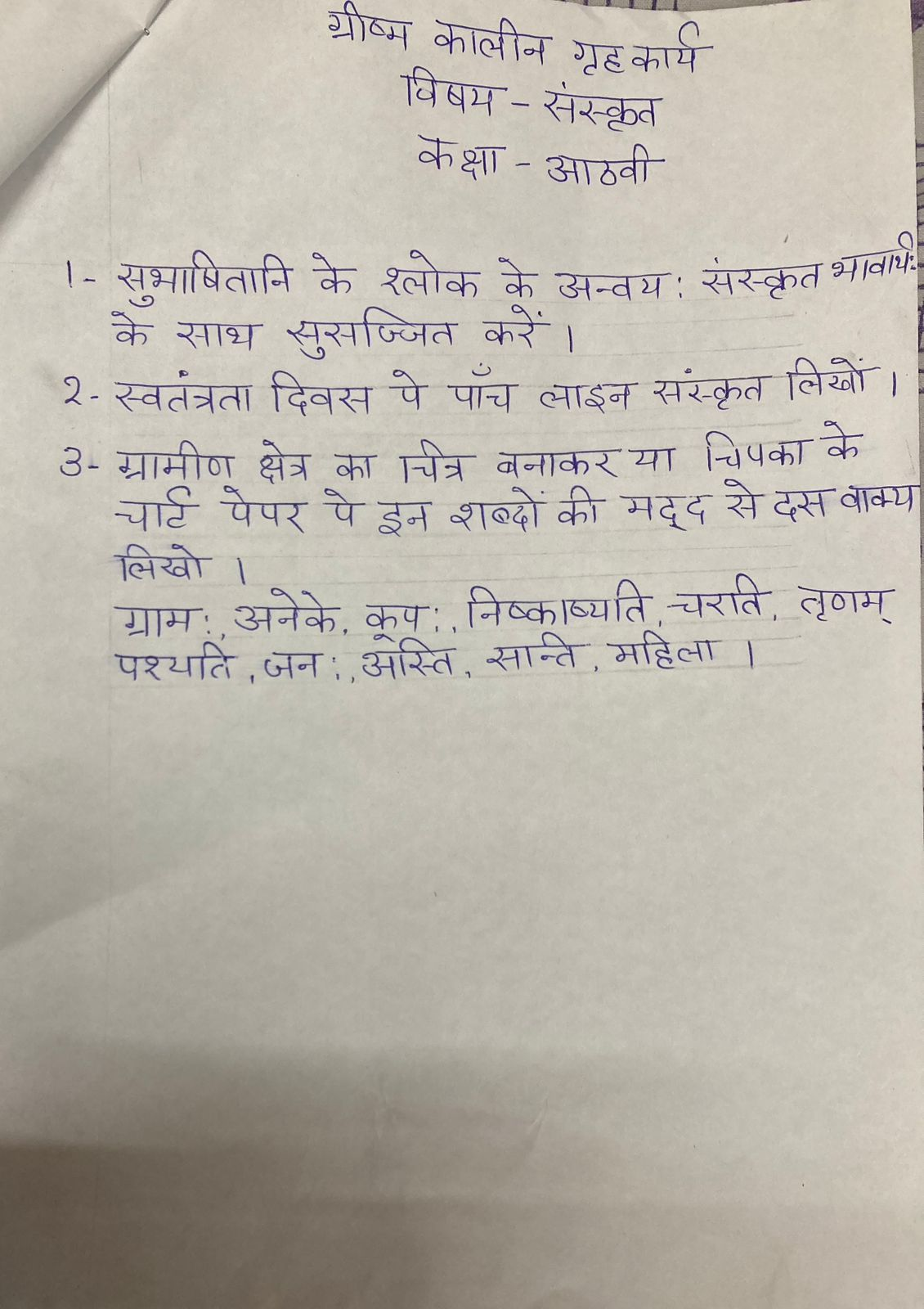

**Global Academy**

**Academic Session – 2024-25**

**Holiday Homework**

**Class – VIII**

**Subject – Computer**

* **Revise the entire syllabus taken up before the summer break of all subject. Make a separate holiday homework copy for each subject .**

1. Make a model of computer area network.

2. Define different type of topology on a chart paper and write about it.

3. Paste images switch, Hub, Router and Modem on chart paper. Write two sentences about each of them.

**Global Academy**

**Academic Session – 2024-25**

**Holiday Homework**

**Class – VIII**

**Subject – Drawing**

1. Make a portrait of Indira Gandhi/ Nirmala Sitharaman/ Nita Ambani/ Falguni Nayar/ Priyanka Chopra/ Sushma Swaraj/ Kiran Bedi/ Saina Nehwal/ Arundhati Roy / Sarojini Naidu or Lata Mangeshkar.

2. Make a water fountain with pump for a school project.

3. Prepare a skeleton leaves wall hanging craft.

**Global Academy**

**Academic Session – 2024-25**

**Holiday Homework**

**Class – VIII**

**Subject – GK**

* **Revise the entire syllabus taken up before the summer break of all subject. Make a separate holiday homework copy for each subject .**

1. Cut and paste five headlines of atleast ten days in a scrap book.

2. Prepare a chart of National Awards for different fields and write few lines on these awards.

3. Make poster on Nipah Virus.

4. Make a chart on renowed Scientists of the world.