**Global Academy**

**Academic Session – 2024-25**

**Holiday Homework**

**Class – VII**

**Subject – English**

* **Revise the entire syllabus taken up before the summer break of all subject. Make a separate holiday homework copy for each subject .**

1. Make a story with pictures on chart paper.

2. Prepare a report on life and works of APJ Abdul Kalam. Include the points – (Introduction, Birth, Parents, Education, Notable works)

3. Prepare an “E-magazine” focusing on the following topics –

a. Write about the favourite place you have visited recently. What are the important factors that attracted you? What effective impact you feel you have acquired? Describe the experience to the readers in 5 10 lines.

Or

b. Compose a poem about your mother/Father and express your gratitude about their remarkable qualities of love, care, affection and their guidance.

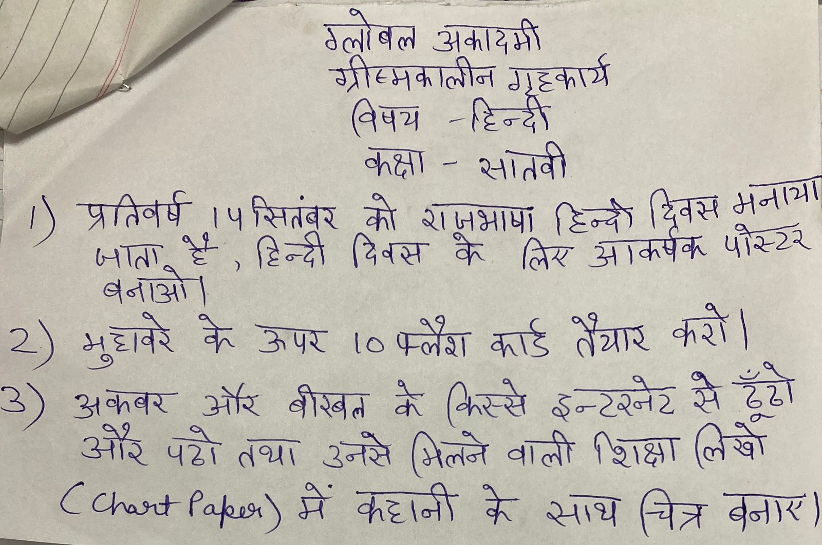

* **Revise the entire syllabus taken up before the summer break of all subject. Make a separate holiday homework copy for each subject .**

**Global Academy**

**Academic Session – 2024-25**

**Holiday Homework**

**Class – VII**

**Subject – Maths**

* **Revise the entire syllabus taken up before the summer break of all subject. Make a separate holiday homework copy for each subject .**

Q1. Make working model of –

a. Algebric expression (Roll no. 1 to 10)

b. Types of triangle (Roll no. 11 to 20)

c. Addition Machine (Roll no. 21 to 30)

d. Parallelogram Properties (Roll no. 31 to 38)

Q2. Make chart paper of –

a. Types of quadrilateral and mention their no. of sides, vertices, formulae of area. (Roll no. 1 to 10)

b. Parallel lines and angles. (Roll no. 11 to 20)

c. Types of polygon, mention its side and vertices, draw its diagram, no. of diagonals, sum of the interior angles. (Roll no. 21 to 30)

d. Draw flow chart of Real numbers. (Roll no. 31 to 38)

Q3. Draw picture of Indian Mathematician

a. Satyendra Nath Bose. (Roll No. 1 to 10)

b. Barhmagupta (Roll no. 11 to 20)

c. Srinivasa Ramanujan (Roll no. 21 to 30)

d. Nilakantha Somayaji (Roll no. 31 to 38)

**Global Academy**

**Academic Session – 2024-25**

**Holiday Homework**

**Class – VII**

**Subject – Science**

* **Revise the entire syllabus taken up before the summer break of all subject. Make a separate holiday homework copy for each subject .**

1(a). Prepare model of reflection and refraction of light (1 – 10)

(b) Construct a model of volcano (working). (11-20)

(c) Make your own anemometer and windsock. (21 – 30)

(d) Prepare a model of stethoscope (31 – 38)

Q2. Prepare a chart paper on food web and food chain.

Q3.Write few lines about Soren Sorenson with his picture on chart paper.

**Global Academy**

**Academic Session – 2024-25**

**Holiday Homework**

**Class – VII**

**Subject – SST**

* **Revise the entire syllabus taken up before the summer break of all subject. Make a separate holiday homework copy for each subject .**

Q1. Make a chart on –

a. Landforms

b. Three branches of Environment

c. Domains of Environment

Q2. Make a scrapbook and paste the following –

a. Mughal rulers

b. Types of Rocks

c. Different modes of transport

Q3. Make a model on –

(a)Ecosystem(Roll no. 1 to 5)

(b)Desert (Roll no. 6 to 10)

(c)Dam (Roll no. 11 to 15)

(d)Geothermal energy (Roll no. 16 to 20)

(e)Types of Crops (Roll no. 21 to 25)

(f)Cyclone (Roll no. 26 to 30)

(g)Internal structure of Earth (Roll no. 31 to 35)

(h)Glacier (Roll no. 36 to 40)

Q4. Our Environment consist if all living and non-living organisms components around us. But due to unplanned use of technology, we are polluting our environment and thereby causing harm to it. With reference to the lesson, demonstrate (diagram, oral or power point presentation) how this environment mental pollution affect the earth.

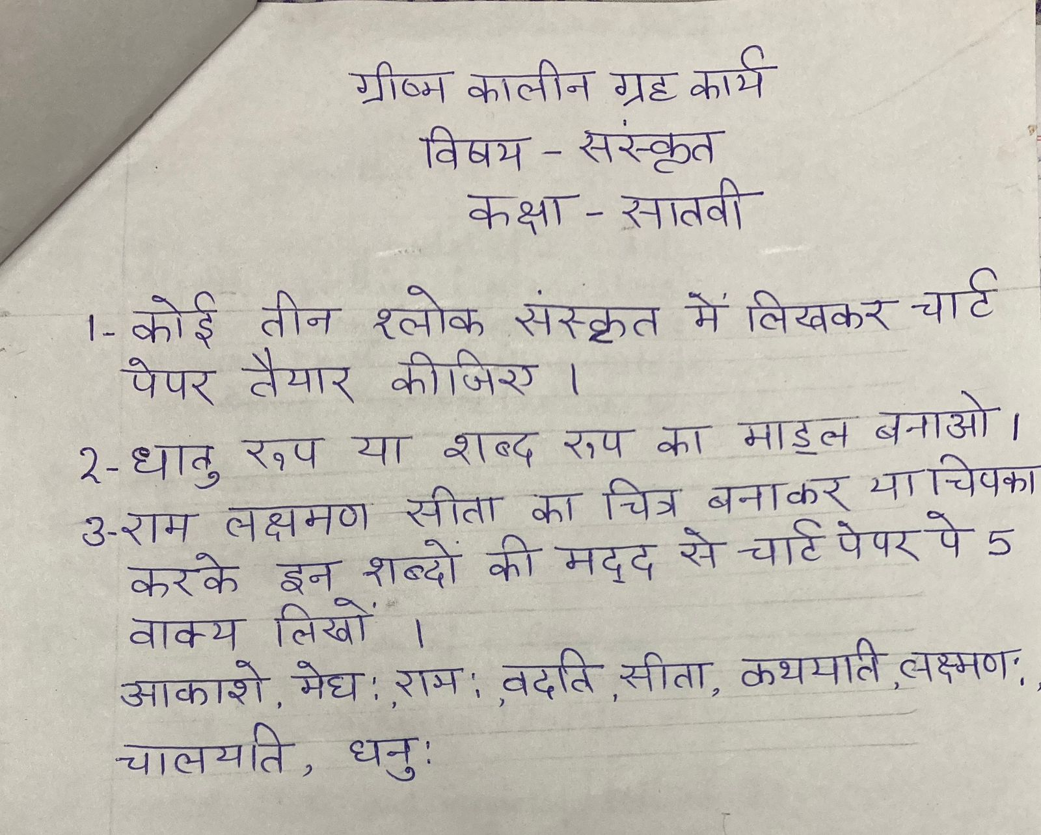

* **Revise the entire syllabus taken up before the summer break of all subject. Make a separate holiday homework copy for each subject .**

**Global Academy**

**Academic Session – 2024-25**

**Holiday Homework**

**Class – VII**

**Subject – Computer**

* **Revise the entire syllabus taken up before the summer break of all subject. Make a separate holiday homework copy for each subject .**

1. Design and create a chart and poster on any of the topics.

a. Computer Hardware

b. Networking devices

2. Make a poster of different type of computer keys.

**Global Academy**

**Academic Session – 2024-25**

**Holiday Homework**

**Class – VII**

**Subject – Drawing**

1. Draw picture of –

a. Savitribai phule (Roll no. 1 to 10)

b. Ahilyabai Holkar (Roll no. 11 to 20)

c. Anandi Gopal joshi (Roll no. 21 to 30)

d. Rani Lakshmibai (Roll no. 31 to 38)

2. Write quotations about women empowerment on chart paper (In English, Hindi and Sanskrit).

3. Make a Coconut shell craft.

**Global Academy**

**Academic Session – 2024-25**

**Holiday Homework**

**Class – VII**

**Subject – GK**

* **Revise the entire syllabus taken up before the summer break of all subject. Make a separate holiday homework copy for each subject .**

1. Make a chart showing five famous Indian authors (English) and the books written by them. Also paste their pictures.

2. Make a chart on Olympic Medalists of India. (Any six)

3. Write about any five movement and revolution in about 100 words each. Also, draw or paste relatable pictures on A4 size sheet.