**Global Academy**

**Academic Session – 2024-25**

**Holiday Homework**

**Class – VI**

**Subject – English**

* **Revise the entire syllabus taken up before the summer break of all subject. Make a separate holiday homework copy for each subject .**

1. Make a chart on the topic of “Say no to drugs or Illiteracy.

2. Draw a flow chart of the following grammar topic (choose any one):

a. Sentences

b. Nouns

c. Phrases

d. Conjunction and Interjection

3. Make a bookmark. Decorate it and write an inspirational quotation by a well know poet or author. Laminate and present it beautifully.

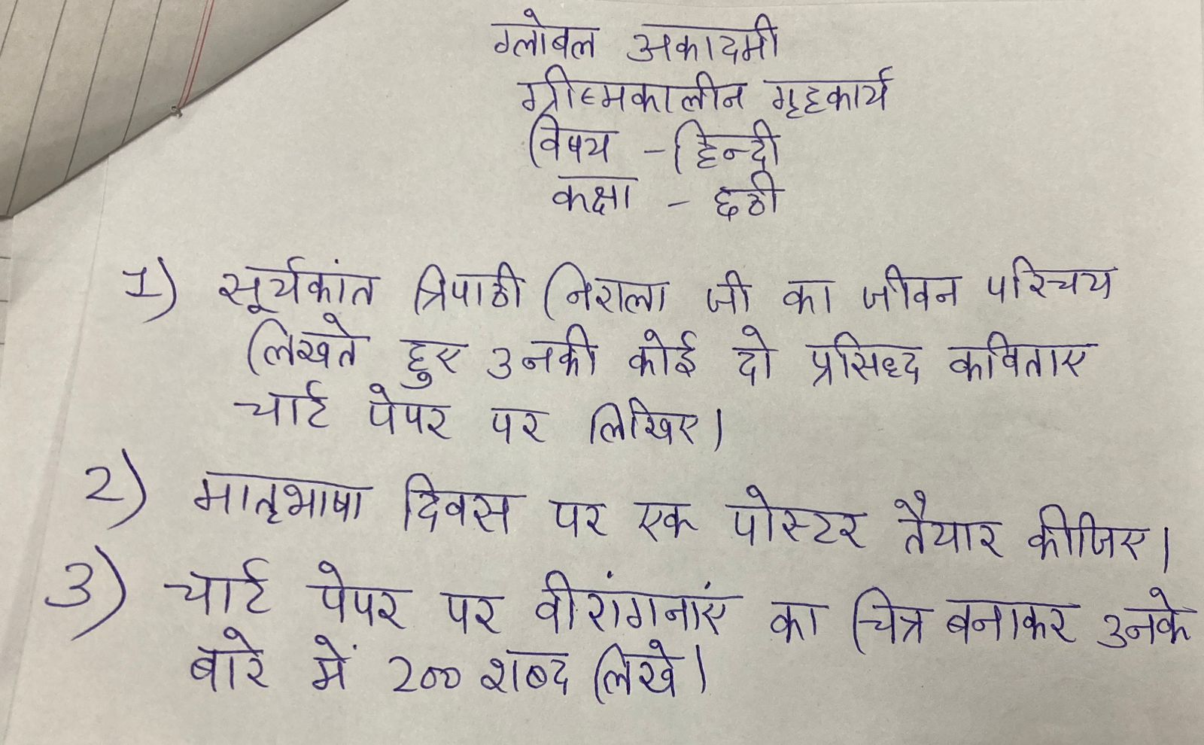

* **Revise the entire syllabus taken up before the summer break of all subject. Make a separate holiday homework copy for each subject .**

**Global Academy**

**Academic Session – 2024-25**

**Holiday Homework**

**Class – VI**

**Subject – Maths**

* **Revise the entire syllabus taken up before the summer break of all subject. Make a separate holiday homework copy for each subject .**

1. Prepare a chart –

a. Types of fraction

b. Types of triangle

c. Definitions of -

1. Natural number
2. Whole number
3. Integer
4. Even number
5. Odd number
6. Prime number
7. Composite number
8. Perfect number

2. Make a model of a game, snake and ladders on A3 size by following the steps given below–

Step 1 – Make a square paper.

Step 2 – Making 100 small squares

Step 3 – Numbering the squares.

Step 4 – Sketching the snakes and ladders.

Step 5 – Coloring the snake and ladders.

Step 6 – Using marker lids

3. Prepare a working model

a. Spiral board number game (Roll no. 1 to 5)

b. Diagonal move (math game) by cardboard. (Roll no. 6 to 10)

c. Triangular peg board game. (Roll no. 11 to 15)

d. Cardboard game of using addition, subtraction, division and multiplication (Roll no. 16 to 20)

e. Model on types of fraction (Roll no. 21 to 26)

**Global Academy**

**Academic Session – 2024-25**

**Holiday Homework**

**Class – VI**

**Subject – Science**

* **Revise the entire syllabus taken up before the summer break of all subject. Make a separate holiday homework copy for each subject .**

1.(a). Prepare a working model of Greenhouse effect (1 – 8)

(b) Prepare model of acid rain (9 – 16)

(c )Make working model of water cycle (17 – 24)

(d )Prepare working model of pinhole camera (25,26)

Q2. Prepare a model of home gardening.

Q3 . Prepare a chart paper on all joints of body.

**Global Academy**

**Academic Session – 2024-25**

**Holiday Homework**

**Class – VI**

**Subject – SST**

* **Revise the entire syllabus taken up before the summer break of all subject. Make a separate holiday homework copy for each subject .**

Q1. Make a chart on –

a. Ashoka’s Emblem

b. Three Tier Panchayati Raj system

Q2. Make in scrap book and paste the following –

a. Types of forest

b. Social reformer (Jyotirao Govindrao phule)

Q3. Make a model on –

a)Gram Sabha (Roll no. 1 to 5)

b)Women Empowerment (Roll no. 6 to 10)

c)Types of Mountains (Roll no. 11 to 15)

d)Solar system (Roll no. 16 to 20)

e)Three R’s (Roll no. 21 to 25)

f)Types of Pollution (Roll no. 26 to 30)

g)Natural disasters (Roll no. 31 to 34)

Q4. Though India is a country with diversity in language, food, dress and other cultural aspects, still we are united. Use the slogan ‘Unity in Diversity’ and write a short paragraph on India.

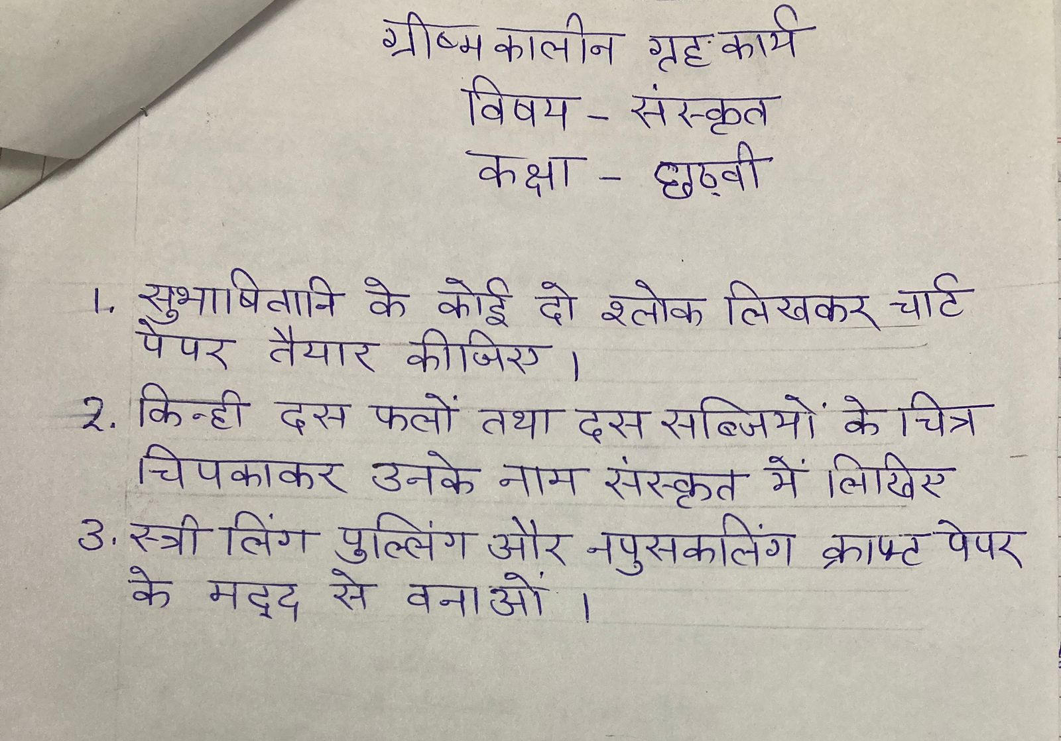

* **Revise the entire syllabus taken up before the summer break of all subject. Make a separate holiday homework copy for each subject .**

**Global Academy**

**Academic Session – 2024-25**

**Holiday Homework**

**Class – VI**

**Subject – Computer**

* **Revise the entire syllabus taken up before the summer break of all subject. Make a separate holiday homework copy for each subject .**

1. Build a model different type of computer.

2. Make a chart of different type of computer software and computer languages.

3. Read and learn lesson 1 and 2. Write 20 difficult words from both lesson in computer notebook.

**Global Academy**

**Academic Session – 2024-25**

**Holiday Homework**

**Class – VI**

**Subject – GK**

* **Revise the entire syllabus taken up before the summer break of all subject. Make a separate holiday homework copy for each subject .**

1. Search top five companies or brands (India). Paste the logo and while about the company on chart.

2. List the flag of 10 Asian countries, list of folk Dances of India, state wise on A4 sheet.

3. Find the names of the women who have contributed in Mangalyaan Mission by ISRO and collect their pictures, paste on colored sheet.

**Global Academy**

**Academic Session – 2024-25**

**Holiday Homework**

**Class – VI**

**Subject – Drawing**

* **Revise the entire syllabus taken up before the summer break of all subject. Make a separate holiday homework copy for each subject .**

1. Make any one decorative object by using waste material

a) Chandelier

b) Wall art

c) Flower vase

2. Draw pictures of famous women athletes on chart paper.

3. Make a picture of any bird of your own choice by pasting different kinds of leaves.