**Global Academy**

**Academic Session – 2024-25**

**Holiday Homework**

**Class – V**

**Subject – English**

* **Revise the entire syllabus taken up before the summer break of all subject. Make a separate holiday homework copy for each subject .**

1. Watch a movie of your choice and complete the review below on chart paper.

Name of the movie:

Your Rating:

Genre: Comedy/ Tragedy/ Action/ Fantasy

Setting of the movie, Place: ______________________________________

The main characters of the movie are: _______________________________

Who is your favourite character and why?

Did you like this movie? Why or Why not?

2. Make a chart on any one famous female authors with a picture of author.

3. Make a collage of ‘Save your environment’. Collect pictures from your old books and newspapers. (On chart paper)

Or

Prepare a greeting card for your parents wedding anniversary by wishing them for their love and affection showered on you and their admirable qualities using your creative and thoughts.

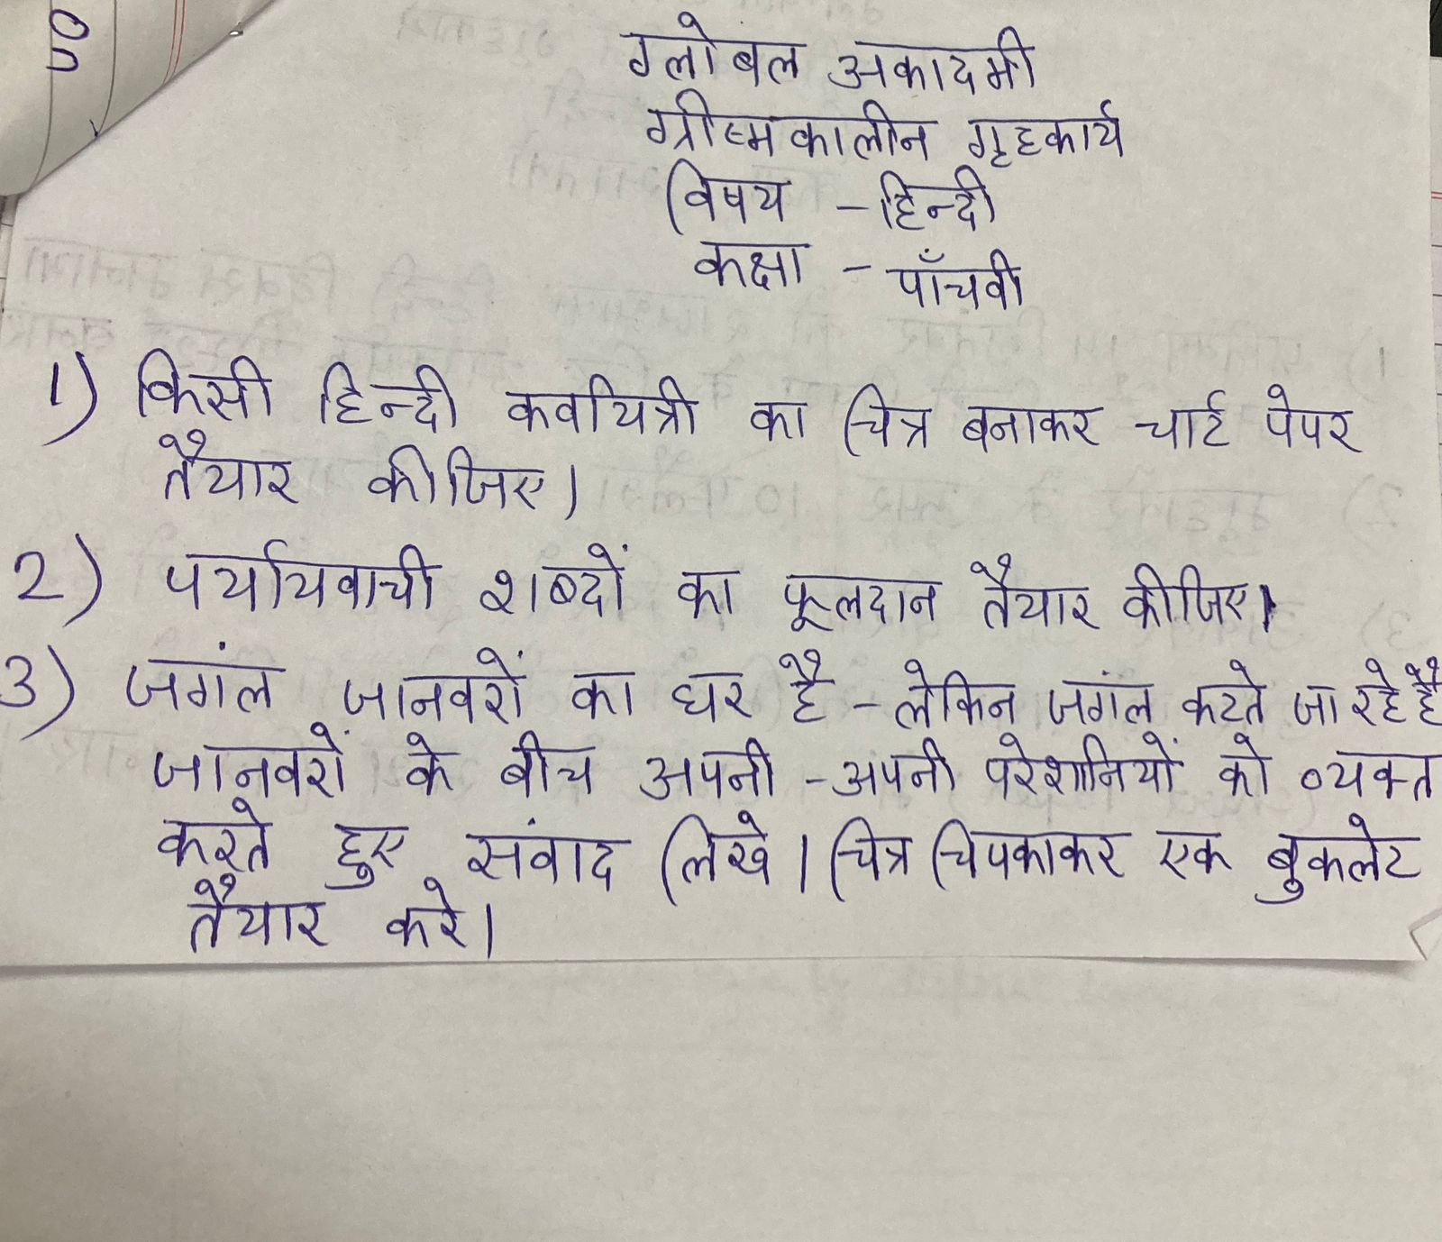

* **Revise the entire syllabus taken up before the summer break of all subject. Make a separate holiday homework copy for each subject .**

**Global Academy**

**Academic Session – 2024-25**

**Holiday Homework**

**Class – V**

**Subject – Maths**

* **Revise the entire syllabus taken up before the summer break of all subject. Make a separate holiday homework copy for each subject .**

1.(a). Make a model on types of graph. (Roll no. 1 to 10)

(b). Make a working model of LCM and HCF (Roll no. 11 to 20)

(c) . Make a multiplication game (Roll no. 21 to 33)

2. Make symmetrical patterns on chart paper. (All students)

3. Make a song about numbers or math facts and write in A3 sheet .

**Global Academy**

**Academic Session – 2024-25**

**Holiday Homework**

**Class – V**

**Subject – Science**

* **Revise the entire syllabus taken up before the summer break of all subject. Make a separate holiday homework copy for each subject .**

1.(a). Prepare working model of rain water harvesting. (1 – 10)

(b) Prepare working model on wind mills and solar panel (11 – 20)

(c) Prepare working model on these types of motion ( 21 -26 )

i )Translator

ii) periodic

iii) Oscillatory

iv) Rotation

d) Construct a magnetic swing using cardboard magnet and straw (27 – 33)

2. Make a chart paper on different forms of energy present around us.

3. Write few lines about ‘Dr. Hoini Jehangir Bhabha” with picture on chart paper.

4. Prepare a model of layers of earth.

**Global Academy**

**Academic Session – 2024-25**

**Holiday Homework**

**Class – V**

**Subject – SST**

* **Revise the entire syllabus taken up before the summer break of all subject. Make a separate holiday homework copy for each subject .**

Q1. Make a chart on –

a. Heat Zones

b. List of fundamental duties.

Q2. Paste in scrap book the following –

a. Tools of earliest Humans

b. Social reformers.

Q3. Make a model on –

Globe (Roll no. 1 to 5)

Natural resources (Roll no. 6 to 10)

Torrid Zone (Roll no. 11 to 15)

Types of wastes (Roll no. 16 to 20)

Three R’s (Roll no. 21 to 25)

Types of Pollution (Roll no. 26 to 30)

Natural disasters (Roll no. 31 to 34)

Q4. With the help of the Internet, find and write the names of different fuels used to run the vehicles given below –

1. Cars

2. Motorcycles

3. Aeroplanes

4. Trucks

5. Auto-Rikshaws

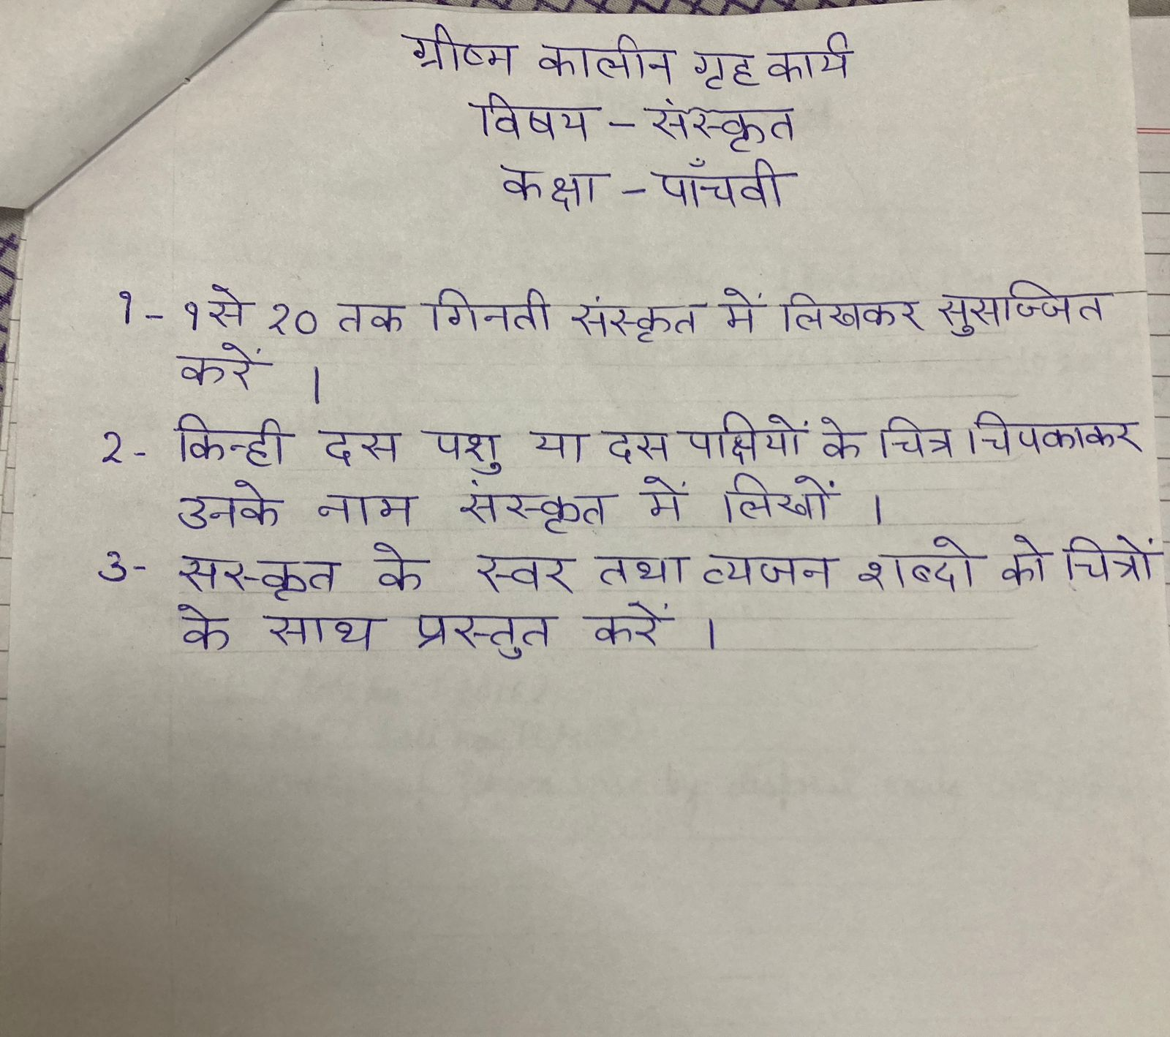

* **Revise the entire syllabus taken up before the summer break of all subject. Make a separate holiday homework copy for each subject .**

**Global Academy**

**Academic Session – 2024-25**

**Holiday Homework**

**Class – V**

**Subject – Computer**

* **Revise the entire syllabus taken up before the summer break of all subject. Make a separate holiday homework copy for each subject .**

1. Paste the pictures of the generation of computer in a chart paper and write about them.

2. Write down about hardware and software in A3 Size sheet and also paste pictures of their devices.

**Global Academy**

**Academic Session – 2024-25**

**Holiday Homework**

**Class – V**

**Subject – GK**

* **Revise the entire syllabus taken up before the summer break of all subject. Make a separate holiday homework copy for each subject .**

1. Make a poster of healthy food.

2. Draw a picture of any sports and write few lines about it. (on A3 size sheet)

3. Make a chart of Scientific Instrument.

Or

Make a chart of famous hill stations which are located In India.

**Global Academy**

**Academic Session – 2024-25**

**Holiday Homework**

**Class – V**

**Subject – Drawing**

1 (a). Bhil Art (Roll no. 1 to 16)

(b). Mandana Art (Roll no. 17 to 33)

2. Make a drawing of cartoon character in A3 size sheet .

3.Make a model of flower vase by disposal bowls and papers .