**Global Academy**

**Academic Session – 2024-25**

**Holiday Homework**

**Class – IV**

**Subject – English**

* **Revise the entire syllabus taken up before the summer break of all subject. Make a separate holiday homework copy for each subject .**

1. Make a scrap book on the topic of “famous female authors”

2. You can read the following books (any one) and write book report.

Book 1 – The jungle Book by Rudyard Kipling.

Book 2 – Tigers for Dinner by Ruskin Bond.

Book 3 – Black Beauty by Anna Sewell.

* Read English newspaper daily chooses to new words daily and prepare a dictionary with decorative cover .

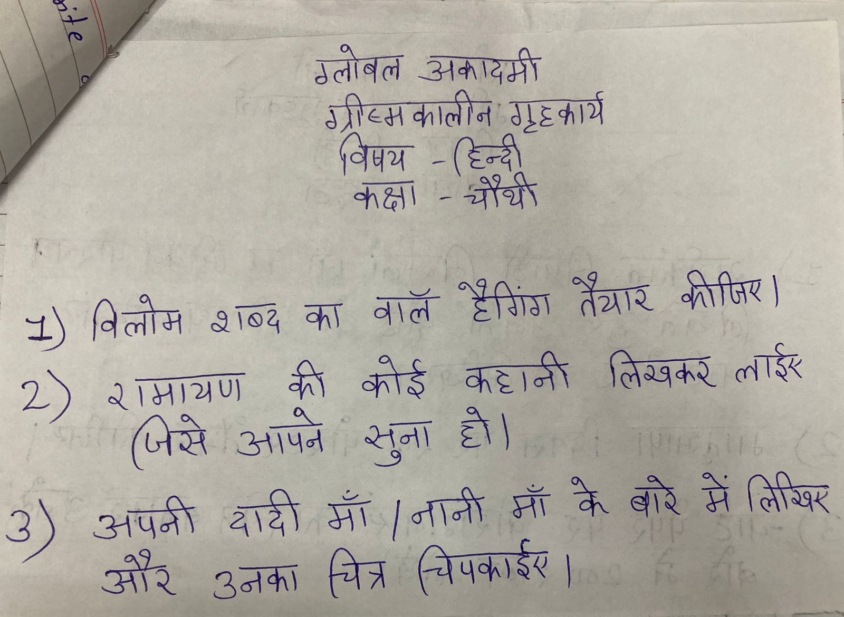

* **Revise the entire syllabus taken up before the summer break of all subject. Make a separate holiday homework copy for each subject .**

**Global Academy**

**Academic Session – 2024-25**

**Holiday Homework**

**Class – IV**

**Subject- maths**

* **Revise the entire syllabus taken up before the summer break of all subject. Make a separate holiday homework copy for each subject .**

1. Make a chart on geometric shapes eg circle, pentagon, Rhombus etc.

2. Make a working model on

a. Types of angles (Roll 1 to 5)

b. LCM of number system (Roll no. 6 to 10)

c. Place value model (Roll no. 11 to 15)

d. LCM model (Roll no. 16 to 20)

e. Multiplication calculator (Roll no. 21 to 25)

f. Multiplication working model. (Roll no. 26 to 30)

g. Clock working model (Roll no. 31 to 34)

3. Make a chart on circle properties.

**Global Academy**

**Academic Session – 2024-25**

**Holiday Homework**

**Class – IV**

**Subject – Science**

* **Revise the entire syllabus taken up before the summer break of all subject. Make a separate holiday homework copy for each subject .**

1. (a). Prepare a model of Hydrologic cycle (1-10).

(b). Prepare working model of Solar System using different size of balls (11-20)

(c) Prepare working model of see – saw, pulley. (21-30)

(d) Prepare working model of Photosynthesis. (31 – 34)

2. Make a chart paper on ‘Stephen Hawking’ with his picture.

3. Make a chart paper on ‘life cycle of birds’.

**Global Academy**

**Academic Session – 2024-25**

**Holiday Homework**

**Class – IV**

**Subject – SST**

* **Revise the entire syllabus taken up before the summer break of all subject. Make a separate holiday homework copy for each subject .**

Q1. Make a chart on –

a. Chipko Movement

b. Three R’s (Recycle, reduce or Reuse)

Q2. Paste in scrap book the following –

a. Means of transport

b. National Symbols

Q3. Make a model on –

National Festivals (Roll no. 1 to 5)

National Emblem (Roll no. 5 to 10)

Means of Communication (Roll no. 10 to 15)

Types of Roads (Roll no. 15 to 20)

Save Water (Roll no. 20 to 25)

Tidal Forests (Roll no. 25 to 30)

Types of soil (Roll no. 30 to 35)

Three main Season (Roll no. 35 to 40)

**Global Academy**

**Academic Session – 2024-25**

**Holiday Homework**

**Class – IV**

**Subject – Computer**

* **Revise the entire syllabus taken up before the summer break of all subject. Make a separate holiday homework copy for each subject .**

1. Craft model of computer system by using thermocol sheet.

2. Draw a chart of generation of computer with posting their pictures.

**Global Academy**

**Academic Session – 2024-25**

**Holiday Homework**

**Class – IV**

**Subject – GK**

1. Paste picture of any five monuments in a drawing sheet or chart paper and explain about them in three lines.

2. Draw a poster on world environment. Colour it and write a catchy slogan for the same.

3. Make a scrap book, paste picture of any 5 – herbal plant and write a catchy slogan for the same.

**Global Academy**

**Academic Session – 2024-25**

**Holiday Homework**

**Class – IV**

**Subject – Drawing**

1. Make a Rajasthani musician showpiece by old pens and refills.

2. Make a drawing of mermaid or fairy in A3 size paper.

3. Make a modern art of women.