**Global Academy**

**Academic Session – 2024-25**

**Holiday Homework**

**Class – III**

**Subject – English**

* **Revise the entire syllabus taken up before the summer break of all subject. Make a separate holiday homework copy for each subject .**

1. Make a beautiful and colourful chart on the topic Nouns.

2. Make a slogan on the topic – ‘Save Water’.

3. Paste pictures of famous poetess in a scrap book and also write few lines about them.

4. Make a beautiful book cover on any topic.

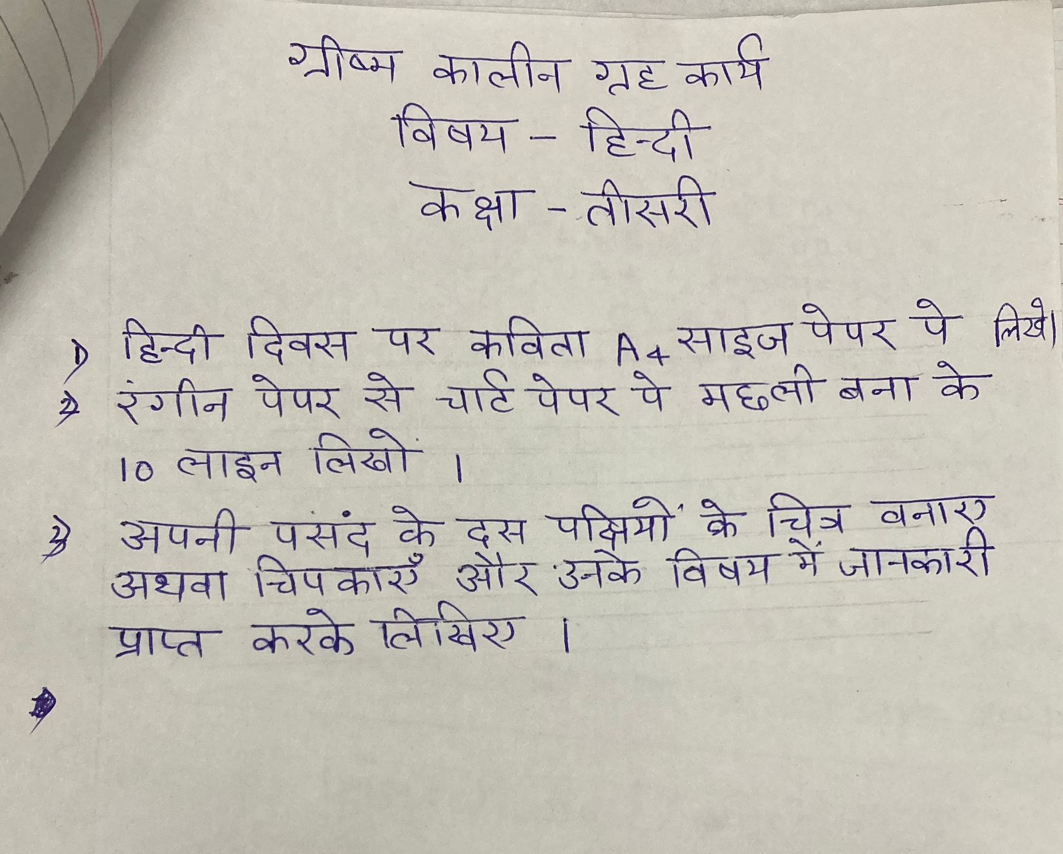

* **Revise the entire syllabus taken up before the summer break of all subject. Make a separate holiday homework copy for each subject .**

**Global Academy**

**Academic Session – 2024-25**

**Holiday Homework**

**Class – III**

**Subject – Maths**

* **Revise the entire syllabus taken up before the summer break of all subject. Make a separate holiday homework copy for each subject .**

1. Paste picture of great mathematicians and write about their contributions in a scrap book.

2. Make a model on 2D and 3D shapes.

3. Make a table book from 2 to 20.

4. Make a project on ‘fractions’.

**Global Academy**

**Academic Session – 2024-25**

**Holiday Homework**

**Class – III**

**Subject – EVS**

* **Revise the entire syllabus taken up before the summer break of all subject. Make a separate holiday homework copy for each subject .**

1. Make a braille script model. (<https://youtube/mktm1asCndy>)

2. Make a menu card of the meals in a day. Take half a chart paper and fold it like a card. Decorate the front portion by pasting pictures of different types of foods on it. Inside it write breakfast, lunch and dinner in bold letters.

3. Make a model of your own. Take a cardboard piece as the floor of your room. Make models of chairs, tables and windows and place them in the proper directions on the cardboard piece.

4. Make a model of safety rules on road. (<https://youtube/c-doTaEMKQ>)

5. Make a chart on the given topic –

a. Clean India, Green India.

b. Different types of land forms.

**Global Academy**

**Academic Session – 2024-25**

**Holiday Homework**

**Class – III**

**Subject – Computer**

* **Revise the entire syllabus taken up before the summer break of all subject. Make a separate holiday homework copy for each subject .**

1. Make a chart paper using paper and draw or paste the pictures of 5 storage devices and write about it.

2. Read and learn 1 and 2 and write 20 difficult words from both lesson in computer notebook.

3. Make a model of computer and it’s parts.

**Global Academy**

**Academic Session – 2024-25**

**Holiday Homework**

**Class – III**

**Subject – GK**

1. Collect and write any ten highlights of year 2024 (Jan to May) in A3 size sheet.

2. Make chart and paste the pictures of different games of India.

**Global Academy**

**Academic Session – 2024-25**

**Holiday Homework**

**Class – III**

**Subject – Drawing**

1. Make impressive cock using your palm. Also draw its comb, beak, eye and feet using sketch pens.

2. Make a beautiful flower using matchsticks and thermocol balls.

3. Make a Origami Giraffe.