**Global Academy**

**Academic Session – 2024-25**

**Holiday Homework**

**Class – II**

**Subject – English**

* **Revise the entire syllabus taken up before the summer break of all subject. Make a separate holiday homework copy for each subject .**

1. Prepare a colorful chart on the topic Noun – Gender.

2. Make a chart on Independence Day with a picture of our flag.

3. Prepare a scrap book on the topic – Verbs and also paste pictures.

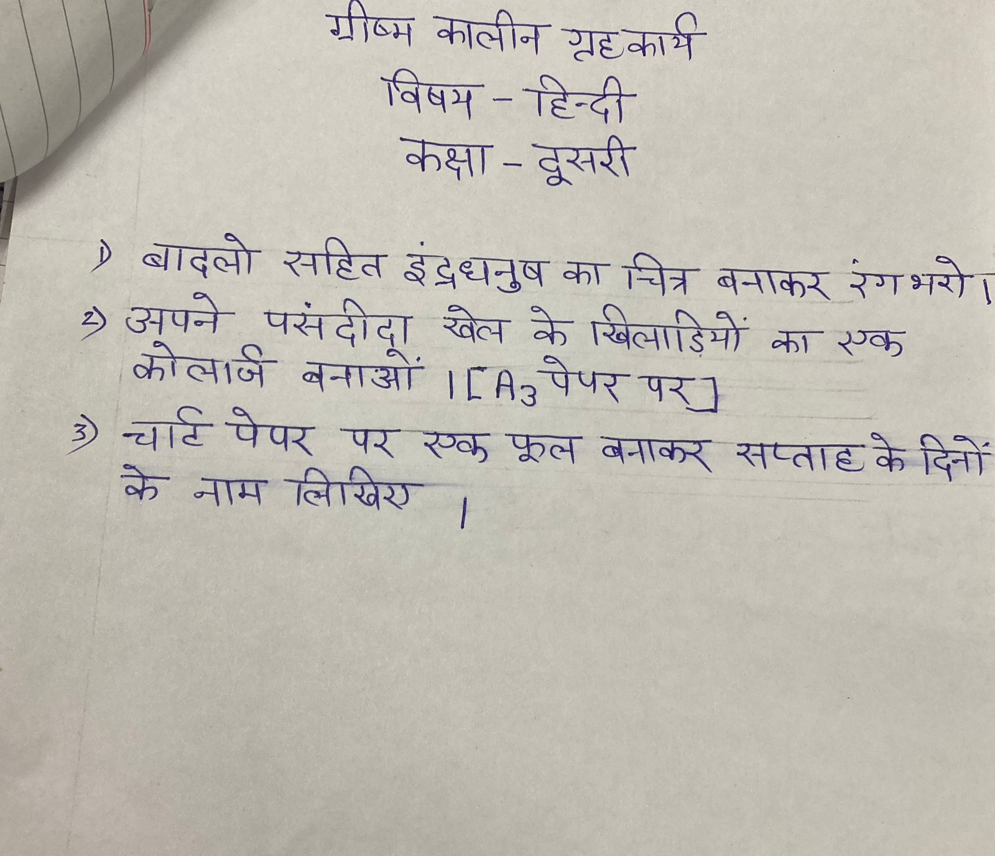

* **Revise the entire syllabus taken up before the summer break of all subject. Make a separate holiday homework copy for each subject .**

**Global Academy**

**Academic Session – 2024-25**

**Holiday Homework**

**Class – II**

**Subject – Maths**

* **Revise the entire syllabus taken up before the summer break of all subject. Make a separate holiday homework copy for each subject .**

1. Make a model of Abacus.

2. Make a wall hanging using different 3D shapes on a chart paper.

3. Make roman Numbers 1 to 20 with the help of colorful matchstick in a chart paper.

**Global Academy**

**Academic Session – 2024-25**

**Holiday Homework**

**Class – II**

**Subject – EVS**

* **Revise the entire syllabus taken up before the summer break of all subject. Make a separate holiday homework copy for each subject .**

1. Make a south Indian dish with the help of parents. Make a scrapbook with the pictures of child while making dish. (Do not forget wear apron and chef’s cap.)

2. Make a Santa Claus using strips of colorful cloth or paper and paste it in your scrapbook. You may take help from your parents.

3. The most important weapon against air pollution is awareness. It is only when people know about the causes and bad effects of air pollution that it can be controlled. Form a club to fight with problem. Make a chart on causes of air pollution.

4. Prepare a chart displaying the pictures and names of energy giving food, body building food and energy giving food.

**Global Academy**

**Academic Session – 2024-25**

**Holiday Homework**

**Class – II**

**Subject – Computer**

* **Revise the entire syllabus taken up before the summer break of all subject. Make a separate holiday homework copy for each subject .**

1. Draw a part of computer with a name on a chart paper.

2. Make a poster on Do’s and Don’t in computer lab.

3. Paste picture of 5 input device and write the about it on chart paper.

**Global Academy**

**Academic Session – 2024-25**

**Holiday Homework**

**Class – II**

**Subject – GK**

1. Make a poster on ‘clean India’.

2. Make a chart on National symbol of India.

3. Paste pictures of different means of transport on a thick colored sheet.

4. Paste and write 2 – 2 lines on different seasons in India on colored sheet.

**Global Academy**

**Academic Session – 2024-25**

**Holiday Homework**

**Class – II**

**Subject – Drawing**

1. Make a sketch on anyone famous women personalities of India.

2. Make a Mother’s Day or Father’s Day card.

3. Make a pen pencil holder or book holder with the help of plastic bottle or cartoon box.