**Global Academy**

**Academic Session – 2024-25**

**Holiday Homework**

**Class – I**

**Subject – English**

* **Revise the entire syllabus taken up before the summer break of all subject. Make a separate holiday homework copy for each subject .**

1. Make a birthday chart for classroom.

2. With the help of ice cream sticks, make puppets on the topic “My Family”.

3. With the help of Cardboard, make flash cards/Wall hanging on ‘one and many’.

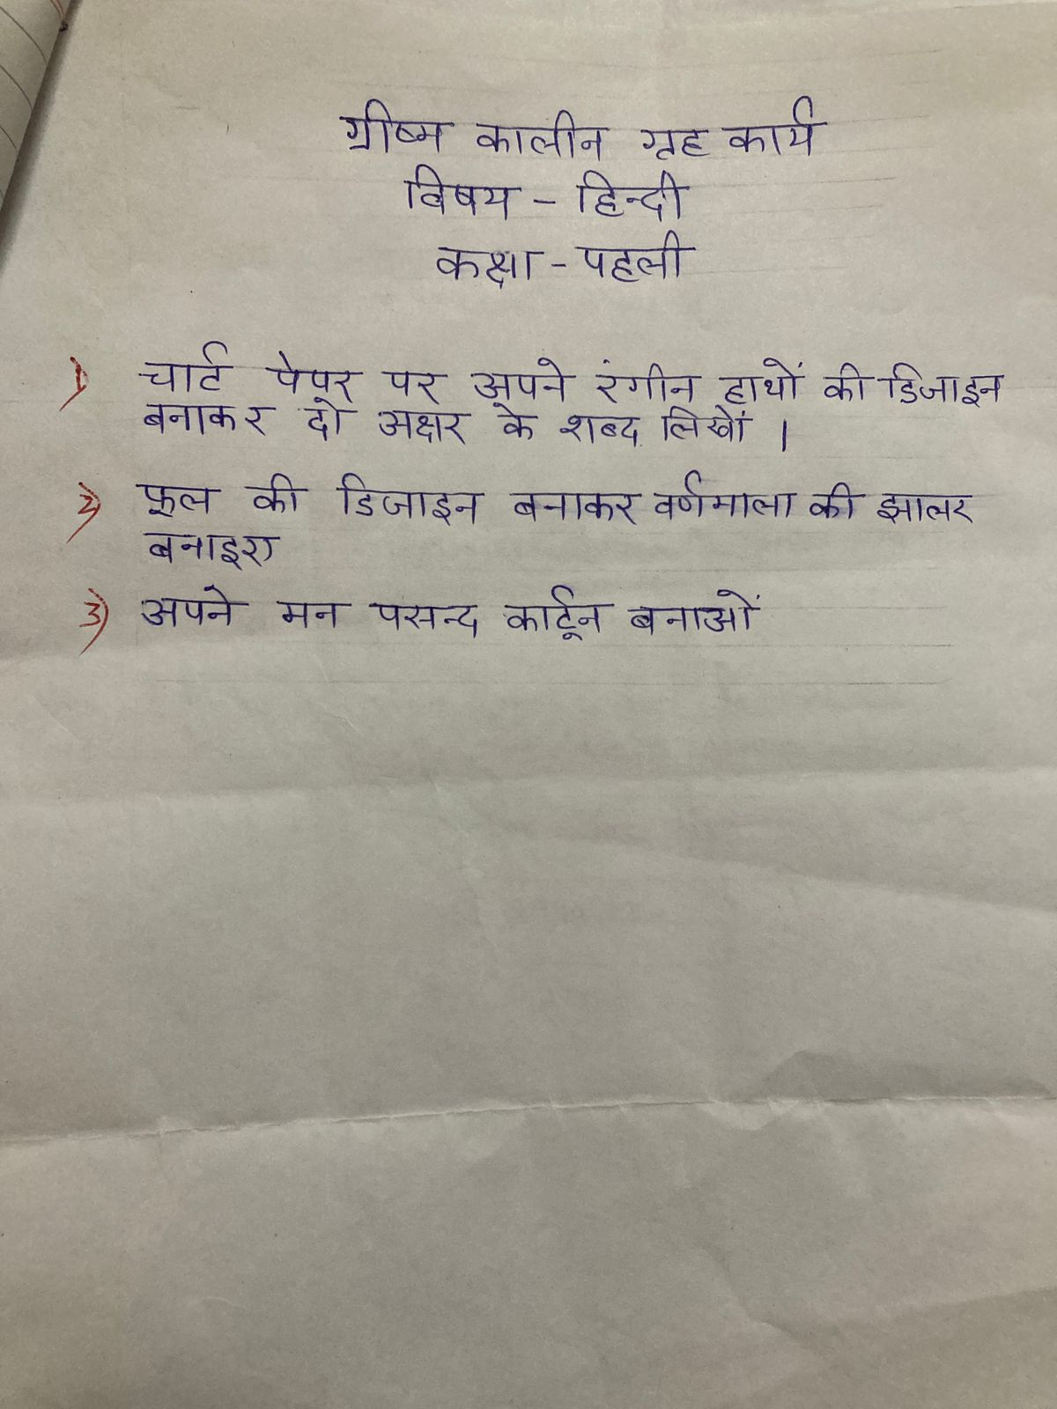

**Global Academy**

**Academic Session – 2024-25**

**Holiday Homework**

**Class – I**

**Subject – EVS**

* **Revise the entire syllabus taken up before the summer break of all subject. Make a separate holiday homework copy for each subject .**

1. Make a north Indian dish with the help of parents. Make a scrapbook with the pictures of the child while making dish. (Do not forgot to wear apron and chef’s cap.

2. Make a time table on chart paper showing the times of the day and what you do during that time of a day.

3. Observe the changes in the shapes of the moon at night daily. Write days and dates in your scrapbook.

4. Make a model of aquarium.

**Global Academy**

**Academic Session – 2024-25**

**Holiday Homework**

**Class – I**

**Subject – Maths**

* **Revise the entire syllabus taken up before the summer break of all subject. Make a separate holiday homework copy for each subject .**

1. Make a game, shake and ladders on A3 size sheet by following the steps given below.

Step 1 – Make a square paper, the first step is making a squared paper.

Step 2 – Making 100 small squares.

Step 3 – Numbering the squares

Step 4 – Sketching the snakes and ladders.

Step 5 – Colouring the snakes and ladders.

Step 6 – Using maker lids

Q2. Make a beautiful lamp with thermocol cups and decorate it.

Q3. Make a numbers chart using matchsticks. (1 to 100)

Q4. Make three kites with A3 size sheet and write table of 2,4 and 3 on their tail and color it.

Example is given below.

**Global Academy**

**Academic Session – 2024-25**

**Holiday Homework**

**Class – I**

**Subject – GK**

* **Revise the entire syllabus taken up before the summer break of all subject. Make a separate holiday homework copy for each subject .**

1. Learn and write fruit name and also paste pictures of each on a chart paper.

2. Make a chart and paste the pictures of the animal to the food they eat.

3. Draw five grains or cereals and five vegetable on a chart paper.

**Global Academy**

**Academic Session – 2024-25**

**Holiday Homework**

**Class – I**

**Subject – Computer**

* **Revise the entire syllabus taken up before the summer break of all subject. Make a separate holiday homework copy for each subject .**

1. Draw a part of computer with a name in a chart paper.

2. Paste pictures of five input devices and 5 output devices on a chart paper.

**Global Academy**

**Academic Session – 2024-25**

**Holiday Homework**

**Class – I**

**Subject – Drawing**

1. Make a elephant or Rabbit with Pules in A chart paper .
2. Make an hut craft with uses of ice- creams sticks .
3. Make a colourful ice-cream with thermocol and paste it on A4 size sheet.